

*Annexure-7*

**Preparation of Integrated Transport Network Development Plan (ITNDP)**

**Sponsored by**

**MEGHALAYA INFRASTRUCTURE DEVELOPMENT FINANCE CORPORATION LTD**



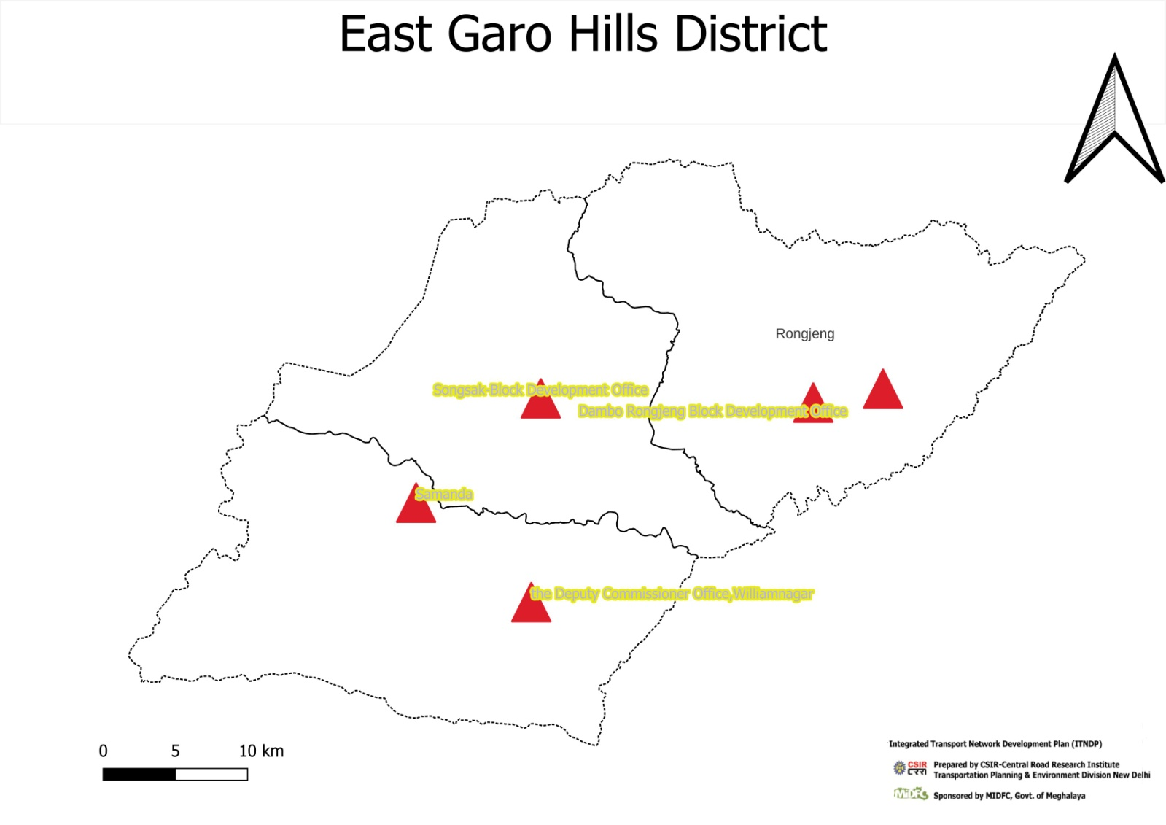**District: East Garo Hills**

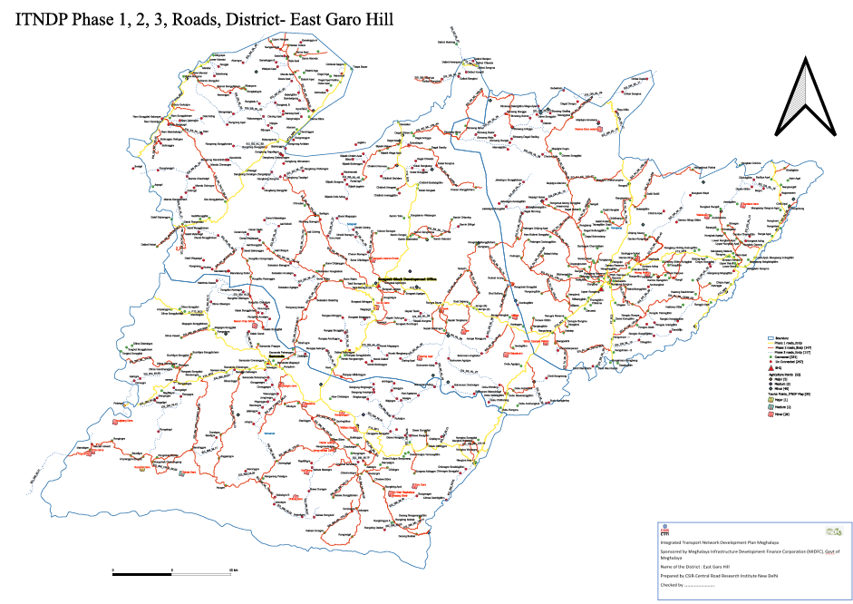

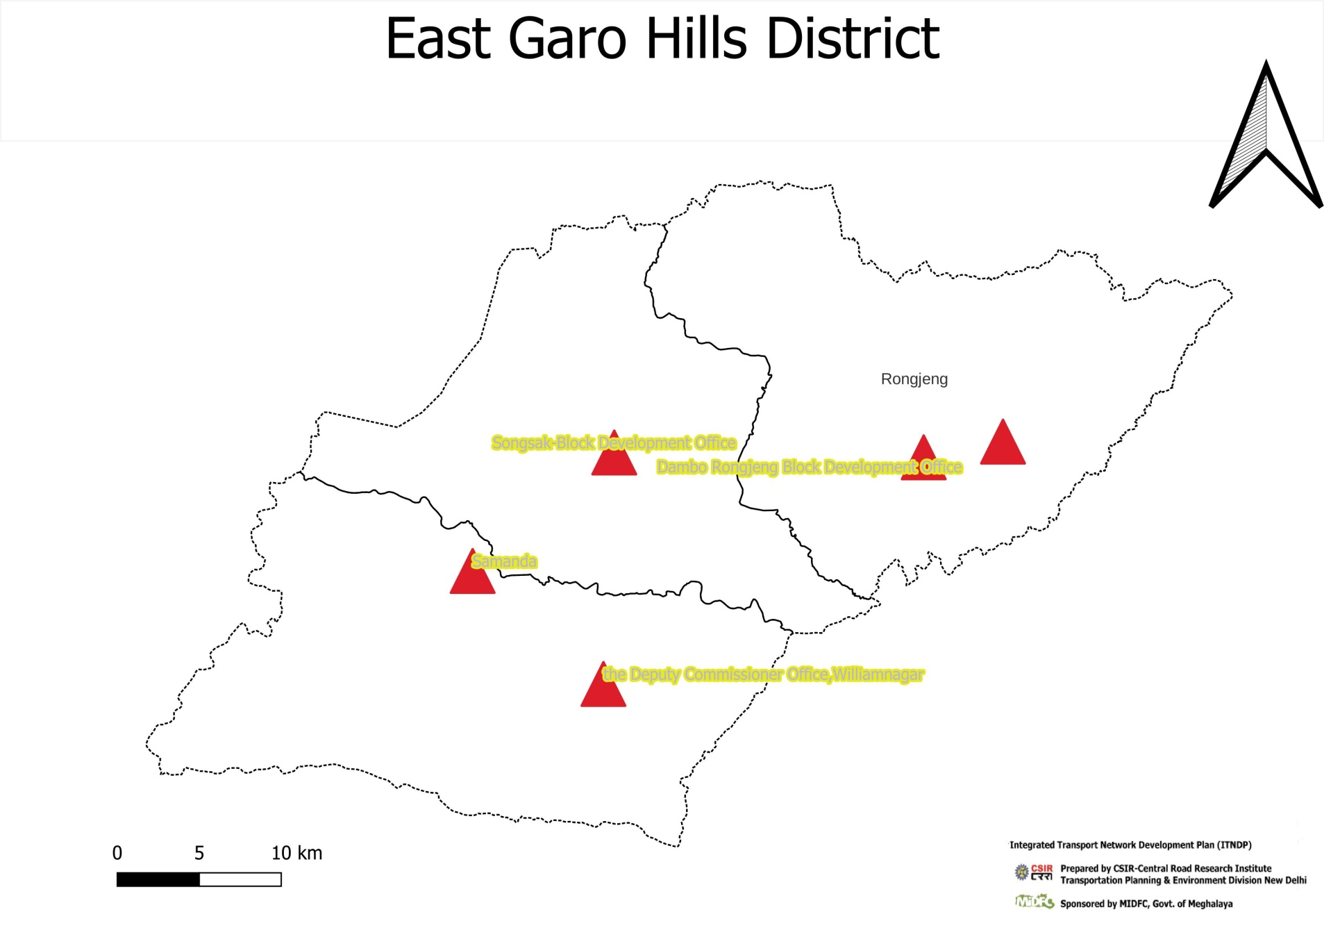  
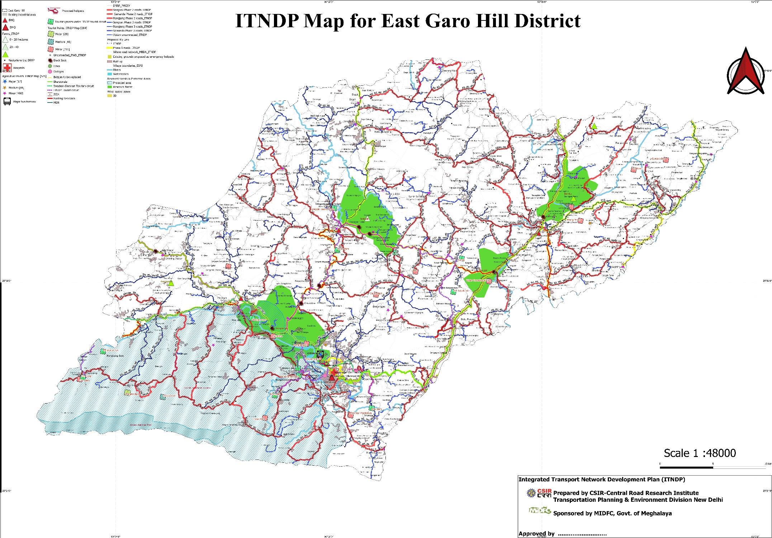

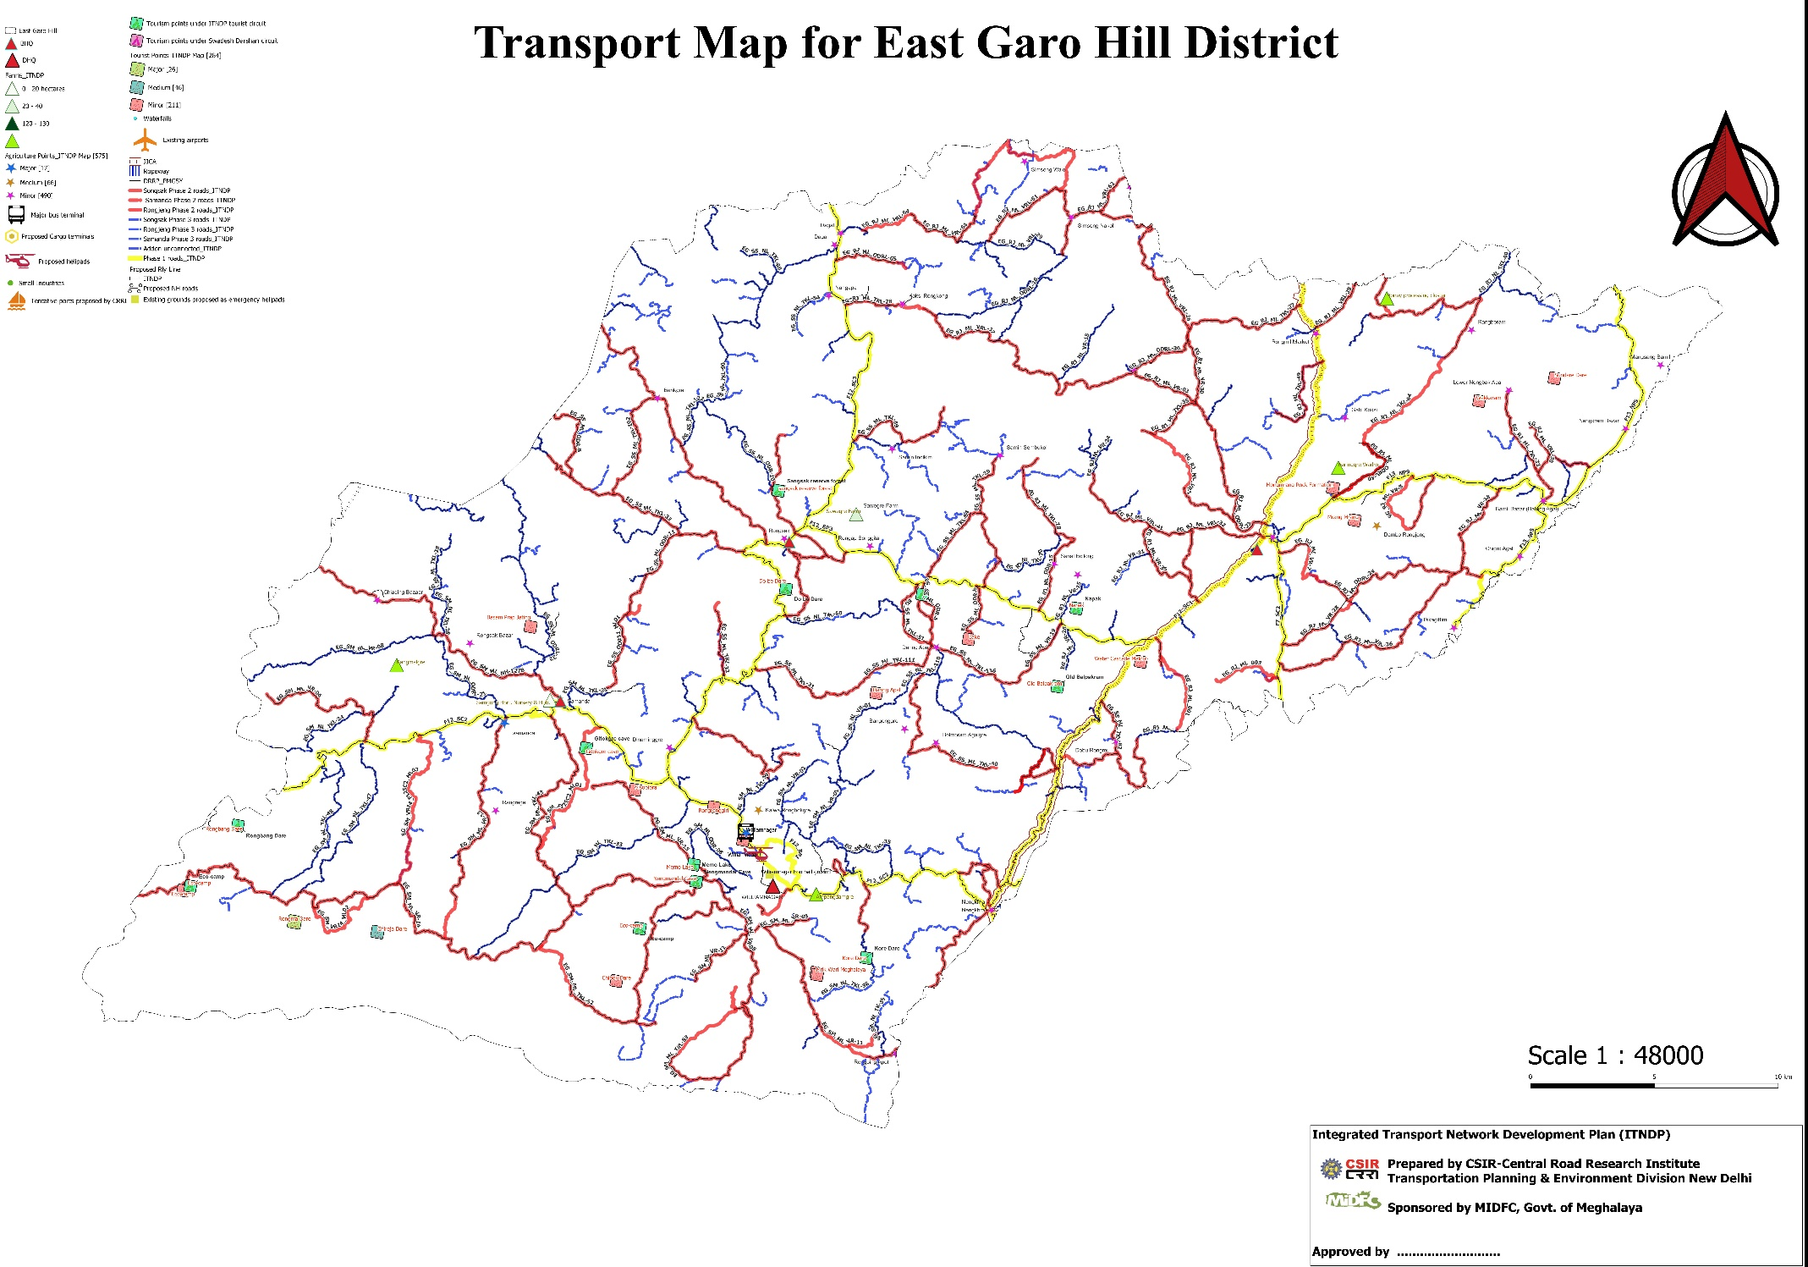

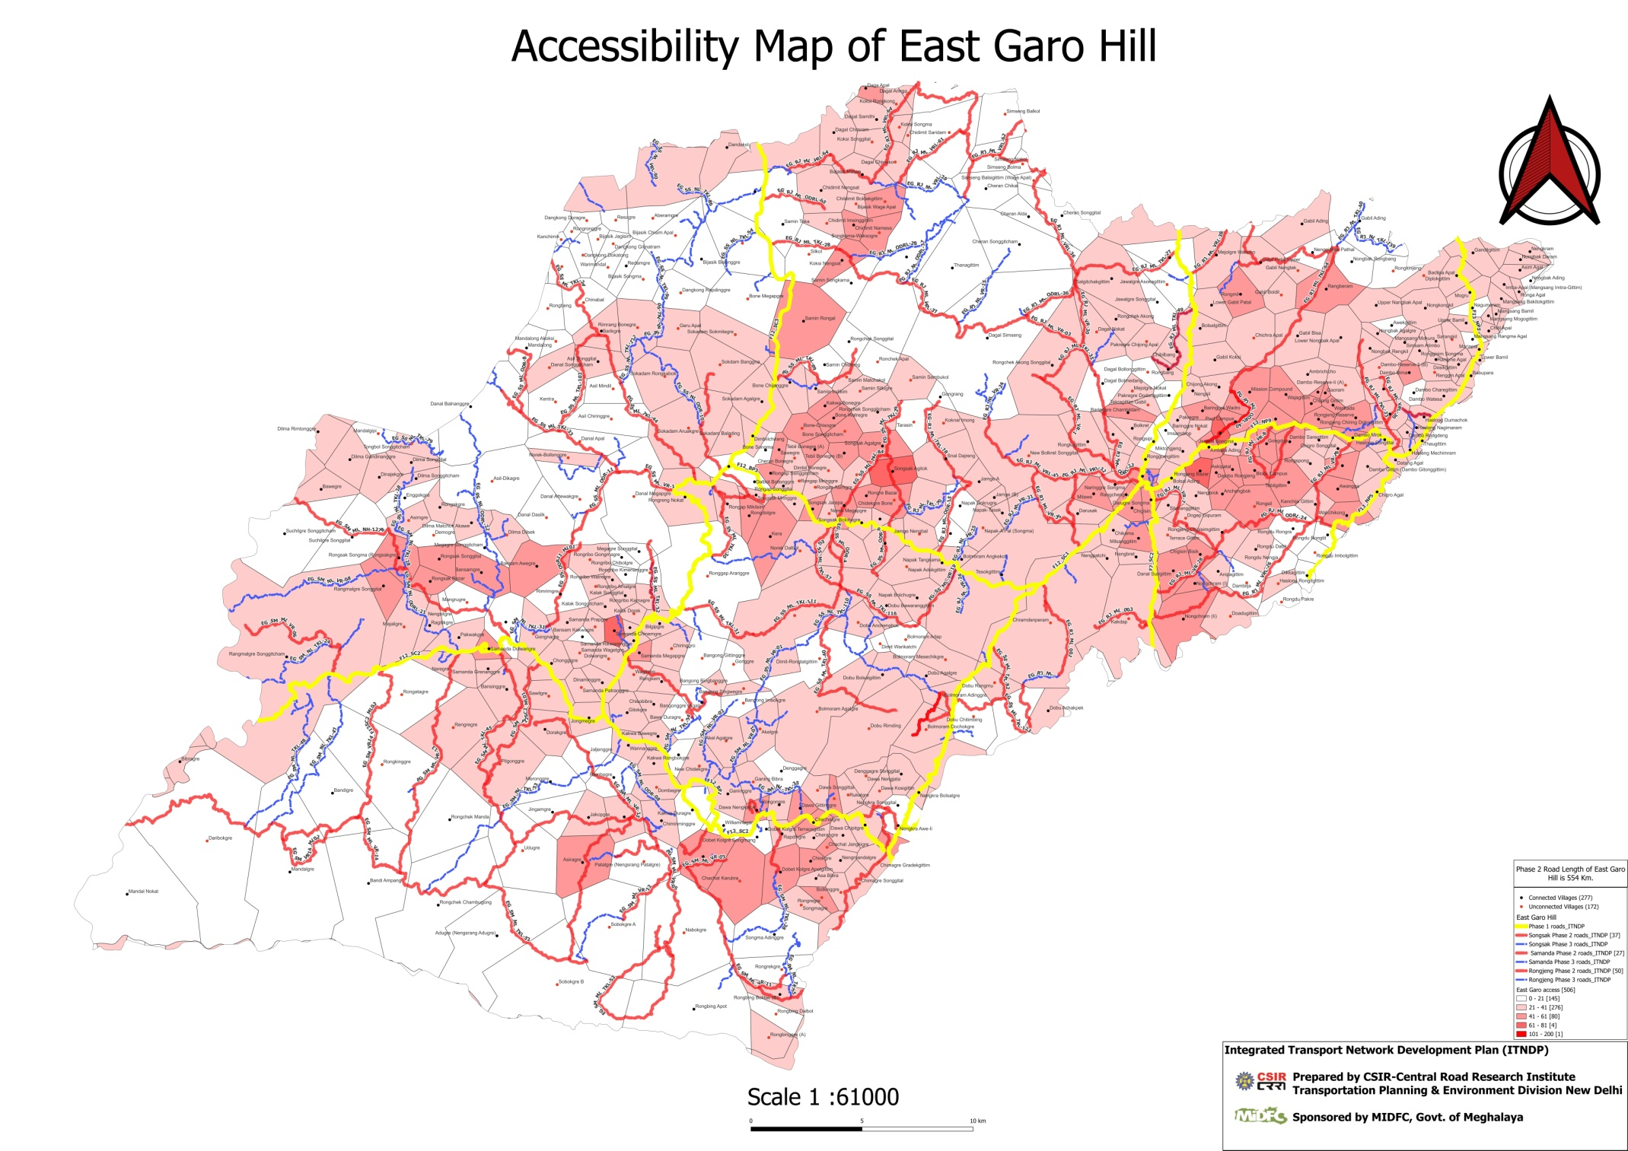

**Summary of East Garo**

|  |  |  |  |  |
| --- | --- | --- | --- | --- |
|  | **Dambo-Rongjong** | **Samanda** | **Songsak** | **EGH** |
| **Total No of Road** | 20 | 30 | 68 | 118 |
| **Total Length of New Construction(km)** | 92.33298093 | 136.4139871 | 200.81 | 429.556968 |
| **Total Cost of Road** | 10340.95 | 16093 | 28283.5 | 54717.45 |
| **Total no of Connected Habitation** | 135 | 84 | 117 | 336 |
| **Total no of Unconnected Habitation** | 50 | 63 | 233 | 346 |
|  |  |  |  |  |
| **Total no of Bridge Bridge/CD/Culvert upto 10m** | 2 | 6 | 4 | 12 |
| **Total no of Bridge Between 10 m-30 m** | 11 | 9 | 26 | 46 |
| **Total number of bridge Between 30-60m** | 5 | 57 | 21 | 83 |
| **Total no of bridge greater than 60m** | 2 | 14 | 17 | 33 |
| **Total no bridge** | 20 | 29 | 68 | 117 |
| **Total Cost of Bridge and Culvert** | 2421.5 | 18630 | 3172 | 24223.5 |

**Summary of Yearly Financial allocation of Phase -3 roads and Bridge of ITNDP, District: East Garo Hill.**

|  |  |  |  |  |  |  |  |  |  |  |  |  |  |  |  |  |  |  |  |  |  |  |  |
| --- | --- | --- | --- | --- | --- | --- | --- | --- | --- | --- | --- | --- | --- | --- | --- | --- | --- | --- | --- | --- | --- | --- | --- |
| **Un ID** | **Block:** | **Name of road Proposed from** | **Road code** | **Length** | **Total Cost in Lakhs** | **Population serve by New Alignment .** | **Ranking** | **Absolute Ranking** | **Block Wise Ranking** | **Habbitation:** | **Whether Road is Sanctioned under any scheme ( Yes/No) eg. MNREGA, PMGSY, PWD, C&RD, BADO, etc. (?)** | **Whether road alignment considered in CRRI ITNDP Phase-3 Roads (Yes/No)** | **Existing Surface Type E/G/WBM. (?) Proposed E/G/WBM/BT(Provide KML)** | **Road Agency (PWD/C&RD/Industry/Mining/Agriculture/Tourist/Water/BADA/any other).** | **Length (KM) of New Roads Construction Proposed.** | **Length portion (KM).** | **Width of road length(metre) proposed.** | **Total Cost based on cost per km average rate 2024(in Lakhs) Length* Rate. @ ` 1,25,000.00/km** | **Length of New construction of Bridge/CD/Culvert (Meter).** | **Type Bridge/CD/Culvert/etc.** | **Cost for Bridge/CD/Culvert/etc.** | **a) Agriculture areas eg- 5,10.** | **b) Economic potential areas eg- 5,10** |
| 1004 | Dambb-Rongjong | NH62 TO Chrandenperam | EG_DR_NL_21 | 1.062811404 | 172.5 | 7319 | 0.023568794 | 1 | Dambb-Rongjong 1 | Chrandunpera, Dapugre | FALSE |  | E | PWD | 1 | 1 | 6/3.75 | 150 | 10 |  | 22.5 | 2.5 | 3 |
| 5242 | Samanda | L-41 to Rongbing Dolbot | EG_SM_NL23 | 1.745502283 | 218 | 788 | 0.276649746 | 2 | Samanda 1 | Rongbing Dolbot | FALSE | FALSE | Kutcha | PWD | 1.86 | 1.86 | 3.75 | 186 | 18 | Bridge Culvert | 32 | 2 | 2 |
| 188 | Dambb-Rongjong | 101st km of NH 1278 TO 48th of NH 62 | EG_DR_NL_20 | 2.493967359 | 472.95 | 1436 | 0.329352368 | 3 | Dambb-Rongjong 2 | Anipagittim , Anchengbok | FALSE |  | E | PWD | 2.5 | 2.5 | 6/3.75 | 400.95 | 24 |  | 72 | 3 | 7 |
| 1868 | Samanda | Dolwagre road to Gonggnagre | EG_SM_NL27 | 0.762859464 | 106 | 236 | 0.449152542 | 4 | Samanda 2 | Gonggnagre | FALSE | TRUE | Kutcha | PWD | 0.8 | 0.8 | 3.75 | 100 | 3 | LSB ,Salb Culvert | 6 | 1 | 1 |
| 1933 | Dambb-Rongjong | Nagimaram To RMA(Datong) | EG_DR_NL_02 | 2.984118195 | 350 | 593 | 0.590219224 | 5 | Dambb-Rongjong 3 | Hoslong Dilmachok, Nagimaram | FALSE |  | E | PWD | 2.9 | 2.9 | 6/ 3.00 | 280 | 18 |  | 70 | 9 | 15 |
| 4107 | Dambb-Rongjong | Chikal Songma TO Nenggitehak patal | EG_DR_NL_10 | 1.487039871 | 195 | 310 | 0.629032258 | 6 | Dambb-Rongjong 4 | Chikal Songma, Nenggitehak patal | FALSE |  | E | PWD | 1.5 | 1.5 | 6/3.75 | 150 | 17.5 |  | 45 | 8 | 7 |
| 1092 | Dambb-Rongjong | Dawa Songgital Dalnan | EG_DR_NL_17 | 1.648950863 | 231.5 | 290 | 0.798275862 | 7 | Dambb-Rongjong 5 | Rogu Alda | FALSE |  | E | PWD | 1.6 | 1.6 | 6/3.75 | 200 | 14 |  | 31.5 | 3 | 4 |
| 2060 | Dambb-Rongjong | Jalwagre Songgital VIA Jalwagre songiticham TO Dagal Dogre | EG_DR_NL_14 | 4.470550757 | 580 | 647 | 0.896445131 | 8 | Dambb-Rongjong 6 | Jalwagre Songgital, Jalwagre songiticham , Dagal Dogre | FALSE | TRUE | E | PWD | 4.5 | 4.5 | 6/3.75 | 450 | 30 |  | 130 | 8 | 5 |
| 1554 | Dambb-Rongjong | NH-1278 To Dombugittim | EG_DR_NL_03 | 2.144170439 | 242 | 264 | 0.916666667 | 9 | Dambb-Rongjong 7 | Domdugittim | FALSE | FALSE | E | PWD | 2 | 2 | 6/3.75 | 200 | 12 |  | 42 | 3 | 5 |
| 1285 | Dambb-Rongjong | Rondu Rongra TO Imbelgittim | EG_DR_NL_07 | 1.400973512 | 240 | 243 | 0.987654321 | 10 | Dambb-Rongjong 8 | Rondu Rongra, Imbelgittim | FALSE |  | E | PWD | 1.5 | 1.5 | 6/3.75 | 200 | 10 |  | 40 | 5 | 3 |
| 1143 | Dambb-Rongjong | Dambo Rongdeng TO Dambo gittongittui | EG_DR_NL_05 | 3.113020211 | 517.5 | 501 | 1.032934132 | 11 | Dambb-Rongjong 9 | Mansang Mogogittim, Dambo gittongittui | FALSE |  | E | PWD | 3 | 3 | 6/3.00 | 450 | 30 |  | 67.5 | 3 | 7 |
| 5399 | Samanda | L-22 to Rongribo Kamagre | EG_SM_NL20 | 1.46273849 | 195 | 163 | 1.196319018 | 12 | Samanda 3 | Rongribo Kamagre | FALSE | FALSE | Kutcha | PWD | 1.5 | 1.5 | 3.75 | 150 | 8 | Bridge 4Culvert | 45 |  |  |
| 4635 | Samanda | Rangmalgre to Pakwegri | EG_SM_NL30 | 0.549174717 | 100 | 82 | 1.219512195 | 13 | Samanda 4 | Pakwegri | FALSE | FALSE | Kutcha | PWD | 0.55 | 0.55 | 3.75 | 100 | 4 | LSB ,Salb Culvert |  | 2 | 2 |
| 1282 | Samanda | To3 to Chipitgre | EG_SM_NL13 | 2.044688543 | 230 | 188 | 1.223404255 | 14 | Samanda 5 | Chipitgre | FALSE | TRUE | E | PWD | 2 | 2 | 3.75 | 200 | 9 | Bridge 6Culvert | 30 | 3 | 3 |
| 5788 | Dambb-Rongjong | Simseng bongga TO simseng sakol | EG_DR_NL_04 | 4.612418932 | 540 | 438 | 1.232876712 | 15 | Dambb-Rongjong 10 | Simseng Nakol, Simseng Aringgre | FALSE |  | E | PWD | 4.5 | 4.5 | 6/3.00 | 450 | 40 |  | 90 | 13 | 18 |
| 741 | Samanda | PMGSY road to Asiragre | EG_SM_NL10 | 2.975787562 | 345 | 270 | 1.277777778 | 16 | Samanda 6 | Chachat Gangkegre Chachat Karubra | FALSE | TRUE | E | PWD | 3 | 3 | 3.75 | 300 | 13.5 | Bridge 9Culvert | 45 |  |  |
| 5815 | Samanda | L44 to Sobokgre B | EG_SM_NL32 | 4.036000108 | 447 | 336 | 1.330357143 | 17 | Samanda 7 | Sobokgre B , Sobokgre Nabokgre | FALSE | TRUE | Kutcha | PWD | 4.2 | 4.2 | 3.75 | 420 | 20 | Minor Bridge culvert | 27 | 2 | 2 |
| 3119 | Samanda | PMGSY road to Mandal Nokwat | EG_SM_NL24 | 1.2349215 | 120 | 89 | 1.348314607 | 18 | Samanda 8 | Mandal Nokwat | FALSE | TRUE | Kutcha | PWD | 1.2 | 1.2 | 3.75 | 120 | 3 |  |  | 1 | 1 |
| 1142 | Dambb-Rongjong | L21(RMA) TO Rongitgottim | EG_DR_NL_13 | 2.758490863 | 485 | 352 | 1.377840909 | 19 | Dambb-Rongjong 11 | Dambo Chanegittim, Noughah Ading | FALSE |  | E | PWD | 2.8 | 2.8 | 6/3.00 | 420 | 26 |  | 65 | 2 | 7 |
| 1286 | Samanda | T03 to Dawa Nengjata | EG_SM_NL25 | 1.775880826 | 191 | 133 | 1.436090226 | 20 | Samanda 9 | Dawa Nengjata | FALSE | TRUE | Kutcha | PWD | 1.75 | 1.75 | 3.75 | 175 | 16 | Minor | 16 |  |  |
| 3777 | Dambb-Rongjong | NH-62 TO MejolgreAmebang | EG_DR_NL_15 | 3.531872217 | 400 | 276 | 1.449275362 | 21 | Dambb-Rongjong 12 | Mejalgre Amebang | FALSE |  | E | PWD | 3.5 | 3.5 | 6/3.75 | 350 | 27.5 |  | 50 |  | 10 |
| 1288 | Dambb-Rongjong | Dawa Songgital TO Dakram | EG_DR_NL_06 | 1.664761248 | 231.5 | 155 | 1.493548387 | 22 | Dambb-Rongjong 13 | Dawa Songgital , Dakram | FALSE |  | E | PWD | 1.6 | 1.6 | 6/3.75 | 200 | 14 |  | 31.5 | 3 | 4 |
| 2119 | Dambb-Rongjong | Jalwagre Songgital TO Cheran Songgital | EG_DR_NL_18 | 8.294707068 | 932 | 610 | 1.527868852 | 23 | Dambb-Rongjong 14 | Jalwagre Asokagiltim , Jalwagre Songital | FALSE |  | E | PWD | 8.2 | 8.2 | 6/3.75 | 800 | 48 |  | 132 | 6 | 10 |
| 1831 | Dambb-Rongjong | Chikal Songma To Gobekram | EG_DR_NL_09 | 5.201473813 | 685 | 409 | 1.674816626 | 24 | Dambb-Rongjong 15 | Chikal Songma, Gobekram | FALSE |  | E | PWD | 4.9 | 4.9 | 6/3.75 | 490 | 45 |  | 195 | 8 | 10 |
| 2238 | Samanda | L22 to Kalak Dorek | EG_SM_NL19 | 1.908912053 | 210 | 117 | 1.794871795 | 25 | Samanda 10 | Kalak Dorek | FALSE | TRUE | Kutcha | PWD | 1.8 | 1.8 | 3.75 | 180 | 15 | LSB ,Salb Culvert | 30 | 2 | 2 |
| 238 | Samanda | Asimgre Nawegre to Dimigre | EG_SM_NL08 | 7.62179392 | 997 | 549 | 1.816029144 | 26 | Samanda 11 | Asimgre, Baisegre, Dimsgre | FALSE | FALSE | E | PWD | 7.5 | 7.5 | 3.75 | 750 | 65 | Bridge 32Culvert | 247 | 5 | 5 |
| 5921 | Samanda | T03 to Songmegre | EG_SM_NL16 | 3.396277306 | 388 | 197 | 1.969543147 | 27 | Samanda 12 | Songmegre | FALSE | TRUE | Kutcha | PWD | 2.9 | 2.9 | 3.75 | 290 | 98 | LSB ,Salb Culvert | 98 | 5 | 5 |
| 5435 | Samanda | Samgonggre to Agalge via Akelgre | EG_SM_NL01 | 8.147848053 | 1270.5 | 574 | 2.213414634 | 28 | Samanda 13 | Akel Agal, Rukalgre, Akegre | FALSE | TRUE | Kutcha | PWD | 8.5 | 8.5 | 3.75 | 1062.5 | 60 | Bridge ,Culvert | 208 | 5 | 5 |
| 1289 | Samanda | To3 toDangagre Songgital | EG_SM_NL14 | 6.454582928 | 1854 | 803 | 2.308841843 | 29 | Samanda 14 | Dangagre Songgital | FALSE | TRUE | E | PWD | 6.2 | 6.2 | 3.75 | 620 | 71 | Bridge 21Culvert | 1234 | 3 | 3 |
| 5396 | Samanda | Kalak Songgital to Rongribo Amelgre | EG_SM_NL21 | 2.455329314 | 290 | 103 | 2.815533981 | 30 | Samanda 15 | Rongribo Amelgre | FALSE | FALSE | Kutcha | PWD | 2.45 | 2.45 | 3.75 | 245 | 18 | Bridge 5Culvert | 45 | 4 | 4 |
| 4073 | Samanda | Amparggre to Maregri | EG_SM_NL31 | 10.45960044 | 1107 | 387 | 2.860465116 | 31 | Samanda 16 | Naregre, Nengsitgre Raengegre | FALSE | TRUE | Kutcha | PWD | 10.1 | 10.1 | 3.75 | 1010 | 65 | Minor Bridge culvert | 97 | 4 | 4 |
| 222 | Samanda | Nengmandalgre to Kakwa Rongbokgre | EG_SM_NL07 | 11.29982381 | 2722.75 | 850 | 3.203235294 | 32 | Samanda 17 | Bawe Duragre, Rapdikgre, Kakwa Rongbokgre | FALSE | TRUE | Kutcha | PWD | 11.35 | 11.35 | 3.75 | 1418.75 | 114 | Bridge 48Culvert | 1304 | 5 | 5 |
| 5780 | Dambb-Rongjong | Godalgittim to Simseng Rongal | EG_DR_NL_19 | 11.67862235 | 1380 | 430 | 3.209302326 | 33 | Dambb-Rongjong 16 | Simseng Aringga | FALSE | FALSE | E | PWD | 11.7 | 11.7 | 6/3.75 | 1100 | 68 |  | 280 | 3 | 2 |
| 413 | Samanda | Bangong Bingbanggre to Bangong Gittinggre | EG_SM_NL06 | 7.434315546 | 1628.5 | 403 | 4.040942928 | 34 | Samanda 18 | Bangong Bingbanggre , Bangong Gittinggre , Bangong Imsokgre | FALSE | TRUE | Kutcha | PWD | 7.46 | 7.46 | 3.75 | 932.5 | 68 | Bridge Culvert | 696 | 4 | 4 |
| 3776 | Samanda | L42 T01 to Meggligri | EG_SM_NL28 | 1.629361975 | 190 | 45 | 4.222222222 | 35 | Samanda 19 | Meggligri | FALSE | TRUE | Kutcha | PWD | 1.5 | 1.5 | 3.75 | 150 | 68 | LSB, SOHP | 40 | 2 | 2 |
| 432 | Samanda | Akelgre to Biligipgre | EG_SM_NL02 | 2.912822937 | 369.75 | 84 | 4.401785714 | 36 | Samanda 20 | Bilgipgre | FALSE | TRUE | Kutcha | PWD | 2.65 | 2.65 | 3.75 | 331.25 | 15 | Bridge Culvert | 38.5 | 1 | 1 |
| 892 | Dambb-Rongjong | Chikal songma TO Chikal Dawa | EG_DR_NL_11 | 4.687314313 | 712.5 | 127 | 5.61023622 | 37 | Dambb-Rongjong 17 | Chikal Dawa | FALSE |  | E | PWD | 5 | 5 | 6/3.75 | 600 | 37.5 |  | 112.5 | 4 | 9 |
| 5634 | Samanda | L-46 to Sawilgre | EG_SM_NL17 | 4.760250635 | 658 | 107 | 6.14953271 | 38 | Samanda 21 | Sawilgre | FALSE | FALSE | Kutcha | PWD | 4.9 | 4.9 | 3.75 | 490 | 81.69 | Bridge Culvert | 168 | 7 | 7 |
| 5543 | Samanda | Samanda Rikwareng to Dobtilgre | EG_SM_NL15 | 2.781069712 | 456 | 69 | 6.608695652 | 39 | Samanda 22 | Dobtilgre | FALSE |  | E | PWD | 3 | 3 | 3.75 | 385 | 25.5 | Bridge Culvert | 71 | 2 | 2 |
| 698 | Samanda | To3 to Chima Dachitgittim | EG_SM_NL04 | 6.104896181 | 4127.5 | 587 | 7.031516184 | 40 | Samanda 23 | Chima Dachitgittim, Chima Gradegittim, Chmagre Songgital | FALSE | TRUE | Kutcha | PWD | 6.5 | 6.5 | 3.75 | 812.5 | 149 | Bridge Culvert | 3315 | 4 | 4 |
| 5290 | Dambb-Rongjong | NH-1278 VIA Rongtitgittim to Haslong | EG_DR_NL_12 | 10.69785998 | 1325 | 174 | 7.614942529 | 41 | Dambb-Rongjong 18 | Rongdu Rongdigittim | FALSE |  | E | PWD | 10.7 | 10.7 | 6/3.75 | 1070 | 47 |  | 255 | 8 | 5 |
| 706 | Samanda | Dorengkegre to Dolwagre | EG_SM_NL05 | 12.36212528 | 5646 | 713 | 7.918653576 | 42 | Samanda 24 | Dolwarigre, Chonggegre, Wananggre, Jongmegre, Pilgonggre, Rambogre, Jaljenggre, Udugre | FALSE | TRUE | Kutcha | PWD | 13.5 | 13.5 | 3.75 | 1687.5 | 202.5 | Bridge Culvert | 3958.5 | 2 | 2 |
| 5787 | Dambb-Rongjong | Chenau flda TO simseng Minol | EG_DR_NL_08 | 9.369480121 | 1652.5 | 208 | 7.944711538 | 43 | Dambb-Rongjong 19 | Sinseng Bongga, simseng menol | FALSE | FALSE | E/BT | PWD | 9 | 9 | 6/3.75 | 1300 | 100 |  | 352.5 | 20 | 24 |
| 1250 | Samanda | Mandalgre to Daribekgre, | EG_SM_NL11 | 7.147496755 | 4558.5 | 509 | 8.955795678 | 44 | Samanda 25 | Daribekgre, | TRUE | TRUE | E | PWD | 7.3 | 7.3 | 3.75 | 1730 | 135.75 | Bridge Culvert | 2828.5 | 4 | 4 |
| 1408 | Samanda | Magagre Songgital to Dilma Matchok Akawe | EG_SM_NL12 | 9.949303096 | 1772.5 | 191 | 9.280104712 | 45 | Samanda 26 | Dilma Dilsekgsa , Dilma Matchok Akawe | FALSE | TRUE | E | PWD | 10.5 | 10.5 | 3.75 | 1050 | 57 | Bridge Culvert | 722.5 | 4 | 4 |
| 3811 | Samanda | Rongrenggre Aidigree to Nengsrang Sonntim | EG_SM_NL29 | 2.139464224 | 301.75 | 32 | 9.4296875 | 46 | Samanda 27 | Meronggre | FALSE | TRUE | Kutcha | PWD | 2.15 | 2.15 | 3.75 | 268.75 | 6 | LSB, SOHP | 33 | 4 | 4 |
| 5154 | Samanda | L-22 to Rongribo Chibolgre | EG_SM_NL22 | 6.96501359 | 1345 | 138 | 9.746376812 | 47 | Samanda 28 | Ronribo Chibogre, Rimrimgre | FALSE | FALSE | Kutcha | PWD | 7.3 | 7.3 | 3.75 | 730 | 61.5 | Bridge Culvert | 615 | 8 | 8 |
| 1455 | Dambb-Rongjong | Mittegittim Chibra Jambal Road TO Diplokgittin | EG_DR_NL_16 | 9.03037741 | 1417.5 | 112 | 12.65625 | 48 | Dambb-Rongjong 20 | Diplakgittim | FALSE |  | E | PWD | 9 | 9 | 6/3.75 | 1080 | 150 |  | 337.5 | 30 | 49 |
| 1553 | Samanda | L53 to Dombegre | EG_SM_NL26 | 1.072505085 | 405 | 12 | 33.75 | 49 | Samanda 29 | Dombegre | FALSE | TRUE | Kutcha | PWD | 1.2 | 1.2 | 3.75 | 120 | 28.5 | LSB ,Salb Culvert | 285 | 2 | 2 |
| 1541 | Samanda | RRD road to Bansam Kakwagre | EG_SM_NL03 | 2.823640782 | 2752.5 | 81 | 33.98148148 | 50 | Samanda 30 | Bansam Kakwagre | FALSE | TRUE | Kutcha | PWD | 2.86 | 2.86 | 3.75 | 357.5 | 150 | Bridge ,Culvert | 2395 | 2 | 2 |

**Summary of Yearly Financial allocation of Phase -3 roads and Bridge of ITNDP, District: East Garo Hill.**

|  |  |  |  |  |  |  |  |
| --- | --- | --- | --- | --- | --- | --- | --- |
| **Year** | **Road Name** | **Road Code** | **Amount** | **Spend per Year** | **Ranking** | **Block Wise Ranking** | **Total cost per Road** |
| 2024 | NH62 TO Chrandenperam | EG_DR_NL_21 | 172.5 | 2309.65 | 1 | Dambb-Rongjong 1 | 172.5 |
|  | L-41 to Rongbing Dolbot | EG_SM_NL23 | 207 | 2 | Samanda 1 | 207 |
|  | 101st km of NH 1278 TO 48th of NH 62 | EG_DR_NL_20 | 472.95 | 3 | Dambb-Rongjong 2 | 472.95 |
|  | Dolwagre road to Gonggnagre | EG_SM_NL27 | 101 | 4 | Samanda 2 | 101 |
|  | Nagimaram To RMA(Datong) | EG_DR_NL_02 | 350 | 5 | Dambb-Rongjong 3 | 350 |
|  | Chikal Songma TO Nenggitehak patal | EG_DR_NL_10 | 195 | 6 | Dambb-Rongjong 4 | 195 |
|  | Dawa Songgital Dalnan | EG_DR_NL_17 | 231.5 | 7 | Dambb-Rongjong 5 | 231.5 |
|  | Jalwagre Songgital VIA Jalwagre songiticham TO Dagal Dogre | EG_DR_NL_14 | 580 | 8 | Dambb-Rongjong 6 | 580 |
| 2025 | NH-1278 To Dombugittim | EG_DR_NL_03 | 242 | 2407.5 | 9 | Dambb-Rongjong 7 | 242 |
| Rondu Rongra TO Imbelgittim | EG_DR_NL_07 | 240 | 10 | Dambb-Rongjong 8 | 240 |
| Dambo Rongdeng TO Dambo gittongittui | EG_DR_NL_05 | 517.5 | 11 | Dambb-Rongjong 9 | 517.5 |
| L-22 to Rongribo Kamagre | EG_SM_NL20 | 191 | 12 | Samanda 3 | 191 |
| Rangmalgre to Pakwegri | EG_SM_NL30 | 100 | 13 | Samanda 4 | 100 |
| Simseng bongga TO simseng sakol | EG_DR_NL_04 | 540 | 14 | Samanda 5 | 540 |
| To3 to Chipitgre | EG_SM_NL13 | 234 | 15 | Dambb-Rongjong 10 | 234 |
| PMGSY road to Asiragre | EG_SM_NL10 | 343 | 16 | Samanda 6 | 343 |
| 2026 | L44 to Sobokgre B | EG_SM_NL32 | 431 | 2388.235 | 17 | Samanda 7 | 431 |
| L21(RMA) TO Rongitgottim | EG_DR_NL_13 | 485 | 18 | Samanda 8 | 485 |
| PMGSY road to Mandal Nokwat | EG_SM_NL24 | 123 | 19 | Dambb-Rongjong 11 | 123 |
| NH-62 TO MejolgreAmebang | EG_DR_NL_15 | 400 | 20 | Samanda 9 | 400 |
| T03 to Dawa Nengjata | EG_SM_NL25 | 194 | 21 | Dambb-Rongjong 12 | 194 |
| Dawa Songgital TO Dakram | EG_DR_NL_06 | 231.5 | 22 | Dambb-Rongjong 13 | 231.5 |
| Jalwagre Songgital TO Cheran Songgital(0-4.6) | EG_DR_NL_18 | 523.735 | 23 | Dambb-Rongjong 14 | 932 |
| 2027 | Jalwagre Songgital TO Cheran Songgital(4.6-8.2) | EG_DR_NL_18 | 408.265 | 2323.265 | 23 | Dambb-Rongjong 14 |  |
| Chikal Songma To Gobekram | EG_DR_NL_09 | 685 | 24 | Dambb-Rongjong 15 | 685 |
| L22 to Kalak Dorek | EG_SM_NL19 | 221 | 25 | Samanda 10 | 221 |
| Asimgre Nawegre to Dimigre | EG_SM_NL08 | 1009 | 26 | Samanda 11 | 1009 |
| 2028 | Samgonggre to Agalge via Akelgre | EG_SM_NL01 | 1226 | 2388.235 | 27 | Samanda 12 | 1226 |
| T03 to Songmegre | EG_SM_NL16 | 438 | 28 | Samanda 13 | 438 |
| To3 toDangagre Songgital (0-2.46) | EG_SM_NL14 | 724.235 | 29 | Samanda 14 | 1879 |
| 2029 | To3 toDangagre Songgital (2.46-6.4) | EG_SM_NL14 | 1154.77 | 2388.235 | 29 | Samanda 14 |  |
| Kalak Songgital to Rongribo Amelgre | EG_SM_NL21 | 291 | 30 | Samanda 15 | 291 |
| Amparggre to Maregri(0-8.5) | EG_SM_NL31 | 942.47 | 31 | Samanda 16 | 1143 |
| 2030 | Amparggre to Maregri(8.5-10.4) | EG_SM_NL31 | 200.25 | 2388.235 | 31 | Samanda 16 |  |
| Nengmandalgre to Kakwa Rongbokgre (0-9.011) | EG_SM_NL07 | 2187.71 | 32 | Samanda 17 | 2716 |
| 2031 | Nengmandalgre to Kakwa Rongbokgre (9.01-11.2) | EG_SM_NL07 | 528.295 | 2388.235 | 32 | Samanda 17 |  |
| Godalgittim to Simseng Rongal | EG_DR_NL_19 | 1380 | 33 | Dambb-Rongjong 16 | 1380 |
| Bangong Bingbanggre to Bangong Gittinggre (0-2.18) | EG_SM_NL06 | 479.94 | 34 | Samanda 18 | 1625 |
| 2032 | Bangong Bingbanggre to Bangong Gittinggre (2.18-7.4) | EG_SM_NL06 | 1145.06 | 2463.56 | 34 | Samanda 18 |  |
| L42 T01 to Meggligri | EG_SM_NL28 | 203 | 35 | Samanda 19 | 203 |
| Akelgre to Biligipgre | EG_SM_NL02 | 403 | 36 | Samanda 20 | 403 |
| Chikal songma TO Chikal Dawa | EG_DR_NL_11 | 712.5 | 37 | Dambb-Rongjong 17 | 712.5 |
| 2033 | L-46 to Sawilgre | EG_SM_NL17 | 644 | 2388.235 | 38 | Samanda 21 | 644 |
| Samanda Rikwareng to Dobtilgre | EG_SM_NL15 | 428 | 39 | Samanda 22 | 428 |
| To3 to Chima Dachitgittim(0-3.5) | EG_SM_NL04 | 1316.24 | 40 | Samanda 23 | 4078 |
| 2034 | To3 to Chima Dachitgittim(3.5-4.1) | EG_SM_NL04 | 2388.24 | 2388.235 | 40 | Samanda 23 |  |
| 2035 | To3 to Chima Dachitgittim(4.1-6.1) | EG_SM_NL04 | 373.53 | 2388.235 | 40 | Samanda 23 |  |
| NH-1278 VIA Rongtitgittim to Haslong | EG_DR_NL_12 | 1325 | 41 | Dambb-Rongjong 18 | 1325 |
| Dorengkegre to Dolwagre(0-1.5) | EG_SM_NL05 | 689.705 | 42 | Samanda 24 | 5503 |
| 2036 | Dorengkegre to Dolwagre(1.5-6.8) | EG_SM_NL05 | 2388.24 | 2388.235 | 42 | Samanda 24 |  |
| 2037 | Dorengkegre to Dolwagre(6.8-12.3) | EG_SM_NL05 | 2425.06 | 2388.24 | 42 | Samanda 24 |  |
| 2038 | Chenau flda TO simseng Minol | EG_DR_NL_08 | 1652.5 | 2388.24 | 43 | Dambb-Rongjong 19 | 1652.5 |
| Mandalgre to Daribekgre(0-1.16) | EG_SM_NL11 | 735.74 | 44 | Samanda 25 | 4523 |
| 2039 | Mandalgre to Daribekgre(1.16-4.9) | EG_SM_NL11 | 2388.24 | 2388.235 | 44 | Samanda 25 |  |
| 2040 | Mandalgre to Daribekgre, (4.9-7.1) | EG_SM_NL11 | 1399.03 | 2388.235 | 44 | Samanda 25 |  |
| Magagre Songgital to Dilma Matchok Akawe (0-5.699) | EG_SM_NL12 | 989.21 | 45 | Samanda 26 | 1718 |
| 2041 | Magagre Songgital to Dilma Matchok Akawe (5.699-9.9) | EG_SM_NL12 | 728.79 | 2340.79 | 45 | Samanda 26 |  |
| Rongrenggre Aidigree to Nengsrang Sonntim | EG_SM_NL29 | 300 | 46 | Samanda 27 | 300 |
| L-22 to Rongribo Chibolgre | EG_SM_NL22 | 1312 | 47 | Samanda 28 | 1312 |
| 2042 | Mittegittim Chibra Jambal Road TO Diplokgittin | EG_DR_NL_16 | 1417.5 | 2388.235 | 48 | Dambb-Rongjong 20 | 1417.5 |
| L53 to Dombegre | EG_SM_NL26 | 392 | 49 | Samanda 29 | 392 |
| RRD road to Bansam Kakwagre (0-0.588) | EG_SM_NL03 | 578.735 | 50 | Samanda 30 | 2748 |
| 2043 | RRD road to Bansam Kakwagre (0.588-2.8) | EG_SM_NL03 | 2169.27 | 2169.265 |  |  |  |
|  |  | 47486.2 | 47449.33 |  |  | 47486.45 |



*Annexure-7-1*

**Preparation of Integrated Transport Network Development Plan (ITNDP)**

**Sponsored by**

**MEGHALAYA INFRASTRUCTURE DEVELOPMENT FINANCE CORPORATION LTD**



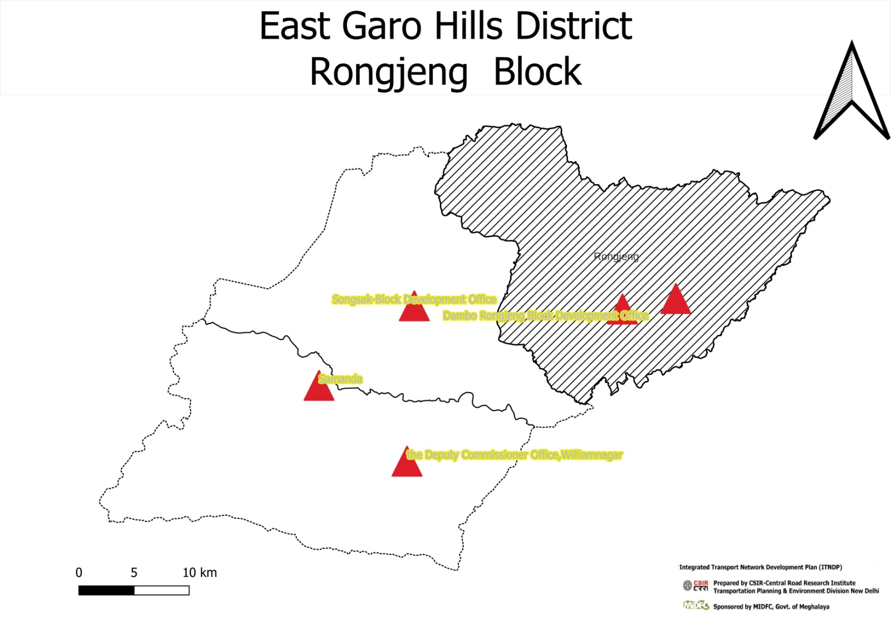

# District: East Garo Hills Block : Dambo Rongjeng C & RD Block

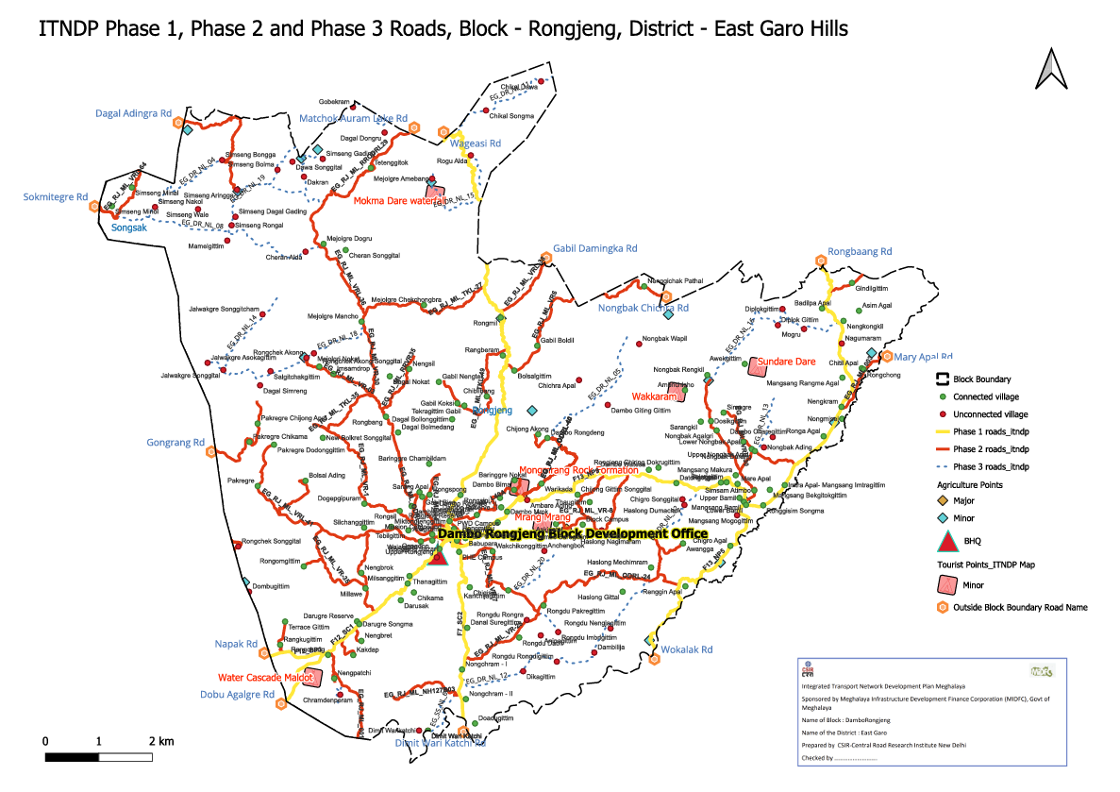

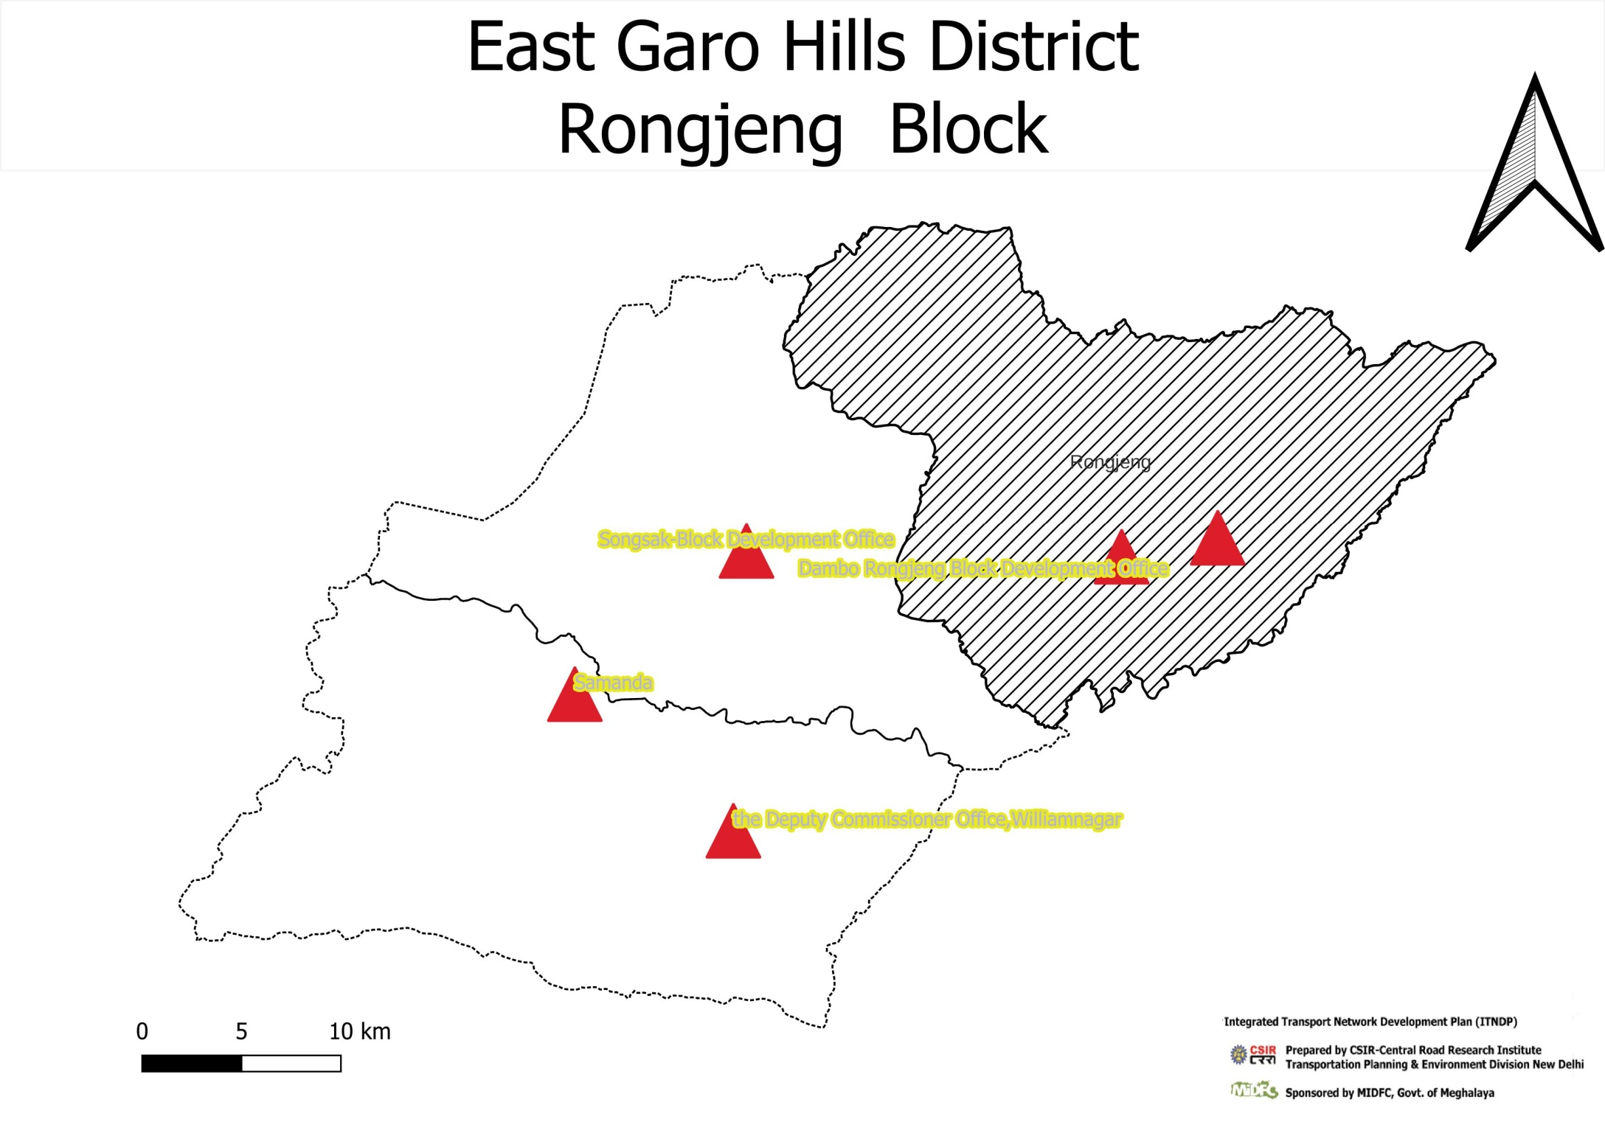

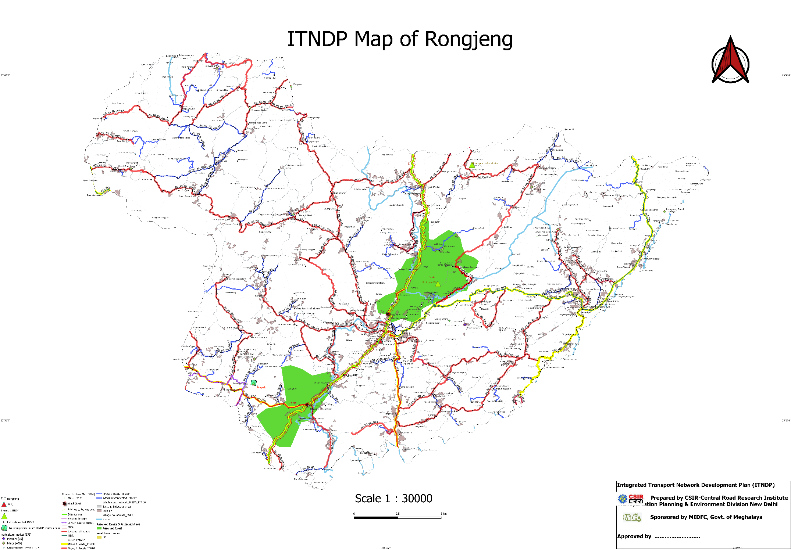

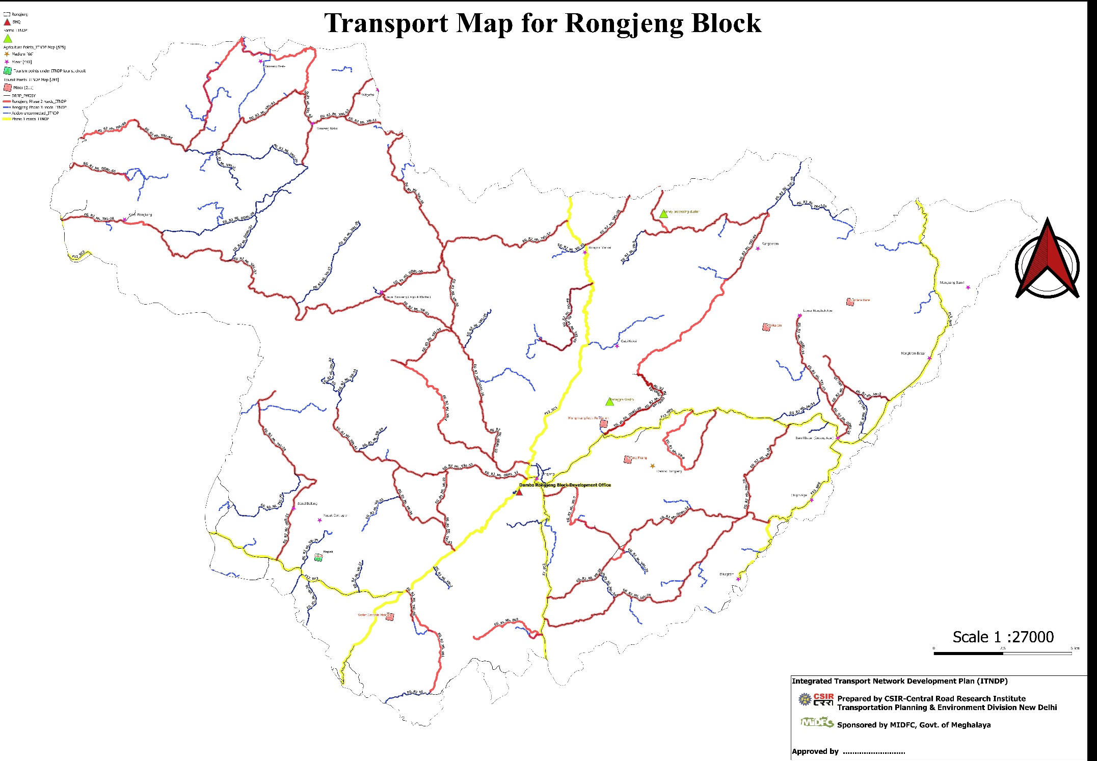

**Summary of allocation of Phase -3 roads and Bridge of ITNDP, Block- Dambo Rongjeng**

|  |  |  |  |  |  |  |  |  |  |  |  |  |  |  |  |  |  |  |  |  |  |
| --- | --- | --- | --- | --- | --- | --- | --- | --- | --- | --- | --- | --- | --- | --- | --- | --- | --- | --- | --- | --- | --- |
| fid | Un ID | Block: | Name of road Proposed from ï¿½............ to ï¿½.................. | Road code | Length | Habbitation: | Population serve by New Alignment . | Total Cost in Lakhs | Ranking | **Absolute Ranking** | Whether Road is Sanctioned under any scheme ( Yes/No) eg. MNREGA, PMGSY, PWD, C&RD, BADO, etc. (?) | Whether road alignment considered in CRRI ITNDP Phase-3 Roads (Yes/No) | Existing Surface Type E/G/WBM. (?) Proposed E/G/WBM/BT(Provide KML) | Road Agency (PWD/C&RD/Industry/Mining/Agriculture/Tourist/Water/BADA/any other). | Length (KM) of New Roads Construction Proposed. | Diffrence | Total Cost based on cost per km average rate 2024(in Lakhs) Length* Rate. @ ` 1,25,000.00/km | Length portion (KM). | Width of road length(metre) proposed. | Length of New construction of Bridge/CD/Culvert (Meter). | Cost for Bridge/CD/Culvert/etc. |
| 3 | 1933 | Dambb-Rongjong | Nagimaram To RMA(Datong) | EG_DR_NL_02 | 2.98 | Hoslong Dilmachok, Nagimaram | 593 | 350 | 0.59 | 3 | FALSE |  | E | PWD | 2.9 | -0.08 | 280 | 2.9 | 6/ 3.00 | 18 | 70 |
| 7 | 1554 | Dambb-Rongjong | NH-1278 To Dombugittim | EG_DR_NL_03 | 2.14 | Domdugittim | 264 | 242 | 0.92 | 7 | FALSE | FALSE | E | PWD | 2 | -0.14 | 200 | 2 | 6/3.75 | 12 | 42 |
| 10 | 5788 | Dambb-Rongjong | Simseng bongga TO simseng sakol | EG_DR_NL_04 | 4.61 | Simseng Nakol, Simseng Aringgre | 438 | 540 | 1.23 | 10 | FALSE |  | E | PWD | 4.5 | -0.11 | 450 | 4.5 | 6/3.00 | 40 | 90 |
| 9 | 1143 | Dambb-Rongjong | Dambo Rongdeng TO Dambo gittongittui | EG_DR_NL_05 | 3.11 | Mansang Mogogittim, Dambo gittongittui | 501 | 517.5 | 1.03 | 9 | FALSE |  | E | PWD | 3 | -0.11 | 450 | 3 | 6/3.00 | 30 | 67.5 |
| 13 | 1288 | Dambb-Rongjong | Dawa Songgital TO Dakram | EG_DR_NL_06 | 1.66 | Dawa Songgital , Dakram | 155 | 231.5 | 1.49 | 13 | FALSE |  | E | PWD | 1.6 | -0.06 | 200 | 1.6 | 6/3.75 | 14 | 31.5 |
| 8 | 1285 | Dambb-Rongjong | Rondu Rongra TO Imbelgittim | EG_DR_NL_07 | 1.40 | Rondu Rongra, Imbelgittim | 243 | 240 | 0.99 | 8 | FALSE |  | E | PWD | 1.5 | 0.10 | 200 | 1.5 | 6/3.75 | 10 | 40 |
| 19 | 5787 | Dambb-Rongjong | Chenau flda TO simseng Minol | EG_DR_NL_08 | 9.37 | Sinseng Bongga, simseng menol | 208 | 1653 | 7.94 | 19 | FALSE | FALSE | E/BT | PWD | 9 | -0.37 | 1300 | 9 | 6/3.75 | 100 | 352.5 |
| 15 | 1831 | Dambb-Rongjong | Chikal Songma To Gobekram | EG_DR_NL_09 | 5.20 | Chikal Songma, Gobekram | 409 | 685 | 1.67 | 15 | FALSE |  | E | PWD | 4.9 | -0.30 | 490 | 4.9 | 6/3.75 | 45 | 195 |
| 4 | 4107 | Dambb-Rongjong | Chikal Songma TO Nenggitehak patal | EG_DR_NL_10 | 1.49 | Chikal Songma, Nenggitehak patal | 310 | 195 | 0.63 | 4 | FALSE |  | E | PWD | 1.5 | 0.01 | 150 | 1.5 | 6/3.75 | 17.5 | 45 |
| 17 | 892 | Dambb-Rongjong | Chikal songma TO Chikal Dawa | EG_DR_NL_11 | 4.69 | Chikal Dawa | 127 | 712.5 | 5.61 | 17 | FALSE |  | E | PWD | 5 | 0.31 | 600 | 5 | 6/3.75 | 37.5 | 112.5 |
| 18 | 5290 | Dambb-Rongjong | NH-1278 VIA Rongtitgittim to Haslong | EG_DR_NL_12 | 10.70 | Rongdu Rongdigittim | 174 | 1325 | 7.61 | 18 | FALSE |  | E | PWD | 10.7 | 0.00 | 1070 | 10.7 | 6/3.75 | 47 | 255 |
| 11 | 1142 | Dambb-Rongjong | L21(RMA) TO Rongitgottim | EG_DR_NL_13 | 2.76 | Dambo Chanegittim, Noughah Ading | 352 | 485 | 1.38 | 11 | FALSE |  | E | PWD | 2.8 | 0.04 | 420 | 2.8 | 6/3.00 | 26 | 65 |
| 6 | 2060 | Dambb-Rongjong | Jalwagre Songgital VIA Jalwagre songiticham TO Dagal Dogre | EG_DR_NL_14 | 4.47 | Jalwagre Songgital, Jalwagre songiticham , Dagal Dogre | 647 | 580 | 0.90 | 6 | FALSE | TRUE | E | PWD | 4.5 | 0.03 | 450 | 4.5 | 6/3.75 | 30 | 130 |
| 12 | 3777 | Dambb-Rongjong | NH-62 TO MejolgreAmebang | EG_DR_NL_15 | 3.53 | Mejalgre Amebang | 276 | 400 | 1.45 | 12 | FALSE |  | E | PWD | 3.5 | -0.03 | 350 | 3.5 | 6/3.75 | 27.5 | 50 |
| 20 | 1455 | Dambb-Rongjong | Mittegittim Chibra Jambal Road TO Diplokgittin | EG_DR_NL_16 | 9.03 | Diplakgittim | 112 | 1418 | 12.66 | 20 | FALSE |  | E | PWD | 9 | -0.03 | 1080 | 9 | 6/3.75 | 150 | 337.5 |
| 5 | 1092 | Dambb-Rongjong | Dawa Songgital Dalnan | EG_DR_NL_17 | 1.65 | Rogu Alda | 290 | 231.5 | 0.80 | 5 | FALSE |  | E | PWD | 1.6 | -0.05 | 200 | 1.6 | 6/3.75 | 14 | 31.5 |
| 14 | 2119 | Dambb-Rongjong | Jalwagre Songgital TO Cheran Songgital | EG_DR_NL_18 | 8.29 | Jalwagre Asokagiltim , Jalwagre Songital | 610 | 932 | 1.53 | 14 | FALSE |  | E | PWD | 8.2 | -0.09 | 800 | 8.2 | 6/3.75 | 48 | 132 |
| 16 | 5780 | Dambb-Rongjong | Godalgittim to Simseng Rongal | EG_DR_NL_19 | 11.68 | Simseng Aringga | 430 | 1380 | 3.21 | 16 | FALSE | FALSE | E | PWD | 11.7 | 0.02 | 1100 | 11.7 | 6/3.75 | 68 | 280 |
| 2 | 188 | Dambb-Rongjong | 101st km of NH 1278 TO 48th of NH 62 | EG_DR_NL_20 | 2.49 | Anipagittim , Anchengbok | 1436 | 473 | 0.33 | 2 | FALSE |  | E | PWD | 2.5 | 0.01 | 400.95 | 2.5 | 6/3.75 | 24 | 72 |
| 1 | 1004 | Dambb-Rongjong | NH62 TO Chrandenperam | EG_DR_NL_21 | 1.06 | Chrandunpera, Dapugre | 7319 | 172.5 | 0.02 | 1 | FALSE |  | E | PWD | 1 | -0.06 | 150 | 1 | 6/3.75 | 10 | 22.5 |
|  |  |  |  |  | 92.33 |  | 14894 | 12762 |  |  | 0 | 0 |  |  | 91.4 | -0.93 | 10340.95 | 91.4 |  | 768.5 | 2421.5 |

Financing Plan of Roads of Phase 3-Dambo Rongjeng

|  |  |
| --- | --- |
| Total No of Road | 20 |
| Total Length of New Construction(km) | 92.33298093 |
| Total no of Bridge gretart than 10 m | 2 |
| Total no of Bridge gretart than 10 m-30 m | 18 |
| Total no bridge | 20 |
| Total Cost of Bridge and Culvert | 2421.5 |
| Total Cost of Road | 10340.95 |
| Total Cost for Dambb-Rongjong (lakh) | 12762.45 |
| Yearly budget (20 years) | 638.1225 |

|  |  |  |  |  |  |  |
| --- | --- | --- | --- | --- | --- | --- |
| Year | Road Name | Road Code | Amount Spend per Year/Road(lakh) | Per Year Spend(lakhs) | Ranking | Total coat per Road |
| 2024 | NH62 TO Chrandenperam | EG_DR_NL_21 | 350 | 592 | 1 | 350 |
| 101st km of NH 1278 TO 48th of NH 62 | EG_DR_NL_20 | 242 |  | 2 | 242 |
| 2025 | Nagimaram To RMA(Datong) | EG_DR_NL_02 | 540 | 1173.25 | 3 | 540 |
| Chikal Songma TO Nenggitehak patal | EG_DR_NL_10 | 517.5 | 4 | 517.5 |
| Dawa Songgital Dalnan(0-0.82km) | EG_DR_NL_17 | 115.75 | 5 | 231.5 |
| 2026 | Dawa Songgital Dalnan(0.82-1.64km) | EG_DR_NL_17 | 115.75 | 355.75 | 5 |
| Jalwagre Songgital VIA Jalwagre songiticham TO Dagal Dogre | EG_DR_NL_14 | 240 | 6 | 240 |
| 2027 | NH-1278 To Dombugittim | EG_DR_NL_03 | 1652.5 | 2337.5 | 7 | 1652.5 |
| Rondu Rongra TO Imbelgittim | EG_DR_NL_07 | 685 |  | 8 | 685 |
| 2028 | Dambo Rongdeng TO Dambo gittongittui | EG_DR_NL_05 | 195 | 517.5 | 9 | 195 |
| 2029 | Simseng bongga TO simseng sakol | EG_DR_NL_04 | 712.5 | 540 | 10 | 712.5 |
| 2030 | L21(RMA) TO Rongitgottim | EG_DR_NL_13 | 1325 | 485 | 11 | 1325 |
| 2031 | NH-62 TO MejolgreAmebang | EG_DR_NL_15 | 485 | 1065 | 12 | 485 |
| Dawa Songgital TO Dakram | EG_DR_NL_06 | 580 | 13 | 580 |
| 2032 | Jalwagre Songgital TO Cheran Songgital(0-4.1km) | EG_DR_NL_18 | 466 | 466 | 14 | 932 |
| 2033 | Jalwagre Songgital TO Cheran Songgital(4.1-8.2km) | EG_DR_NL_18 | 466 | 466 | 14 |
| 2034 | Chikal Songma To Gobekram | EG_DR_NL_09 | 1417.5 | 685 | 15 | 1417.5 |
| 2035 | Godalgittim to Simseng Rongal(0-5.83km) | EG_DR_NL_19 | 690 | 690 | 16 | 1380 |
| 2036 | Godalgittim to Simseng Rongal(5.83-11.67km) | EG_DR_NL_19 | 690 | 690 | 16 |
| 2037 | Chikal songma TO Chikal Dawa | EG_DR_NL_11 | 932 | 712.5 | 17 | 932 |
| 2038 | NH-1278 VIA Rongtitgittim to Haslong(0-5.34km) | EG_DR_NL_12 | 662.5 | 662.5 | 18 | 1325 |
| 2039 | NH-1278 VIA Rongtitgittim to Haslong(5.34-10.69km) | EG_DR_NL_12 | 662.5 | 662.5 | 18 |
| 2040 | Chenau flda TO simseng Minol(0-3.12km) | EG_DR_NL_08 | 551 | 551 | 19 | 1652.5 |
| 2041 | Chenau flda TO simseng Minol(3.12-6.24km) | EG_DR_NL_08 | 551 | 551 | 19 |
| 2042 | Chenau flda TO simseng Minol(6.24-9.36km) | EG_DR_NL_08 | 550 | 550 | 19 |
| 2043 | Mittegittim Chibra Jambal Road TO Diplokgittin(0-4.5km) | EG_DR_NL_16 | 708.5 | 708.5 | 20 | 1417.5 |
| 2044 | Mittegittim Chibra Jambal Road TO Diplokgittin(4.5-9.03km) | EG_DR_NL_16 | 708.5 | 708.5 | 20 |
| Total |  |  |  | 15169.5 |  | 16812.5 |
|  |  |  | 16811.5 | 15169.5 |  | 16812.5 |

List Unconnected Habitation of Block – Dambo Rongjeng

|  |  |  |  |  |  |
| --- | --- | --- | --- | --- | --- |
| fid | Block | Habitation | Population | Y | X |
| 1 | Dambo Rongjeng | Rongit | 264 | 25.65585 | 90.8580333 |
| 2 | Dambo Rongjeng | Simseng Aringga | 162 | 25.7827316 | 90.7221147 |
| 3 | Dambo Rongjeng | Simseng Bongga | 256 | 25.7937861 | 90.7165806 |
| 6 | Dambo Rongjeng | Simseng Rongal | 268 | 25.7695 | 90.7201166 |
| 7 | Dambo Rongjeng | Simseng Gading | 101 | 25.79422272 | 90.75407584 |
| 8 | Dambo Rongjeng | Rongdu Rongdigittim | 174 | 25.6069778 | 90.8413112 |
| 9 | Dambo Rongjeng | Rongdu Nengjagittim | 545 | 25.6193555 | 90.8613389 |
| 10 | Dambo Rongjeng | Dikagittim | 72 | 25.6033888 | 90.8287683 |
| 11 | Dambo Rongjeng | Dambilija | 76 | 25.6103278 | 90.8552889 |
| 12 | Dambo Rongjeng | Rongdu Imbrlgittim | 107 | 25.6179861 | 90.8418167 |
| 13 | Dambo Rongjeng | Haslong Dumachok | 162 | 25.6653334 | 90.8888666 |
| 14 | Dambo Rongjeng | Nagumaram | 593 | 25.72547616 | 90.94749551 |
| 15 | Dambo Rongjeng | Chikal Songma | 310 | 25.81228819 | 90.81492046 |
| 16 | Dambo Rongjeng | Gobekram | 99 | 25.8135195 | 90.7653389 |
| 17 | Dambo Rongjeng | Dombugittim | 264 | 25.63299019 | 90.7266234 |
| 18 | Dambo Rongjeng | Ambare Ading | 260 | 25.66718315 | 90.83027265 |
| 19 | Dambo Rongjeng | Anchengbok | 282 | 25.64822016 | 90.83665951 |
| 20 | Dambo Rongjeng | Jalwakgre Asokagittim | 101 | 25.7182667 | 90.71115 |
| 23 | Dambo Rongjeng | Chramdenperam | 195 | 25.59465607 | 90.76059024 |
| 24 | Dambo Rongjeng | Simseng Nakol | 438 | 25.7762944 | 90.6915639 |
| 25 | Dambo Rongjeng | Rogu Alda | 290 | 25.79555 | 90.8092666 |
| 26 | Dambo Rongjeng | Chikal Dawa | 127 | 25.82310456 | 90.83543379 |
| 28 | Dambo Rongjeng | Dambo Charegittim | 0 | 25.69062609 | 90.92176958 |
| 29 | Dambo Rongjeng | Nongbak Ading | 109 | 25.6867868 | 90.9184978 |
| 30 | Dambo Rongjeng | Mangsang Mogogittim | 228 | 25.6615 | 90.9084833 |
| 31 | Dambo Rongjeng | Dambo Giting Gittim | 273 | 25.7026 | 90.8602833 |
| 32 | Dambo Rongjeng | Jalwakgre Songgital | 356 | 25.7156167 | 90.7170167 |
| 33 | Dambo Rongjeng | Jalwakgre Songgitcham | 150 | 25.7363283 | 90.73164 |
| 34 | Dambo Rongjeng | Mejolgre Amebang | 276 | 25.7868667 | 90.79485 |
| 35 | Dambo Rongjeng | Dawa Songgital | 110 | 25.7931834 | 90.7427833 |
| 36 | Dambo Rongjeng | Dakran | 45 | 25.7875889 | 90.7470667 |
| 37 | Dambo Rongjeng | Rongdu Rongra | 243 | 25.6224781 | 90.8301172 |
| 38 | Dambo Rongjeng | Simseng Balsrigittim-Wage Apal | 372 | 25.8001667 | 90.7441 |
| 39 | Dambo Rongjeng | Anipagittim | 1436 | 25.61675018 | 90.83531367 |
| 40 | Dambo Rongjeng | Simseng Wale | 90 | 25.7755002 | 90.7075995 |
| 41 | Dambo Rongjeng | Simseng Bolma | 142 | 25.7901861 | 90.7372278 |
| 42 | Dambo Rongjeng | Diplok Gittim | 112 | 25.7322833 | 90.9236833 |
| 43 | Dambo Rongjeng | Upper Rongjeng | 1015 | 25.6458167 | 90.7965667 |
| 45 | Dambo Rongjeng | Dagal Simreng | 283 | 25.70988552 | 90.73071732 |
| 47 | Dambo Rongjeng | Dagal Dongru | 141 | 25.80403277 | 90.77712216 |
| 50 | Dambo Rongjeng | Dimit Wari Katchi | 123 | 25.58125934 | 90.79329933 |
| 51 | Dambo Rongjeng | Cheran Alda | 234 | 25.75965243 | 90.74765693 |
| 52 | Dambo Rongjeng | Mamelgittim | 117 | 25.76380752 | 90.71849335 |
| 53 | Dambo Rongjeng | Salgitchakgittim | 146 | 25.71515 | 90.7346 |
| 54 | Dambo Rongjeng | Mejolgri Nokat | 166 | 25.7218167 | 90.7507833 |
| 55 | Dambo Rongjeng | Rongchek Akong | 197 | 25.7201333 | 90.748 |
| 56 | Dambo Rongjeng | Diplokgittim | 0 | 25.73831997 | 90.92540405 |
| 57 | Dambo Rongjeng | Mogru | 105 | 25.7308834 | 90.93345 |
| 59 | Dambo Rongjeng | Chichra Apal | 179 | 25.71183147 | 90.84958545 |
| 60 | Dambo Rongjeng | Simseng Dagal Gading | 101 | 25.7726627 | 90.721546 |
| 61 | Dambo Rongjeng | Chigro Songgital | 72 | 25.66743369 | 90.88812352 |

List Connected Habitation of Block -Dambo Rongjeng

|  |  |  |  |  |  |
| --- | --- | --- | --- | --- | --- |
| fid | Block | Habitation | Population | Y | X |
| 51 | Dambo Rongjeng | Ambrichicho | 305 | 25.70808305 | 90.8890767 |
| 54 | Dambo Rongjeng | Warikada | 209 | 25.6732812 | 90.8355825 |
| 55 | Dambo Rongjeng | Asim Agal | 301 | 25.73765339 | 90.95391174 |
| 56 | Dambo Rongjeng | Askipatal | 506 | 25.65825239 | 90.84100533 |
| 57 | Dambo Rongjeng | Awangga | 353 | 25.65101029 | 90.88834308 |
| 58 | Dambo Rongjeng | Awekgittim | 0 | 25.71786865 | 90.91134889 |
| 59 | Dambo Rongjeng | Nengkram | 526 | 25.7019 | 90.9473833 |
| 60 | Dambo Rongjeng | Nongmisei | 286 | 25.69741686 | 90.94757415 |
| 61 | Dambo Rongjeng | Badilpa Apal | 162 | 25.73854237 | 90.94013252 |
| 63 | Dambo Rongjeng | Lower Nongbak Apal | 455 | 25.688866 | 90.9108827 |
| 64 | Dambo Rongjeng | Nongbak Agalgri | 169 | 25.6931 | 90.9008667 |
| 65 | Dambo Rongjeng | Baringgre Chambildam | 315 | 25.68065268 | 90.79372828 |
| 66 | Dambo Rongjeng | Baringgre Nokat | 137 | 25.6745379 | 90.82557053 |
| 67 | Dambo Rongjeng | Dambo Bima | 286 | 25.67095 | 90.8253667 |
| 68 | Dambo Rongjeng | Block Campus | 14 | 25.65799974 | 90.85095499 |
| 69 | Dambo Rongjeng | Dambo Saregittim | 243 | 25.6554667 | 90.8542163 |
| 70 | Dambo Rongjeng | Babupara | 267 | 25.653 | 90.8072666 |
| 71 | Dambo Rongjeng | Rongmithu | 510 | 25.6588 | 90.8193 |
| 72 | Dambo Rongjeng | Wakchikonggittim | 427 | 25.64805 | 90.8173833 |
| 73 | Dambo Rongjeng | Bolsalgittim | 236 | 25.71539149 | 90.82546983 |
| 74 | Dambo Rongjeng | Rangberam | 472 | 25.7210167 | 90.8211834 |
| 79 | Dambo Rongjeng | Mejolgre Dogru | 163 | 25.7625805 | 90.7543972 |
| 80 | Dambo Rongjeng | Chibilbang | 173 | 25.70579954 | 90.81521736 |
| 84 | Dambo Rongjeng | Chigro Agal | 254 | 25.65008502 | 90.90598176 |
| 87 | Dambo Rongjeng | Chijong Akong | 111 | 25.6916644 | 90.8343713 |
| 88 | Dambo Rongjeng | Dambo Rongdeng | 411 | 25.6902755 | 90.8377804 |
| 89 | Dambo Rongjeng | Chijong Gittim Songgital | 93 | 25.66916172 | 90.84904455 |
| 92 | Dambo Rongjeng | Chikama | 255 | 25.63274501 | 90.78804584 |
| 93 | Dambo Rongjeng | Darusak | 226 | 25.62983973 | 90.78317063 |
| 94 | Dambo Rongjeng | Milsanggitim | 421 | 25.6360667 | 90.7857333 |
| 95 | Dambo Rongjeng | Thanagittim | 200 | 25.63885 | 90.7864 |
| 96 | Dambo Rongjeng | Chitil Apal | 384 | 25.71623227 | 90.95493776 |
| 99 | Dambo Rongjeng | Darugre Reserve | 127 | 25.6219833 | 90.7668333 |
| 100 | Dambo Rongjeng | Darugre Songma | 616 | 25.62095 | 90.7677167 |
| 101 | Dambo Rongjeng | Kakdap | 114 | 25.6094167 | 90.7654333 |
| 102 | Dambo Rongjeng | Nengbret | 140 | 25.6146993 | 90.7684872 |
| 103 | Dambo Rongjeng | Nengpatchi | 127 | 25.60073375 | 90.75836073 |
| 104 | Dambo Rongjeng | Rangcheng | 271 | 25.6094833 | 90.7560667 |
| 110 | Dambo Rongjeng | Dagal Nokat | 237 | 25.71325772 | 90.77906742 |
| 114 | Dambo Rongjeng | Pakregre Chijong Apal | 334 | 25.69565 | 90.7298 |
| 115 | Dambo Rongjeng | Pakregre Chikama | 174 | 25.6888128 | 90.7267576 |
| 116 | Dambo Rongjeng | Pakregre Dodonggittim | 87 | 25.6877917 | 90.7359055 |
| 118 | Dambo Rongjeng | Rongchek Akong Songgital | 105 | 25.7168699 | 90.7527952 |
| 126 | Dambo Rongjeng | Rangme | 137 | 25.6736833 | 90.9024667 |
| 127 | Dambo Rongjeng | Mangsang Makura | 382 | 25.6764167 | 90.9079833 |
| 128 | Dambo Rongjeng | Nongbak Darang | 291 | 25.6854167 | 90.9151167 |
| 129 | Dambo Rongjeng | Upper Nongbak Apal | 547 | 25.6861653 | 90.9139602 |
| 130 | Dambo Rongjeng | Datong Agal | 148 | 25.6734667 | 90.88585 |
| 131 | Dambo Rongjeng | Ronga Agal | 647 | 25.6909167 | 90.9407333 |
| 132 | Dambo Rongjeng | Dosikgittim | 499 | 25.6965549 | 90.898763 |
| 133 | Dambo Rongjeng | Simagre | 142 | 25.6997167 | 90.9034667 |
| 134 | Dambo Rongjeng | Danal Suregittim | 268 | 25.6195667 | 90.8079166 |
| 135 | Dambo Rongjeng | Aragittim | 596 | 25.65435 | 90.7948834 |
| 136 | Dambo Rongjeng | Gauram | 128 | 25.6538667 | 90.8048666 |
| 137 | Dambo Rongjeng | Mission Compound | 28 | 25.65515 | 90.7995166 |
| 138 | Dambo Rongjeng | PWD Campus | 25 | 25.6564167 | 90.8029833 |
| 139 | Dambo Rongjeng | Rongjeng Songma | 680 | 25.6520833 | 90.8040833 |
| 140 | Dambo Rongjeng | PHE Campus | 11 | 25.6478667 | 90.8049 |
| 141 | Dambo Rongjeng | Nengbrok | 456 | 25.6400167 | 90.76845 |
| 142 | Dambo Rongjeng | Lower Bamil | 471 | 25.6653472 | 90.9118377 |
| 143 | Dambo Rongjeng | Mangsang Bamil | 444 | 25.6664667 | 90.9110667 |
| 144 | Dambo Rongjeng | Ronggisim Songma | 315 | 25.6651965 | 90.918232 |
| 147 | Dambo Rongjeng | Kanchijagittim | 159 | 25.6335333 | 90.8232166 |
| 148 | Dambo Rongjeng | Jambal Songma | 405 | 25.6649167 | 90.7872 |
| 149 | Dambo Rongjeng | Mongshram Rongbeng | 675 | 25.58448078 | 90.80461936 |
| 153 | Dambo Rongjeng | Thaugittim | 273 | 25.6663834 | 90.85355 |
| 154 | Dambo Rongjeng | Mangsang Bekgitokgittim | 215 | 25.6709834 | 90.9206833 |
| 155 | Dambo Rongjeng | Balsrigittim | 279 | 25.6738065 | 90.9045675 |
| 156 | Dambo Rongjeng | Mare Apal | 328 | 25.6731667 | 90.9086667 |
| 157 | Dambo Rongjeng | Simsam Atimbo | 350 | 25.6707667 | 90.9148833 |
| 158 | Dambo Rongjeng | Upper Bamil | 250 | 25.6679613 | 90.909356 |
| 159 | Dambo Rongjeng | Rongmil | 867 | 25.73515 | 90.8204 |
| 161 | Dambo Rongjeng | Doadugittim | 133 | 25.58395 | 90.8108333 |
| 162 | Dambo Rongjeng | Nongchram - I | 1051 | 25.60405 | 90.806 |
| 163 | Dambo Rongjeng | Haslong Mechimram | 258 | 25.6420167 | 90.8764333 |
| 164 | Dambo Rongjeng | Gabil Boldil | 198 | 25.7246333 | 90.834 |
| 165 | Dambo Rongjeng | Nongbak Rengkil | 341 | 25.7137265 | 90.897387 |
| 166 | Dambo Rongjeng | Sarangkil | 395 | 25.69635577 | 90.8949684 |
| 168 | Dambo Rongjeng | Mangsang Rangme Agal | 0 | 25.71274758 | 90.94772678 |
| 169 | Dambo Rongjeng | Dambo Mrok | 406 | 25.6628167 | 90.8228166 |
| 170 | Dambo Rongjeng | Dambo Reserve - I | 270 | 25.66445 | 90.8205834 |
| 171 | Dambo Rongjeng | Dambo Reserve - II | 157 | 25.6679667 | 90.8201334 |
| 172 | Dambo Rongjeng | Nengringgittim | 377 | 25.6616167 | 90.8115 |
| 173 | Dambo Rongjeng | Nengkongkil | 217 | 25.73389318 | 90.94815982 |
| 176 | Dambo Rongjeng | Gongdop | 363 | 25.6521167 | 90.7949166 |
| 177 | Dambo Rongjeng | Tebilgittim | 30 | 25.6558667 | 90.7859833 |
| 178 | Dambo Rongjeng | Wajagittim | 398 | 25.6517 | 90.79065 |
| 179 | Dambo Rongjeng | Bolsal Ading | 142 | 25.6743417 | 90.7476458 |
| 180 | Dambo Rongjeng | Dogepgipuram | 195 | 25.6658 | 90.7695834 |
| 181 | Dambo Rongjeng | Pakregre | 628 | 25.67239531 | 90.72983045 |
| 183 | Dambo Rongjeng | Nongbak Chichra | 366 | 25.750449 | 90.913566 |
| 184 | Dambo Rongjeng | Rongdu Dabit | 442 | 25.6159334 | 90.8272834 |
| 186 | Dambo Rongjeng | Nongchram - II | 961 | 25.5930333 | 90.8074167 |
| 189 | Dambo Rongjeng | Gabil Nengtek | 44 | 25.711162 | 90.7973448 |
| 190 | Dambo Rongjeng | Gabil Bisa | 541 | 25.6683774 | 90.7911325 |
| 191 | Dambo Rongjeng | Rongspong | 166 | 25.66915 | 90.7939334 |
| 192 | Dambo Rongjeng | Sarang Apal | 161 | 25.6701202 | 90.7901355 |
| 194 | Dambo Rongjeng | Rongjeng Bazar | 681 | 25.6489667 | 90.7975833 |
| 195 | Dambo Rongjeng | Gabil Koksi | 404 | 25.7032 | 90.80425 |
| 196 | Dambo Rongjeng | Tekragittim Gabil | 208 | 25.7023333 | 90.80685 |
| 197 | Dambo Rongjeng | Nengsil | 148 | 25.7159834 | 90.7863333 |
| 198 | Dambo Rongjeng | Imsamdrop | 136 | 25.71417672 | 90.75808545 |
| 199 | Dambo Rongjeng | New Bolkret Songgital | 68 | 25.6903392 | 90.7541219 |
| 201 | Dambo Rongjeng | Haslong Gittal | 71 | 25.6330231 | 90.8658289 |
| 202 | Dambo Rongjeng | Rongjeng Reserve | 956 | 25.6593333 | 90.8013333 |
| 203 | Dambo Rongjeng | Rongdu Pakregittim | 92 | 25.6278679 | 90.8363681 |
| 204 | Dambo Rongjeng | Dambo Watesa | 292 | 25.6784167 | 90.8756167 |
| 205 | Dambo Rongjeng | Rongjeng Chiring Dokrugittim | 274 | 25.67923788 | 90.87920875 |
| 206 | Dambo Rongjeng | Miktongjenggittim | 285 | 25.6571833 | 90.7796167 |
| 207 | Dambo Rongjeng | Rongsil | 219 | 25.6631 | 90.78275 |
| 208 | Dambo Rongjeng | Rongsipi | 0 | 25.66908041 | 90.80543389 |
| 209 | Dambo Rongjeng | Mejolgre Chekchongbra | 406 | 25.7398 | 90.7918 |
| 210 | Dambo Rongjeng | Mejolgre Mancho | 408 | 25.7336167 | 90.76855 |
| 214 | Dambo Rongjeng | Tetenggitok | 88 | 25.790848 | 90.771997 |
| 221 | Dambo Rongjeng | Haslong Nagimaram | 431 | 25.6537333 | 90.8738666 |
| 224 | Dambo Rongjeng | Chigisin | 306 | 25.6346667 | 90.80885 |
| 225 | Dambo Rongjeng | Millawe | 606 | 25.6342667 | 90.7700167 |
| 226 | Dambo Rongjeng | Rangkugittim | 293 | 25.61325 | 90.7382167 |
| 227 | Dambo Rongjeng | Rongomgittim | 309 | 25.6424243 | 90.74700574 |
| 228 | Dambo Rongjeng | Terrace Gittim | 304 | 25.62189197 | 90.74004866 |
| 231 | Dambo Rongjeng | Imtra Apal- Mangsang Imtragittim | 512 | 25.6727234 | 90.926254 |
| 232 | Dambo Rongjeng | Renggin Apal | 57 | 25.6350407 | 90.889214 |
| 233 | Dambo Rongjeng | Simseng Minol | 208 | 25.77664767 | 90.67551477 |
| 234 | Dambo Rongjeng | Simseng Minal | 236 | 25.7836027 | 90.6829439 |
| 235 | Dambo Rongjeng | Gindilgittim | 369 | 25.7480333 | 90.9513 |
| 236 | Dambo Rongjeng | Rongchong | 316 | 25.7158166 | 90.9556167 |
| 237 | Dambo Rongjeng | Dagal Bollonggittim | 75 | 25.69724815 | 90.80229845 |
| 238 | Dambo Rongjeng | Cheran Songgital | 153 | 25.76029892 | 90.76262392 |
| 239 | Dambo Rongjeng | Dagal Bolmedang | 80 | 25.69234086 | 90.78217265 |
| 240 | Dambo Rongjeng | Rongbang | 107 | 25.6982 | 90.77765 |
| 241 | Dambo Rongjeng | Nenggichak Pathal | 0 | 25.74676187 | 90.87387088 |





*Annexure-7-2*

**Preparation of Integrated Transport Network Development Plan (ITNDP)**

**Sponsored by**

**MEGHALAYA INFRASTRUCTURE DEVELOPMENT FINANCE CORPORATION LTD**

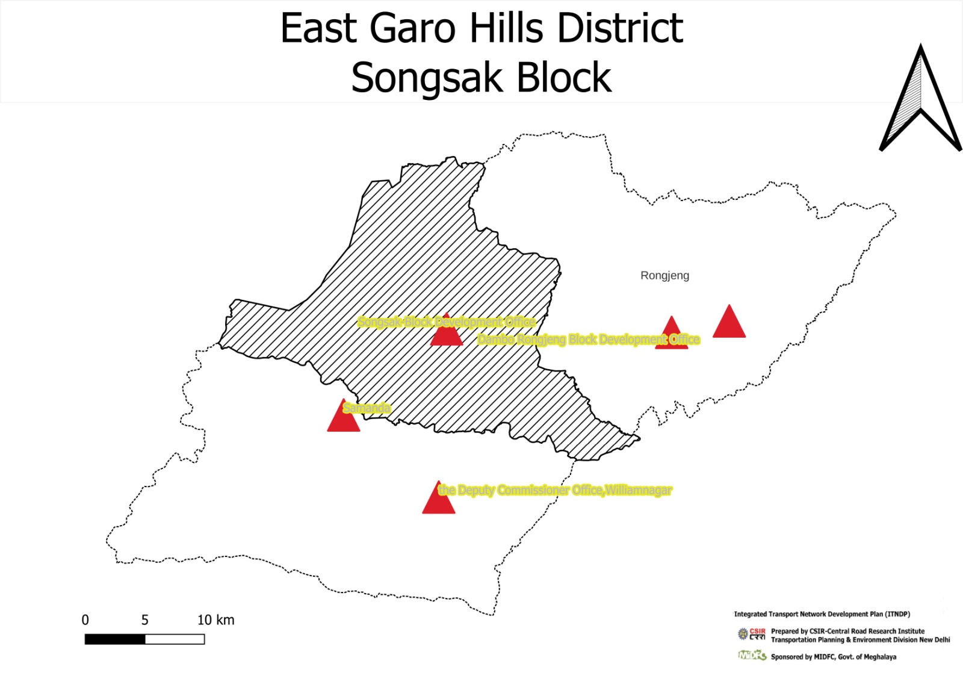

# District: East Garo Hills Block: Songsak C & RD Block

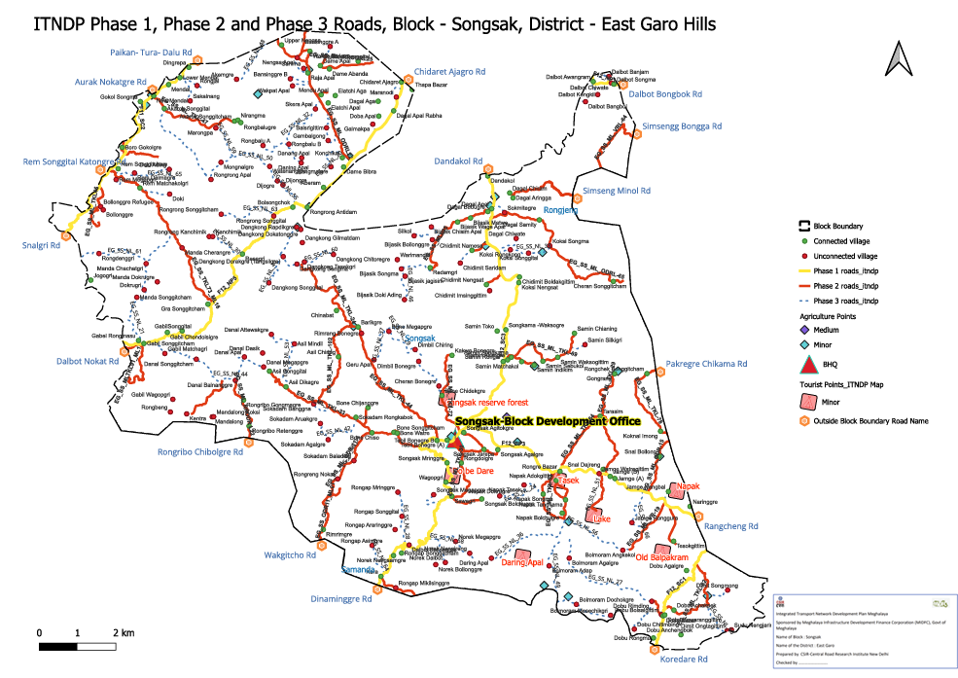

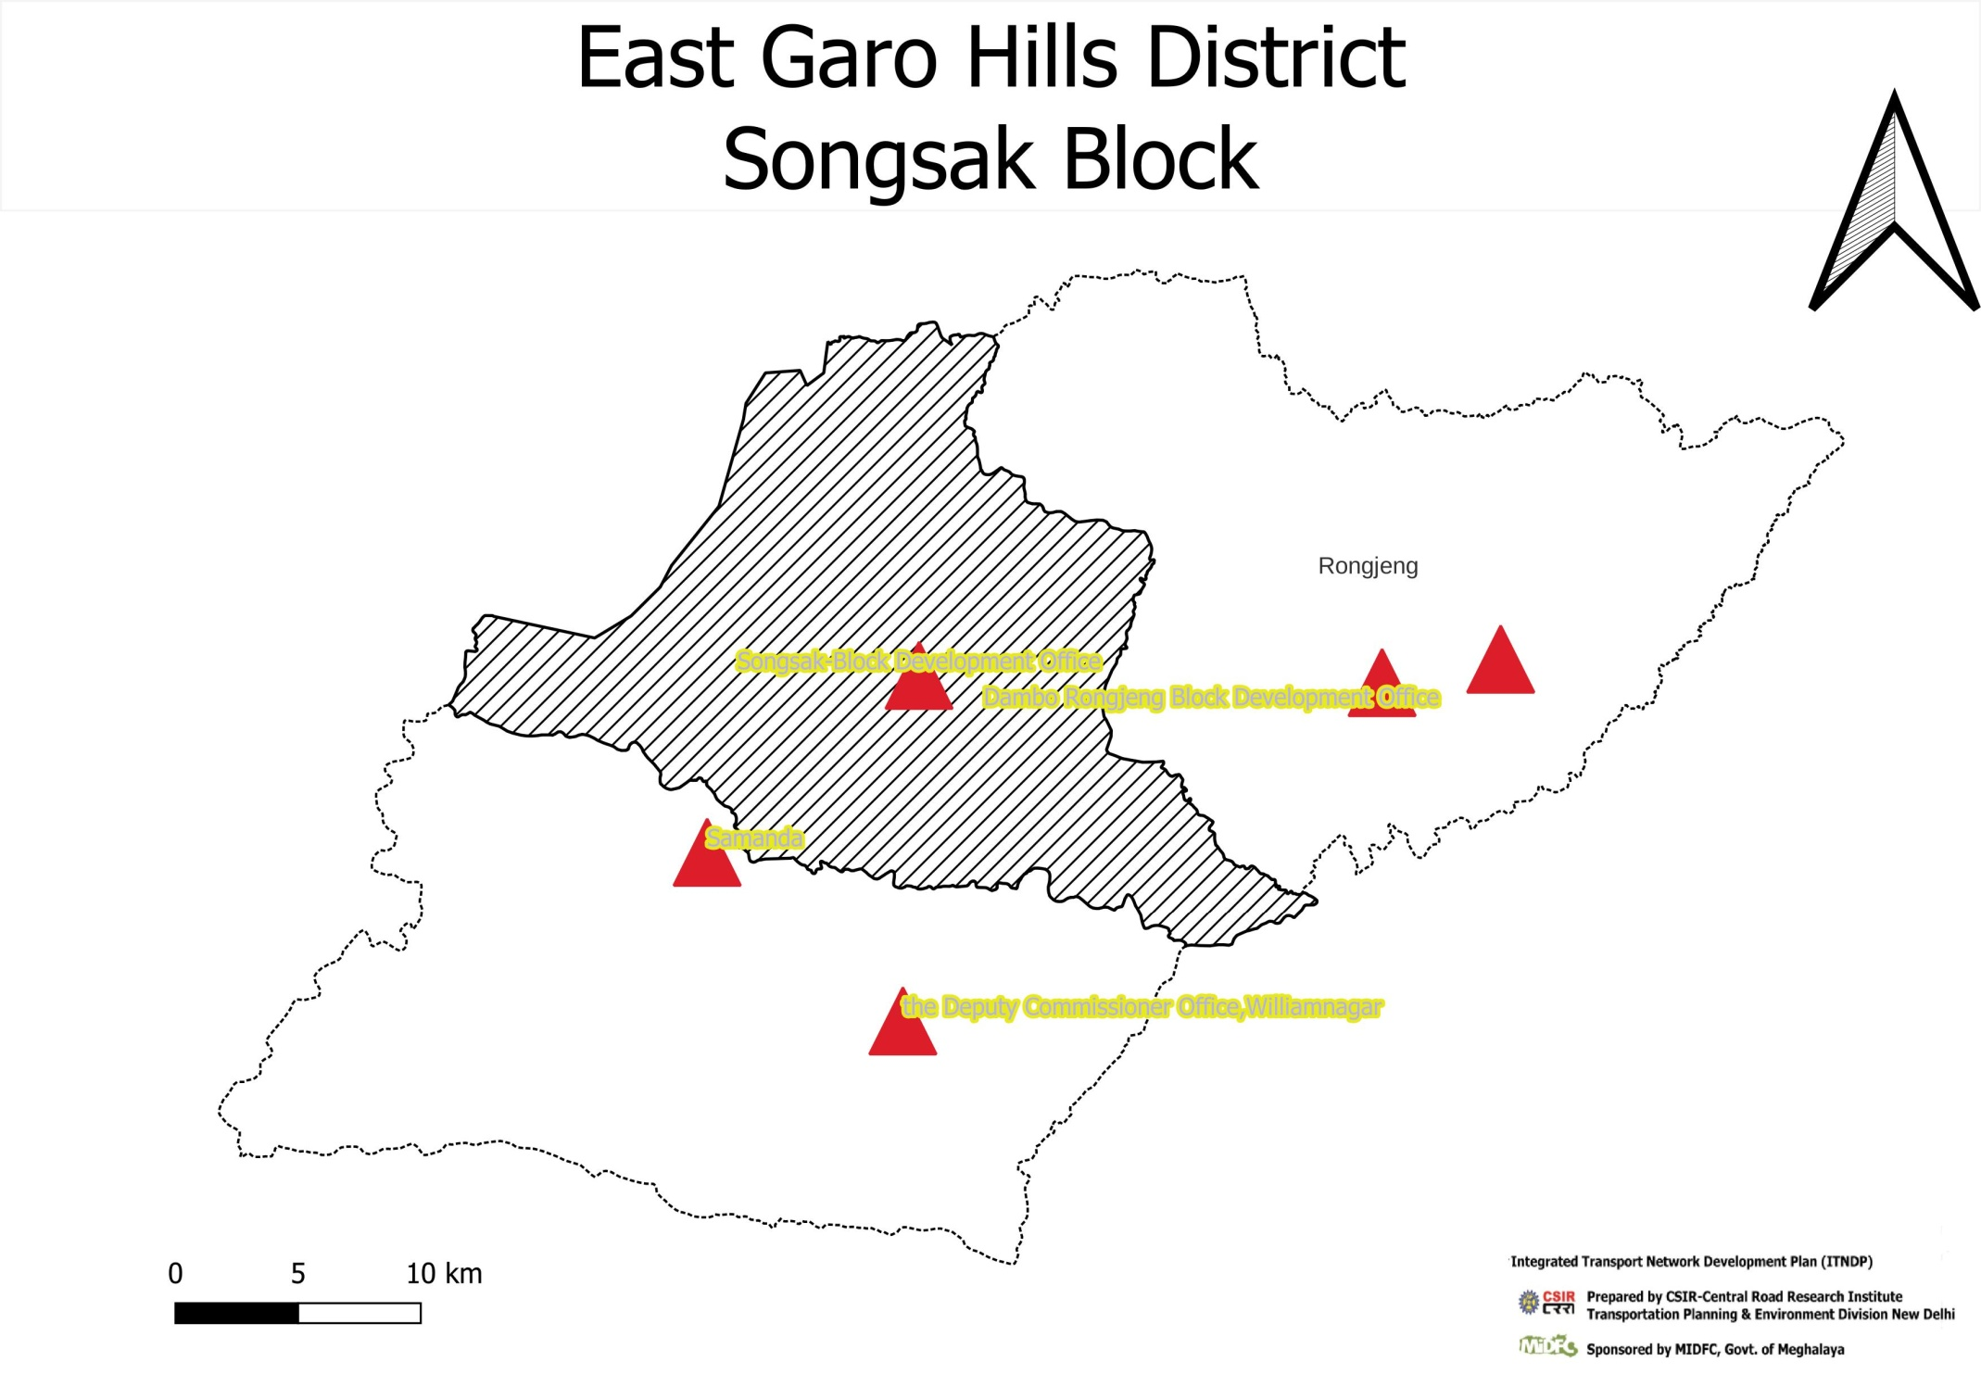

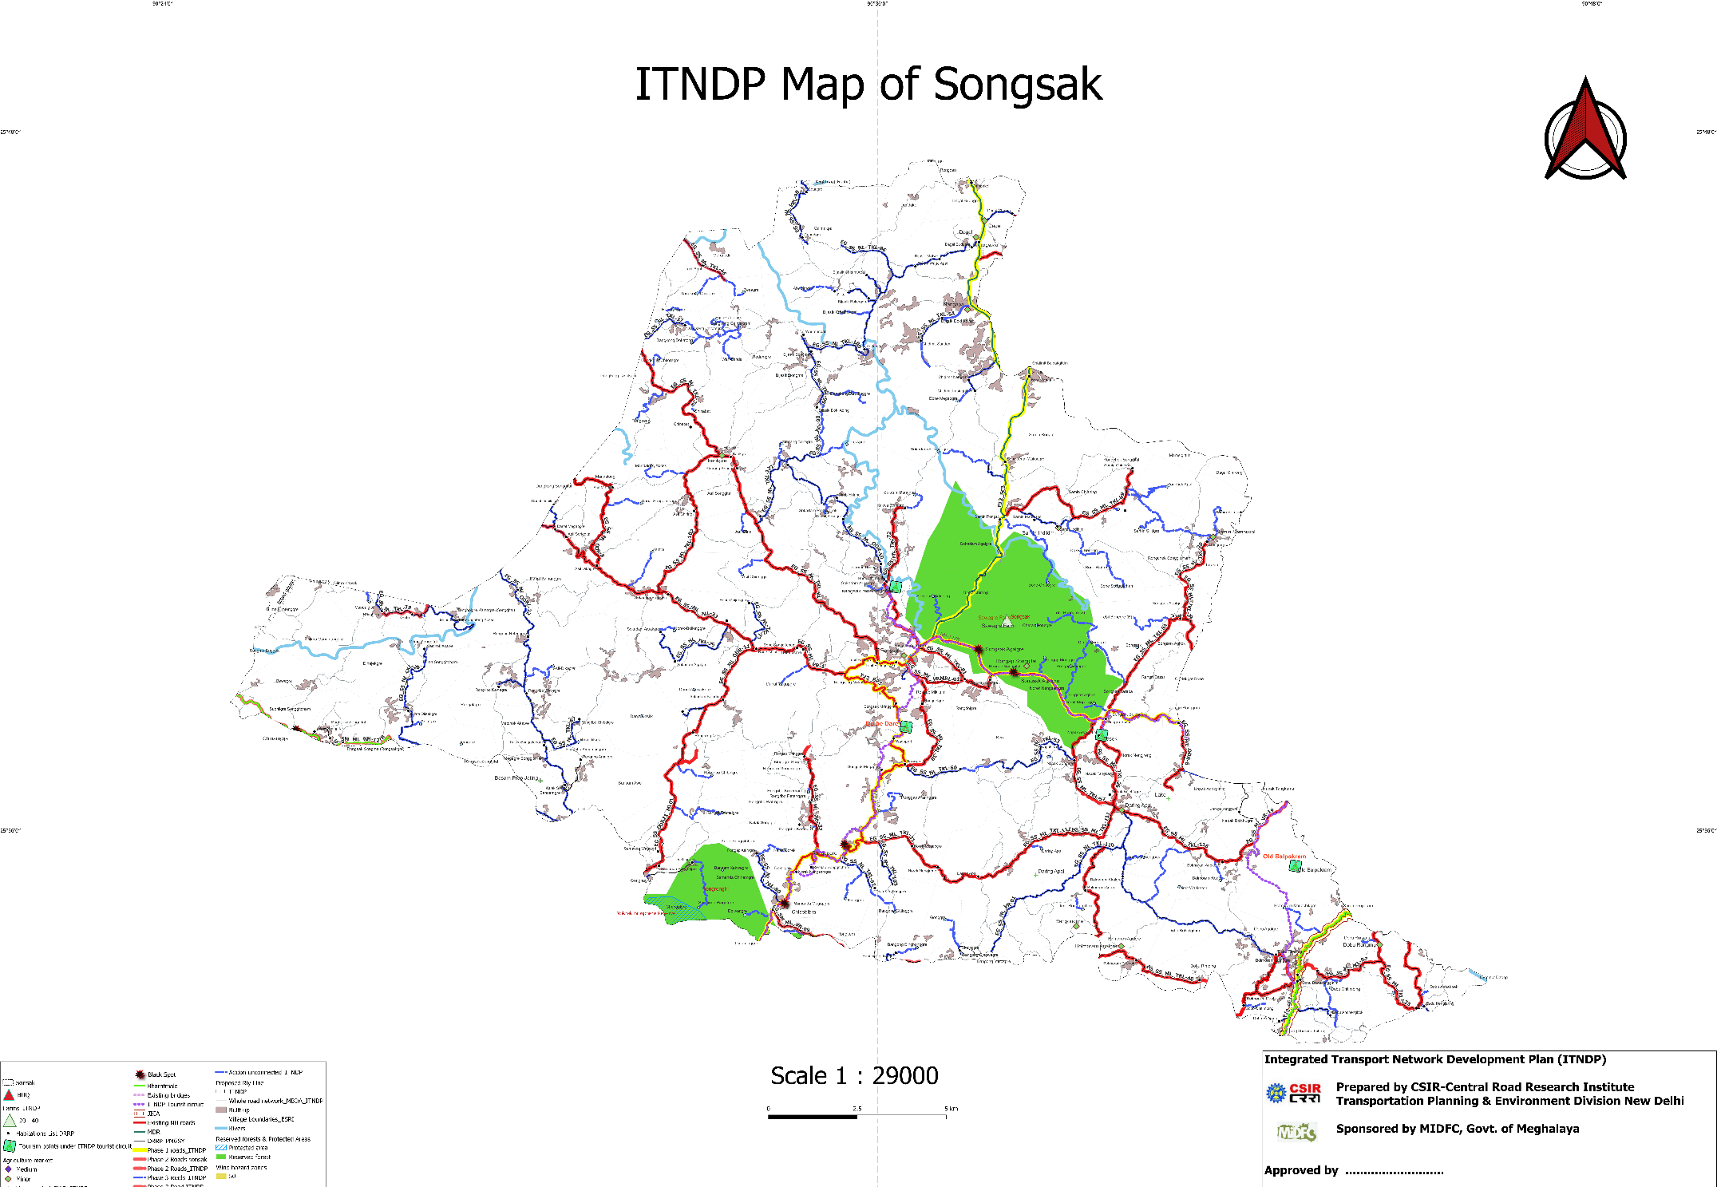

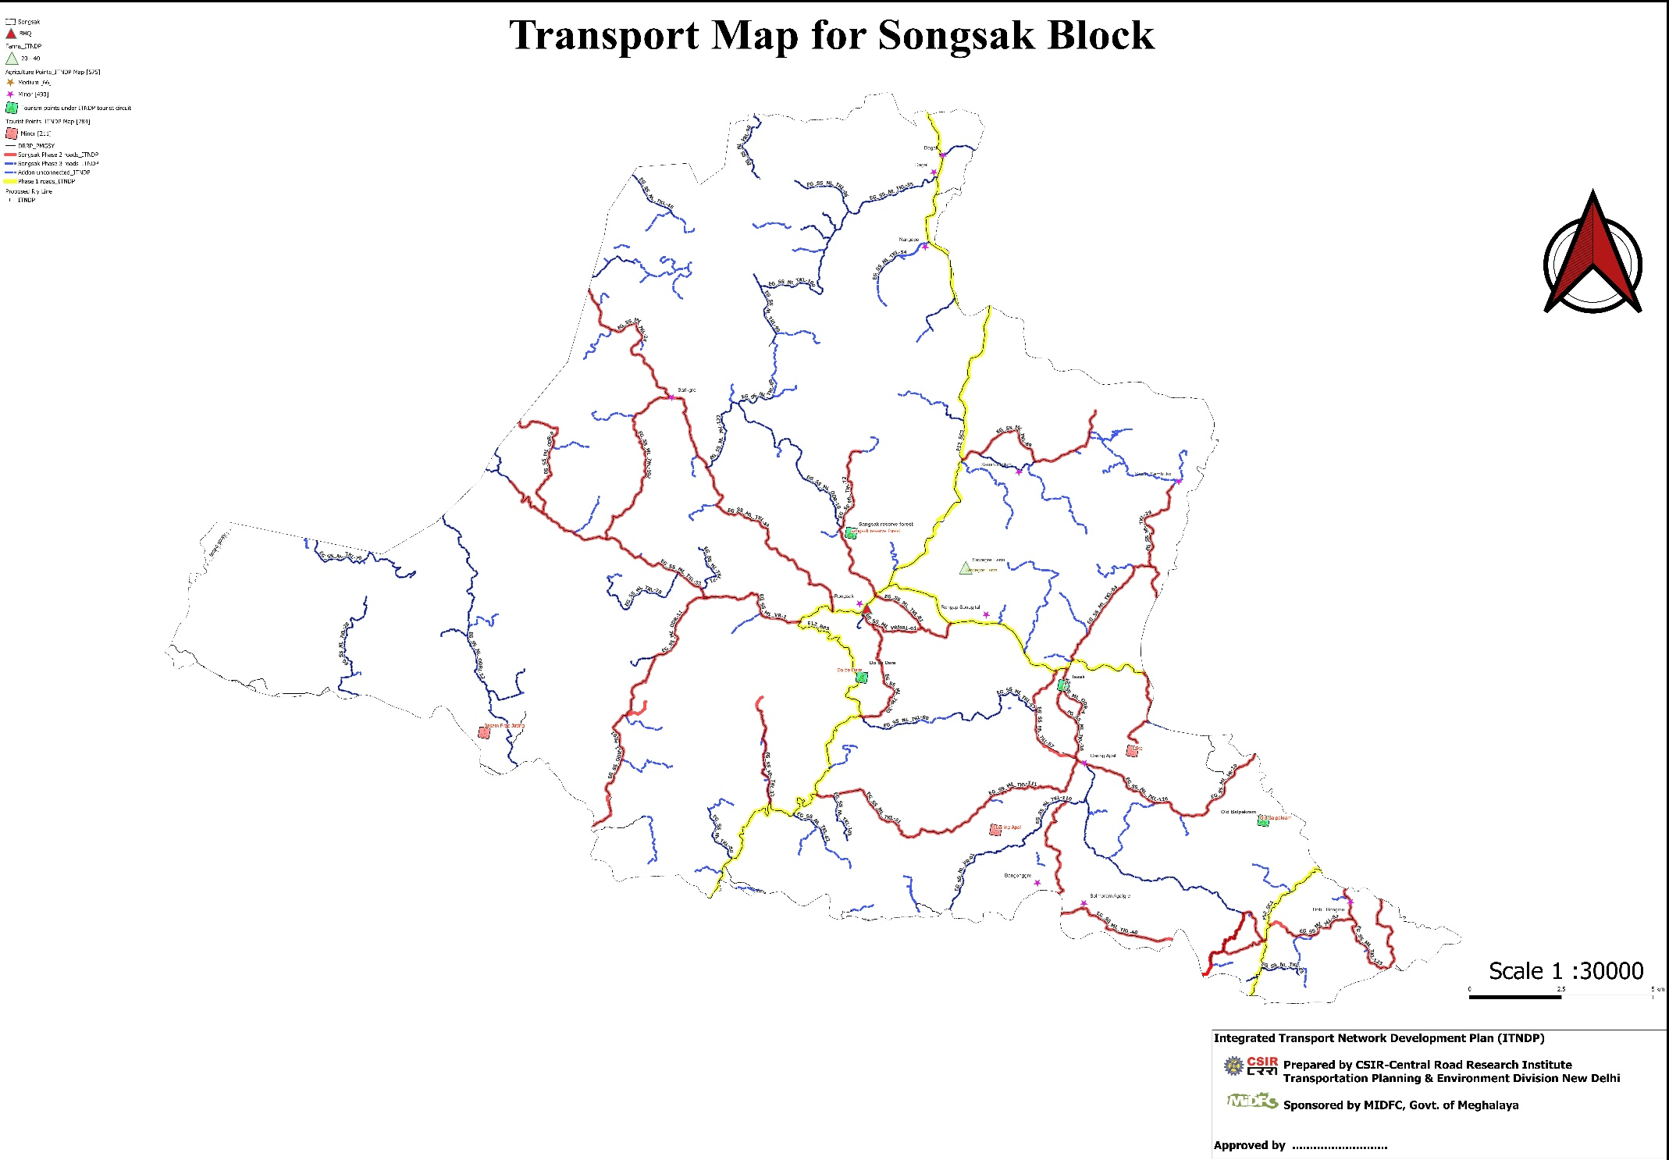

Summary of allocation of Phase -3 roads and Bridge of ITNDP, Block- Songsak

|  |  |  |  |  |  |  |  |  |  |  |  |  |  |  |  |  |  |  |  |  |  |  |  |  |
| --- | --- | --- | --- | --- | --- | --- | --- | --- | --- | --- | --- | --- | --- | --- | --- | --- | --- | --- | --- | --- | --- | --- | --- | --- |
| fid |  | Un ID | Block : Songsak | Road code | Road Name | Length | Length (km.) | x | y | Population serve by New Alignment . | Total Cost (Lakhs) | Ranking | Absolute Ranking | Name & Population served by Habitation in villages. | Existing Surface Type E/G/WBM. (?) Proposed E/G/WBM/BT(Provide KML) | Road Agency (PWD/C&RD/Industry/Mining/Agriculture/Tourist/Water/BADA/any other). | Length (KM) of New Roads Construction Proposed. | difference | Total Cost of road based on cost per km average rate 2024(in Crores) Length*Rate. | Length portion (KM). | Width of road length(metre) proposed. | Length of New construction of Bridge/CD/Culvert (Meter). | Type Bridge/CD/Culvert/etc. | Cost for Bridge/CD/Culvert/etc. (In Lakh) |
| 24 |  | 868 | Songsak | EG_DR_NL_01 | Chidimit nengsat road to chidimit imsinggittim | 0.4009 | 1.75 | 25.72679 | 90.62723 | 389 | 61.34 | 0.16 | 1 | Chidimit Nengsat Road , Chidimit Imsinggittim (868) | E | PWD | 0.4 | 1.35 | 56.14 | 0.4 | 3.75 | 2 | CD | 5.2 |
| 69 |  | 920 | Songsak | EG_DR_NL_02 | NH-51 to Dobu Bolsalgittim | 0.5135 | 3 | 25.558576 | 90.716577 | 309 | 80.88 | 0.26 | 2 | NH-62 , Dobu Bolsalgittim (920) | E | PWD | 0.52 | 2.478 | 73.08 | 0.52 | 3.75 | 3 |  | 7.8 |
| 48 |  | 935 | Songsak | EG_DR_NL_03 | Resu- Dekachang Road to Galmakpa | 0.5597 | 6.8 | 25.81347 | 90.56651 | 216 | 87.18 | 0.40 | 3 | Resu - Dekachang Road , Galmakpa (935) | E | PWD | 0.57 | 6.233 | 79.38 | 0.57 | 3.75 | 3 |  | 7.8 |
| 62 |  | 5409 | Songsak | EG_DR_NL_04 | RDA Road to rongrongre | 0.8504 | 2.5 | 25.77187 | 90.5383 | 315 | 133.26 | 0.42 | 4 | RDA Road , Rongronggre (5409) | E | PWD | 0.86 | 1.641 | 120.26 | 0.86 | 3.75 | 5 |  | 13 |
| 57 |  | 1014 | Songsak | EG_DR_NL_05 | 28th km of NH 51 - Rongrongghat via raja apal road to sanima | 1.3267 | 2 | 25.84241 | 90.53073 | 463 | 210.5 | 0.45 | 5 | 28th Km of NH-51 Rongronghat via Raja Apal Road , Sanima (1014) | E | PWD | 1.36 | 0.645 | 189.7 | 1.36 | 3.75 | 8 |  | 20.8 |
| 8 |  | 921 | Songsak | EG_DR_NL_06 | NH-51 to Dobu Chitimbing | 2.2946 | 8 | 25.551064 | 90.702418 | 784 | 357.7 | 0.46 | 6 | Dobu Rimding , Dobu Chitimbing (921) | E | PWD | 2.3 | 5.705 | 321.3 | 2.3 | 3.75 | 14 |  | 36.4 |
| 11 |  | 850 | Songsak | EG_DR_NL_07 | NH-51 to Bollnggre Refugee | 1.7012 | 2 | 25.7705 | 90.42532 | 557 | 284.94 | 0.51 | 7 | NH-51 , Bollonggre Refugee (850) | E | PWD | 1.7 | 0.3 | 238.14 | 1.7 | 3.75 | 18 | CD | 46.8 |
| 10 |  | 924 | Songsak | EG_DR_NL_08 | T03 - Rem Matchakolgre Road to Doki | 1.7498 | 8.3 | 25.77704 | 90.46104 | 523 | 273.6 | 0.52 | 8 | Rem Matchakolgri , Doki (924) | E | PWD | 1.75 | 6.55 | 245 | 1.75 | 3.75 | 11 |  | 28.6 |
| 17 |  | 883 | Songsak | EG_DR_NL_09 | Dilma Soksan Matrang road to Dalbot Banjam | 1.8565 | 3 | 25.83422519 | 90.69182028 | 503 | 288.02 | 0.57 | 9 | Dilma Soksan Matrang - Dalbot Kongkil Road , Dalbot Songma via Dalbot Banjam (883) | E | PWD | 1.85 | 1.147 | 259.42 | 1.85 | 3.75 | 11 |  | 28.6 |
| 42 |  | 840 | Songsak | EG_DR_NL_10 | Resudekachang Anogre road to Bansinggre | 0.7534 | 2 | 25.8538208 | 90.5443687 | 199 | 115.82 | 0.58 | 10 | Resu Dekachang Anogre Road , Bansinggre A (840 | E | PWD | 0.75 | 1.25 | 105.42 | 0.75 | 3.75 | 4 | CD | 10.4 |
| 54 |  | 962 | Songsak | EG_DR_NL_11 | resu dekachang - Anogre Road to maranodi | 1.1255 | 3 | 25.82755 | 90.57867 | 278 | 179.2 | 0.64 | 11 | Resu Dekachang Anogre Road , Moranadi (962) | E | PWD | 1.15 | 1.85 | 161 | 1.15 | 3.75 | 7 |  | 18.2 |
| 16 |  | 530 | Songsak | EG_DR_NL_12 | Dagal apal redamgre road to Bijasik chisim Apal | 0.8187 | 1.5 | 25.76003 | 90.59701 | 194 | 127.66 | 0.66 | 12 | Dagal Apal Redamgre Road , Bijasik Chisim Apal (530) | E | PWD | 0.82 | 0.68 | 114.66 | 0.82 | 3.75 | 5 | CD | 13 |
| 56 |  | 1013 | Songsak | EG_DR_NL_13 | T04-samin chianing road to samin silkigri | 1.0313 | 2 | 25.698862 | 90.676825 | 226 | 157.56 | 0.70 | 13 | T04 - Samin Chianing Road , Samin Silkigre (1013) | E | PWD | 1.01 | 0.986 | 141.96 | 1.01 | 3.75 | 6 |  | 15.6 |
| 2 |  | 984 | Songsak | EG_DR_NL_14 | T03 rem matchakolgri road to rem megapgre | 0.8129 | 3.8 | 25.784641 | 90.433126 | 184 | 129.62 | 0.70 | 14 | T03 - Rem Matchakolgre Road , Rem Megapgre (984) | E | PWD | 0.83 | 2.967 | 116.62 | 0.83 | 3.75 | 5 |  | 13 |
| 39 |  | 871 | Songsak | EG_DR_NL_15 | chidimit namesa road to chidimit saridam | 1.0153 | 1.5 | 25.74118 | 90.61209 | 223 | 157.7 | 0.71 | 15 | Chidimit Namesa Road , Chidimit Saridam (871) | E | PWD | 1.02 | 0.49 | 142.1 | 1.02 | 3.75 | 6 | CD | 15.6 |
| 25 |  | 1016 | Songsak | EG_DR_NL_16 | Dagal apal redamgre road to silkol | 1.6050 | 3.55 | 25.75541 | 90.58801 | 341 | 249.86 | 0.73 | 16 | Dagal Apal Redamgre Road , Silkol (1016) | E | PWD | 1.6 | 1.951 | 223.86 | 1.6 | 3.75 | 10 |  | 26 |
| 3 |  | 1001 | Songsak | EG_DR_NL_17 | NH-51 to rogral | 1.2291 | 6.5 | 25.83346 | 90.47525 | 237 | 189.7 | 0.80 | 17 | NH-51 - Sakalnang Road , Rongjal (1001) | E | PWD | 1.23 | 5.275 | 171.5 | 1.23 | 3.75 | 7 |  | 18.2 |
| 6 |  | 1038 | Songsak | EG_DR_NL_18 | deingol to rongrong ghat walkpat apal | 1.0254 | 4 | 25.83334 | 90.52486 | 188 | 159.1 | 0.85 | 18 | 28th km of NH-51 , Rongronghat via Raja Apal Road , Wakpat Apal (1038) | E | PWD | 1.03 | 2.975 | 143.5 | 1.03 | 3.75 | 6 |  | 15.6 |
| 49 |  | 2069 | Songsak | EG_DR_NL_19 | NH127B To Jamge Nengbal | 0.4834 | 6.3 | 25.62255 | 90.72018 | 89 | 75.7 | 0.85 | 19 | NH-127B , Jamge Nengbal (2069) | E | PWD | 0.49 | 5.815 | 67.9 | 0.49 | 3.75 | 3 |  | 7.8 |
| 58 |  | 1017 | Songsak | EG_DR_NL_20 | 28th km of NH-51 rongronghat via raja apal road to rangmalgre | 2.0891 | 1.8 | 25.791337 | 90.544769 | 367 | 332 | 0.90 | 20 | 28th km of Nh-51 Rongronghat via Raja Apal Road , Rangmalgre (1017) | E | PWD | 2.13 | -0.33 | 298.2 | 2.13 | 3.75 | 13 |  | 33.8 |
| 19 |  | 956 | Songsak | EG_DR_NL_21 | gabil bazar-gra songitcham road to manda | 6.3321 | 6.25 | 25.740982 | 90.448704 | 1153 | 1048.02 | 0.91 | 21 | Gabil Bazar - Gra Songgitcham road , Manda Chachatgri via Manda Songgitcham (956) | E | PWD | 6.74 | -0.493 | 944.02 | 6.74 | 3.75 | 40 |  | 104 |
| 59 |  | 1024 | Songsak | EG_DR_NL_22 | bonegre asil songgital road to sokadam banggna | 1.4710 | 4.75 | 25.66805 | 90.53587 | 240 | 233.4 | 0.97 | 22 | Bonegre , Asil Songgital Road , Sokadam Banggna (1024) | E | PWD | 1.5 | 3.25 | 210 | 1.5 | 3.75 | 9 |  | 23.4 |
| 22 |  | 994 | Songsak | EG_DR_NL_23 | akarok songgital road to Rongbalu A | 1.9011 | 3.8 | 25.802347 | 90.50947 | 300 | 294.74 | 0.98 | 23 | 28th km of NH-51 Rongronghat via Raja Apal - Danang Apal Road , Rongbalu A (994) | E | PWD | 1.9 | 1.899 | 266.14 | 1.9 | 3.75 | 11 |  | 28.6 |
| 35 |  | 970 | Songsak | EG_DR_NL_24 | L039 - napak bolchugre road t napak tasek | 3.7296 | 2.45 | 25.620274 | 90.632474 | 529 | 579.4 | 1.10 | 24 | NH-127B - Napak Bolchugre Road , Napak Dokrugre via Napak Tasek (970) | E | PWD | 3.73 | -1.28 | 522.2 | 3.73 | 3.75 | 22 |  | 57.2 |
| 5 |  | 902 | Songsak | EG_DR_NL_25 | resu dekachang - anogre road to dakong dorakgre | 1.8788 | 5 | 25.744617 | 90.519993 | 265 | 294.46 | 1.11 | 25 | Resu Dekachang Anogre Road , Dangkong Dorakgre (902) | E | PWD | 1.9 | 3.101 | 265.86 | 1.9 | 3.75 | 11 |  | 28.6 |
| 26 |  | 882 | Songsak | EG_DR_NL_26 | dilma soksan matrang road to dalbot bangbol | 2.1287 | 4 | 25.825125 | 90.677087 | 290 | 331.86 | 1.14 | 26 | Dalbot Rongbok , Dalbot Bangbol (882) | E | PWD | 2.13 | 1.87 | 298.06 | 2.13 | 3.75 | 13 | CD | 33.8 |
| 4 |  | 922 | Songsak | EG_DR_NL_27 | NH-51 To Dobu Rimding | 8.4723 | 6 | 25.58793 | 90.66874 | 1142 | 1318.54 | 1.15 | 27 | NH-62 , Bolmoram Agalgre via Dobu Rimding (922) | E | PWD | 8.47 | -2.471 | 1185.94 | 8.47 | 3.75 | 51 |  | 132.6 |
| 65 |  | 5220 | Songsak | EG_DR_NL_28 | NH127-B to rongap mringgre | 3.3932 | 5.25 | 25.62219 | 90.57967 | 436 | 526.6 | 1.21 | 28 | NH-127B , Rongap Mringgre (5220) | E | PWD | 3.39 | 1.86 | 474.6 | 3.39 | 3.75 | 20 |  | 52 |
| 66 |  | 666 | Songsak | EG_DR_NL_29 | kakwa bonegre road to bone megapgre | 7.3087 | 4 | 25.705785 | 90.57488 | 876 | 1137.66 | 1.30 | 29 | Kakwa Bonegre Road , Bone Megapgre (666) | E | PWD | 7.31 | -3.31 | 1023.26 | 7.31 | 3.75 | 44 | CD | 114.4 |
| 51 |  | 947 | Songsak | EG_DR_NL_30 | RDA Road to Kanchimik | 7.9259 | 4.25 | 25.75496 | 90.48338 | 662 | 904.68 | 1.37 | 30 | Resu Dekachang Anogre Road , Kanchimik (947) | E | PWD | 5.81 | -1.562 | 813.68 | 5.81 | 3.75 | 35 |  | 91 |
| 68 |  | 911 | Songsak | EG_DR_NL_31 | dobu agalgre dobu achakpek road to dimit songmong | 1.2792 | 7 | 25.57131 | 90.75095 | 150 | 205.04 | 1.37 | 31 | Dobu Agalgre - Dobu Achakpek Road , Dimit Songmong (911) | E | PWD | 1.32 | 5.684 | 184.24 | 1.32 | 3.75 | 8 |  | 20.8 |
| 64 |  | 899 | Songsak | EG_DR_NL_32 | 28th km of NH -51rongronghat via raja apal road to danang | 5.2546 | 9 | 25.79573 | 90.52982 | 578 | 818.9 | 1.42 | 32 | 28th km of Nh-51 Rongronghat via Raja Apal Road , Danang Apal (899) | E | PWD | 5.26 | 3.745 | 735.7 | 5.26 | 3.75 | 32 |  | 83.2 |
| 15 |  | 953 | Songsak | EG_DR_NL_33 | Gabil daningka - cheran chikol to koksi songma | 3.1213 | 3.5 | 25.7502 | 90.65866 | 340 | 486.34 | 1.43 | 33 | 13th km of Songsak Mendhipathar Road , Koksi Songma (953) | E | PWD | 3.12 | 0.379 | 436.94 | 3.12 | 3.75 | 19 |  | 49.4 |
| 28 |  | 5394 | Songsak | EG_DR_NL_34 | bone chisogre to rongreng nokat | 3.7637 | 6.9 | 25.62919 | 90.54832 | 404 | 586.76 | 1.45 | 34 | Bone Chisogre , Rongreng Nokat (5394) | E | PWD | 3.76 | 3.136 | 526.96 | 3.76 | 3.75 | 23 |  | 59.8 |
| 32 |  | 975 | Songsak | EG_DR_NL_35 | NH 127B to Norek dalbot | 1.6036 | 2 | 25.58558 | 90.60438 | 170 | 249.44 | 1.47 | 35 | NH-127B - Norek Nengjreng Road , Norek Dalbot (975) | E | PWD | 1.6 | 0.404 | 223.44 | 1.6 | 3.75 | 10 |  | 26 |
| 31 |  | 906 | Songsak | EG_DR_NL_36 | NH127B to Daring apal | 5.8348 | 8 | 25.58786 | 90.62821 | 593 | 907.76 | 1.53 | 36 | Napak Bolchugre - Bolmoram Angkekol Road , Daring Apal (906) | E | PWD | 5.83 | 2.166 | 816.76 | 5.83 | 3.75 | 35 |  | 91 |
| 43 |  | 228 | Songsak | EG_DR_NL_37 | Tebil bonegre Barikgre road to geru apal | 2.7336 | 4.5 | 25.70576 | 90.57491 | 270 | 424.36 | 1.57 | 37 | Tebil bonegre-Barikgre road , Bone Megapgre via Geru Apal (228) | E | PWD | 2.73 | 1.766 | 382.76 | 2.73 | 3.75 | 16 |  | 41.6 |
| 46 |  | 931 | Songsak | EG_DR_NL_38 | gabil Bazar-gra Songgitcham Road to Gabil matchagri | 1.0066 | 1.5 | 25.69416 | 90.45851 | 95 | 154.2 | 1.62 | 38 | Gabil Bazar - Gra Songgitcham Road , Gabil Matchagri (931) | E | PWD | 0.99 | 0.51 | 138.6 | 0.99 | 3.75 | 6 |  | 15.6 |
| 9 |  | 903 | Songsak | EG_DR_NL_39 | resu-dekachang anogre road to dangkong rapdikgre | 1.8660 | 6 | 25.759918 | 90.527003 | 182 | 300.42 | 1.65 | 39 | Dangkong Dorakgre , Dangkong Rapdikgre (903) | E | PWD | 1.92 | 4.077 | 269.22 | 1.92 | 3.75 | 12 |  | 31.2 |
| 20 |  | 904 | Songsak | EG_DR_NL_40 | resu-dekachang - anogre road to dangkong songital | 2.3223 | 7 | 25.7310109 | 90.5125184 | 218 | 361.34 | 1.66 | 40 | Dangkong Dorakgre , Dangkong Songgital (904) | E | PWD | 2.32 | 4.679 | 324.94 | 2.32 | 3.75 | 14 |  | 36.4 |
| 23 |  | 936 | Songsak | EG_DR_NL_41 | 28th km of NH51 Rongronghat Via raja apal road to gambalong | 0.9066 | 4.7 | 25.80499 | 90.54329 | 84 | 139.84 | 1.66 | 41 | 28th km of NH-51 Rongronghat via Raja Apal , Gambalong (936) | E | PWD | 0.91 | 3.794 | 126.84 | 0.91 | 3.75 | 5 |  | 13 |
| 34 |  | 1021 | Songsak | EG_DR_NL_42 | songsak bonegre road to sokadam agalgre | 3.7818 | 3.4 | 25.65789 | 90.53926 | 348 | 589.28 | 1.69 | 42 | Bonegre - Asil Songgital Road , Sokadam Aruakgre via Sokadam Agalgre (1021) | E | PWD | 3.78 | -0.382 | 529.48 | 3.78 | 3.75 | 23 |  | 59.8 |
| 45 |  | 839 | Songsak | EG_DR_NL_43 | 28th km of NH-51 to Resudekachanganogre Road to Balsrigittim | 1.5333 | 1.5 | 25.81152 | 90.54253 | 139 | 237.68 | 1.71 | 43 | 28th km of NH-51-Resudekachang Anogre Road , Balsrigittim (839) | E | PWD | 1.51 | -0.01 | 211.68 | 1.51 | 3.75 | 10 | CD | 26 |
| 47 |  | 893 | Songsak | EG_DR_NL_44 | bonegre asil songital road to danal apal | 9.0820 | 4 | 25.694272 | 90.458471 | 824 | 1409.08 | 1.71 | 44 | Asil Songgital , Gabil Matchagri via Danal Megapgre, Danal Apal, Danal Balnanggre and Danal Songgitcham (893) | E | PWD | 9.06 | -5.062 | 1268.68 | 9.06 | 3.75 | 54 |  | 140.4 |
| 1 |  | 845 | Songsak | EG_DR_NL_46 | Dagal Apal redamgre road to bijasik doki ading | 4.3117 | 3.6 | 25.722255 | 90.582993 | 361 | 670.86 | 1.86 | 46 | Redamgre , Bijasik Doki Ading (845) | E | PWD | 4.31 | -0.71 | 603.26 | 4.31 | 3.75 | 26 | CD | 67.6 |
| 52 |  | 1026 | Songsak | EG_DR_NL_47 | Songsak mendipather road to sokmitegre | 0.9475 | 3.8 | 25.76751 | 90.63494 | 81 | 155.6 | 1.92 | 47 | Songsak-Mendhipathar Road , Sokmitegre (1026) | E | PWD | 1 | 2.8 | 140 | 1 | 3.75 | 6 |  | 15.6 |
| 18 |  | 833 | Songsak | EG_DR_NL_48 | 28th km of NH-51 to Rongronghat via raja apal to akemgre | 3.7987 | 4.5 | 25.83678014 | 90.49573613 | 299 | 589.06 | 1.97 | 48 | 28th km of NH-51 , Rongronghat via Raja Apal , Akemgre (833) | E | PWD | 3.8 | 0.7 | 531.86 | 3.8 | 3.75 | 22 | CD | 57.2 |
| 40 |  | 365 | Songsak | EG_DR_NL_49 | samgong akelgre road to bolmoram adap | 8.8043 | 4 | 25.558216 | 90.690144 | 688 | 1370.36 | 1.99 | 49 | Samgonggre - Agalgre - Akelgre Road , Bolmoram Mesechikgri (365) | E | PWD | 8.8 | -4.8 | 1232.56 | 8.8 | 3.75 | 53 | CD | 137.8 |
| 61 |  | 6838 | Songsak | EG_DR_NL_50 | Gabil bazar -gra road Watenanggre | 10.6517 | 12 | 25.7914988 | 90.5129283 | 767 | 1657.82 | 2.16 | 50 | Akarok Songgitcham - Akarok Songgital Road , Watenanggre (6838) | E | PWD | 10.65 | 1.347 | 1491.42 | 10.65 | 3.75 | 64 |  | 166.4 |
| 12 |  | 2071 | Songsak | EG_DR_NL_51 | NH127 -B to Jaamge watregittim | 2.7270 | 5.5 | 25.63183 | 90.68424 | 193 | 421 | 2.18 | 51 | NH-127B , Chidambong Wari via Jamge Watregittim (2071) | E | PWD | 2.71 | 2.79 | 379.4 | 2.71 | 3.75 | 16 |  | 41.6 |
| 60 |  | 5932 | Songsak | EG_DR_NL_52 | NH127 B to songsak megapgre | 1.5607 | 3.5 | 25.62092 | 90.59825 | 107 | 243.48 | 2.28 | 52 | NH-127B , Songsak Megapgre (5932) | E | PWD | 1.57 | 1.928 | 220.08 | 1.57 | 3.75 | 9 |  | 23.4 |
| 13 |  | 894 | Songsak | EG_DR_NL_53 | Bonegre asil songital road to danal attewakgre | 4.8842 | 3.5 | 25.70421 | 90.51388 | 315 | 758.32 | 2.41 | 53 | Bonegre-Asil songital road , Danal Attewakgre (894) | E | PWD | 4.88 | -1.378 | 682.92 | 4.88 | 3.75 | 29 |  | 75.4 |
| 14 |  | 841 | Songsak | EG_DR_NL_54 | RDA Road To Bansinggre B | 1.1925 | 2 | 25.837 | 90.52375 | 75 | 187.68 | 2.50 | 54 | Resu Dekachang Anogre Road , Bansinggre B (841) | E | PWD | 1.19 | 0.81 | 166.88 | 1.19 | 3.75 | 8 | CD | 20.8 |
| 21 |  | 907 | Songsak | EG_DR_NL_55 | Resu-Dekachang - anogre road to dijonggre | 3.1278 | 5 | 25.791499 | 90.5129267 | 187 | 487.32 | 2.61 | 55 | Resu Dekachang Anogre - Kanchimik Road , Watenanggre (907) | E | PWD | 3.13 | 1.872 | 437.92 | 3.13 | 3.75 | 19 |  | 49.4 |
| 44 |  | 638 | Songsak | EG_DR_NL_56 | napak bolchugre road to bolmoram angkekol | 4.3774 | 4 | 25.592043 | 90.696449 | 311 | 854.96 | 2.75 | 56 | Napak Bolchugre , Bolmoram Angkekol (638) | E | PWD | 5.49 | -1.49 | 769.16 | 5.49 | 3.75 | 33 | CD | 85.8 |
| 37 |  | 1008 | Songsak | EG_DR_NL_57 | NH-51 ti sakalnang | 1.7482 | 2 | 25.825535 | 90.471641 | 96 | 268.34 | 2.80 | 57 | NH-51 , Sakalnang (1008) | E | PWD | 1.73 | 0.269 | 242.34 | 1.73 | 3.75 | 10 |  | 26 |
| 55 |  | 977 | Songsak | EG_DR_NL_58 | NH127B to norek Nengreng | 3.0697 | 2.2 | 25.59044 | 90.61689 | 170 | 489.7 | 2.88 | 58 | NH-127B , Norek Nengjreng (977) | E | PWD | 3.15 | -0.945 | 440.3 | 3.15 | 3.75 | 19 |  | 49.4 |
| 53 |  | 963 | Songsak | EG_DR_NL_59 | Akarok songitcham to akarok songital road to marongna | 2.2581 | 4.2 | 25.811463 | 90.48497 | 118 | 348.52 | 2.95 | 59 | Akarok Songgitcham - Akaraok Songgital - Watenanggre Road , Marongpa (963) | E | PWD | 2.25 | 1.952 | 314.72 | 2.25 | 3.75 | 13 |  | 33.8 |
| 38 |  | 900 | Songsak | EG_DR_NL_60 | resu dekachang - anogre road to dakong chitorenggre | 2.2463 | 4 | 25.745716 | 90.546072 | 115 | 348.24 | 3.03 | 60 | Resu Dekachang Anogre Road , Dangkong Chi,regre (900) | E | PWD | 2.25 | 1.754 | 314.44 | 2.25 | 3.75 | 13 |  | 33.8 |
| 7 |  | 957 | Songsak | EG_DR_NL_61 | gabil bazar -gra songitcham road to manda cherangre | 8.5415 | 5.3 | 25.749198 | 90.467416 | 436 | 1328.48 | 3.05 | 61 | T03 - Jogogri Road , Manda Cherangre (957) | E | PWD | 8.54 | -3.242 | 1195.88 | 8.54 | 3.75 | 51 |  | 132.6 |
| 41 |  | 879 | Songsak | EG_DR_NL_62 | T04 - Dagal samity to dagal chiwate | 1.4694 | 4.5 | 25.75407 | 90.64107 | 73 | 229.06 | 3.14 | 62 | Songsak - Mendipathar road , Dagal Chiwate (879) | E | PWD | 1.47 | 3.031 | 205.66 | 1.47 | 3.75 | 9 |  | 23.4 |
| 50 |  | 5407 | Songsak | EG_DR_NL_63 | RDA to rongrongrrong songgitcham | 3.8997 | 4.8 | 25.7666 | 90.48785 | 187 | 610.78 | 3.27 | 63 | RDA - Kanchimik Road , Rongrong Songgitcham (5407) | E | PWD | 3.92 | 0.883 | 548.38 | 3.92 | 3.75 | 24 |  | 62.4 |
| 33 |  | 2518 | Songsak | EG_DR_NL_64 | NH127-B to Rongap asimgre | 1.9641 | 2.5 | 25.59445 | 90.56628 | 91 | 306.72 | 3.37 | 64 | NH-127B , Rongap Asimgre (2518) | E | PWD | 1.97 | 0.532 | 275.52 | 1.97 | 3.75 | 12 |  | 31.2 |
| 36 |  | 982 | Songsak | EG_DR_NL_65 | T03 rem matchakolgri road to rem dalmgre | 4.0418 | 5 | 25.78989 | 90.46085 | 163 | 628.42 | 3.86 | 65 | T03 - Rem Matchakolgri Road , Doki Ading via Rem Dalmagre (982) | E | PWD | 4.04 | 0.957 | 566.02 | 4.04 | 3.75 | 24 |  | 62.4 |
| 30 |  | 2070 | Songsak | EG_DR_NL_66 | NH127 B to Jamge ronggura | 2.9387 | 4 | 25.60638 | 90.70127 | 115 | 458.4 | 3.99 | 66 | NH-127B , Jamge Ronggura (2070) | E | PWD | 2.94 | 1.06 | 411.6 | 2.94 | 3.75 | 18 |  | 46.8 |
| 27 |  | 885 | Songsak | EG_DR_NL_67 | dilma soksan matrang road to dalbot kongkil | 4.9382 | 5 | 25.82882143 | 90.68342122 | 185 | 769.32 | 4.16 | 67 | Dilma Soksan Matrang Road , Dalbot Kongkil (885) | E | PWD | 4.94 | 0.062 | 691.32 | 4.94 | 3.75 | 30 |  | 78 |
| 29 |  | 910 | Songsak | EG_DR_NL_68 | Dobu Agalgre Dobu Achakpek Road to Dimit Ongtagittim | 2.3636 | 10 | 25.550219 | 90.750694 | 73 | 381.72 | 5.23 | 68 | Dobu Agalgre - Dobu Achakpek Road , Dimit Ontagittim (910) | E | PWD | 2.45 | 7.552 | 342.72 | 2.45 | 3.75 | 15 |  | 39 |
| 67 |  | 912 | Songsak | EG_DR_NL_69 | NH127 B via Nongcharm to Dimit Warikatchi | 3.0755 | 6 | 25.58127 | 90.79005 | 110 | 700.2 | 6.37 | 69 | NH-127B via Nongchram , Dimit Warikatchi (912) | E | PWD | 4.5 | 1.5 | 630 | 4.5 | 3.75 | 27 |  | 70.2 |
|  |  |  |  |  |  |  |  |  |  |  | 31455.5 |  |  |  |  |  |  |  |  |  |  |  |  |  |

Financing Plan of Roads of Phase 3 Songsak

|  |  |
| --- | --- |
|  |  |
| Total No of Road | 68 |
| Total Length of New Construction(km) | 200.8115193 |
| Total no of Bridge less than 10 m | 4 |
| Total no of Bridge 10 m-30 m | 26 |
| Total no bridge | 68 |
| Total Cost of Bridge and Culvert(lakhs) | 3172 |
| Total Cost of Road(lakhs) | 28283.5 |
| Total Cost for Songsak (lakh) | 31455.5 |
| 20 year Budgets | 1572.775 |

|  |  |  |  |  |  |
| --- | --- | --- | --- | --- | --- |
| Year | Road Code | Road Name | Spend per Year(lakhs) | Ranking | Total cost per Road(lakhs) |
| 2024 | EG_DR_NL_01 | Chidimit nengsat road to chidimit imsinggittim | 1573.4 | 1 | 61.34 |
| EG_DR_NL_02 | NH-51 to Dobu Bolsalgittim | 2 | 80.88 |
| EG_DR_NL_03 | Resu- Dekachang Road to Galmakpa | 3 | 87.18 |
| EG_DR_NL_04 | RDA Road to rongrongre | 4 | 133.26 |
| EG_DR_NL_05 | 28th km of NH 51 - Rongrongghat via raja apal road to sanima | 5 | 210.5 |
| EG_DR_NL_06 | NH-51 to Dobu Chitimbing | 6 | 357.7 |
| EG_DR_NL_07 | NH-51 to Bollnggre Refugee | 7 | 284.94 |
| EG_DR_NL_08 | T03 - Rem Matchakolgre Road to Doki | 8 | 273.6 |
| EG_DR_NL_09 | Dilma Soksan Matrang road to Dalbot Banjam (0-84km) | 9 | 84 |
| 2025 | EG_DR_NL_09 | Dilma Soksan Matrang road to Dalbot Banjam (84-288.02km) | 1573 | 9 | 204.02 |
| EG_DR_NL_10 | Resudekachang Anogre road to Bansinggre | 10 | 115.82 |
| EG_DR_NL_11 | resu dekachang - Anogre Road to maranodi | 11 | 179.2 |
| EG_DR_NL_12 | Dagal apal redamgre road to Bijasik chisim Apal | 12 | 127.66 |
| EG_DR_NL_13 | T04-samin chianing road to samin silkigri | 13 | 157.56 |
| EG_DR_NL_14 | T03 rem matchakolgri road to rem megapgre | 14 | 129.62 |
| EG_DR_NL_15 | chidimit namesa road to chidimit saridam | 15 | 157.7 |
| EG_DR_NL_16 | Dagal apal redamgre road to silkol | 16 | 249.86 |
| EG_DR_NL_17 | NH-51 to rogral | 17 | 189.7 |
| EG_DR_NL_18 | deingol to rongrong ghat walkpat apal (0-61.86km) | 18 | 61.86 |
| 2026 | EG_DR_NL_18 | deingol to rongrong ghat walkpat apal (61.86-159.1km) | 1573 | 18 | 97.24 |
| EG_DR_NL_19 | NH127B To Jamge Nengbal | 19 | 75.7 |
| EG_DR_NL_20 | 28th km of NH-51 rongronghat via raja apal road to rangmalgre | 20 | 332 |
| EG_DR_NL_21 | gabil bazar-gra songitcham road to manda | 21 | 1048.02 |
| EG_DR_NL_22 | bonegre asil songgital road to sokadam banggna (0-20.04km) | 22 | 20.04 |
| 2027 | EG_DR_NL_22 | bonegre asil songgital road to sokadam banggna (20.04-233.4km) | 1573 | 22 | 213.36 |
| EG_DR_NL_23 | akarok songgital road to Rongbalu A | 23 | 294.74 |
| EG_DR_NL_24 | L039 - napak bolchugre road t napak tasek | 24 | 579.4 |
| EG_DR_NL_25 | resu dekachang - anogre road to dakong dorakgre | 25 | 294.46 |
| EG_DR_NL_26 | dilma soksan matrang road to dalbot bangbol (0-191.04km) | 26 | 191.04 |
| 2028 | EG_DR_NL_26 | dilma soksan matrang road to dalbot bangbol (191.04-331.86km) | 1573 | 26 | 140.82 |
| EG_DR_NL_27 | NH-51 To Dobu Rimding | 27 | 1318.54 |
| EG_DR_NL_28 | NH127-B to rongap mringgre (0-113.64km) | 28 | 113.64 |
| 2029 | EG_DR_NL_28 | NH127-B to rongap mringgre (113.64-526.6km) | 1573 | 28 | 412.96 |
| EG_DR_NL_29 | kakwa bonegre road to bone megapgre | 29 | 1137.66 |
| 2030 | EG_DR_NL_30 | RDA Road to Kanchimik | 1573 | 30 | 904.68 |
| EG_DR_NL_31 | dobu agalgre dobu achakpek road to dimit songmong | 31 | 205.04 |
| EG_DR_NL_32 | 28th km of NH -51rongronghat via raja apal road to danang (0-463.28km) | 32 | 463.28 |
| 2031 | EG_DR_NL_32 | 28th km of NH -51rongronghat via raja apal road to danang (463.28-818.9km) | 1573 | 32 | 355.62 |
| EG_DR_NL_33 | Gabil daningka - cheran chikol to koksi songma | 33 | 486.34 |
| EG_DR_NL_34 | bone chisogre to rongreng nokat | 34 | 586.76 |
| EG_DR_NL_35 | NH 127B to Norek dalbot (0-144.28km) | 35 | 144.28 |
| 2032 | EG_DR_NL_35 | NH 127B to Norek dalbot (144.28-249.44km) | 1591.48 | 35 | 105.16 |
| EG_DR_NL_36 | NH127B to Daring apal | 36 | 907.76 |
| EG_DR_NL_37 | Tebil bonegre Barikgre road to geru apal | 37 | 424.36 |
| EG_DR_NL_38 | gabil Bazar-gra Songgitcham Road to Gabil matchagri | 38 | 154.2 |
| 2033 | EG_DR_NL_39 | resu-dekachang anogre road to dangkong rapdikgre | 1628.56 | 39 | 300.42 |
| EG_DR_NL_40 | resu-dekachang - anogre road to dangkong songital | 40 | 361.34 |
| EG_DR_NL_41 | 28th km of NH51 Rongronghat Via raja apal road to gambalong | 41 | 139.84 |
| EG_DR_NL_42 | songsak bonegre road to sokadam agalgre | 42 | 589.28 |
| EG_DR_NL_43 | 28th km of NH-51 to Resudekachanganogre Road to Balsrigittim | 43 | 237.68 |
| 2034 | EG_DR_NL_44 | bonegre asil songital road to danal apal | 1409.08 | 44 | 1409.08 |
| 2035 | EG_DR_NL_46 | Dagal Apal redamgre road to bijasik doki ading | 1415.52 | 45 | 670.86 |
| EG_DR_NL_47 | Songsak mendipather road to sokmitegre | 46 | 155.6 |
| EG_DR_NL_48 | 28th km of NH-51 to Rongronghat via raja apal to akemgre | 47 | 589.06 |
| 2036 | EG_DR_NL_49 | samgong akelgre road to bolmoram adap | 1573.36 | 48 | 1370.36 |
| EG_DR_NL_50 | Gabil bazar -gra road Watenanggre | 49 | 203 |
| 2037 | EG_DR_NL_50 | Gabil bazar -gra road Watenanggre | 1454.82 | 49 | 1454.82 |
| 2038 | EG_DR_NL_51 | NH127 -B to Jaamge watregittim | 1610.48 | 50 | 421 |
| EG_DR_NL_52 | NH127 B to songsak megapgre | 51 | 243.48 |
| EG_DR_NL_53 | Bonegre asil songital road to danal attewakgre | 52 | 758.32 |
| EG_DR_NL_54 | RDA Road To Bansinggre B | 53 | 187.68 |
| 2039 | EG_DR_NL_55 | Resu-Dekachang - anogre road to dijonggre | 1610.62 | 54 | 487.32 |
| EG_DR_NL_56 | napak bolchugre road to bolmoram angkekol | 55 | 854.96 |
| EG_DR_NL_57 | NH-51 ti sakalnang | 56 | 268.34 |
| 2040 | EG_DR_NL_58 | NH127B to norek Nengreng | 1415.52 | 57 | 489.7 |
| EG_DR_NL_59 | Akarok songitcham to akarok songital road to marongna | 58 | 348.52 |
| EG_DR_NL_60 | resu dekachang - anogre road to dakong chitorenggre | 59 | 348.24 |
| EG_DR_NL_62 | T04 - Dagal samity to dagal chiwate | 61 | 229.06 |
| 2041 | EG_DR_NL_61 | gabil bazar -gra songitcham road to manda cherangre | 1328.48 | 60 | 1328.48 |
| 2042 | EG_DR_NL_63 | RDA to rongrongrrong songgitcham | 1545.92 | 62 | 610.78 |
| EG_DR_NL_64 | NH127-B to Rongap asimgre | 63 | 306.72 |
| EG_DR_NL_65 | T03 rem matchakolgri road to rem dalmgre | 64 | 628.42 |
| 2043 | EG_DR_NL_66 | NH127 B to Jamge ronggura | 1227.72 | 65 | 458.4 |
| EG_DR_NL_67 | dilma soksan matrang road to dalbot kongkil | 66 | 769.32 |
| 2044 | EG_DR_NL_68 | Dobu Agalgre Dobu Achakpek Road to Dimit Ongtagittim | 1081.92 | 67 | 381.72 |
| EG_DR_NL_69 | NH127 B via Nongcharm to Dimit Warikatchi | 68 | 700.2 |
| Total |  |  | 31455.5 |

List Unconnected Habitation of Block - Songsak

|  |  |  |  |  |  |
| --- | --- | --- | --- | --- | --- |
| fid | Block | Habitation | Population | Y | X |
| 129 | Songsak | Manda Chachatgri | 115 | 25.74096822 | 90.4487063 |
| 130 | Songsak | Manda Cherangre | 195 | 25.7491979 | 90.4673979 |
| 131 | Songsak | Manda Songgitcham | 230 | 25.72350067 | 90.44388576 |
| 132 | Songsak | Maranodi | 84 | 25.82753534 | 90.578736 |
| 133 | Songsak | Marongpa | 118 | 25.811466 | 90.484944 |
| 134 | Songsak | Gabil Wagopgri | 248 | 25.67049056 | 90.4626135 |
| 135 | Songsak | Gambalgong | 84 | 25.80496396 | 90.54329723 |
| 136 | Songsak | Geru Apal | 181 | 25.69102147 | 90.56716789 |
| 137 | Songsak | Kentra | 85 | 25.66291953 | 90.46979602 |
| 138 | Songsak | Koksi Songma | 291 | 25.75022953 | 90.65851361 |
| 139 | Songsak | Mandalong | 94 | 25.66136352 | 90.48307975 |
| 140 | Songsak | Mandalong Koksi | 22 | 25.66142347 | 90.48382834 |
| 141 | Songsak | Napak Tasek | 178 | 25.62597389 | 90.64513454 |
| 142 | Songsak | Nengsa Apal | 314 | 25.84802011 | 90.52723351 |
| 143 | Songsak | Norek Dalbot | 170 | 25.58568652 | 90.6042311 |
| 144 | Songsak | Norek Nengjreng | 170 | 25.59047981 | 90.61687441 |
| 145 | Songsak | Rem Megapgri | 184 | 25.78464268 | 90.43311213 |
| 146 | Songsak | Rimrang Bonegre | 494 | 25.70475676 | 90.56066184 |
| 147 | Songsak | Rongap Asimgre | 137 | 25.59456487 | 90.56618146 |
| 148 | Songsak | Rongap Mikilsinggre | 95 | 25.5725584 | 90.5784367 |
| 149 | Songsak | Rongap Mringgre | 133 | 25.62223216 | 90.57955531 |
| 150 | Songsak | Rongreng Nokat | 217 | 25.62911188 | 90.54831055 |
| 151 | Songsak | Rongrong Songgitcham | 77 | 25.76665993 | 90.48775337 |
| 152 | Songsak | Rongronggre | 315 | 25.77187308 | 90.53827414 |
| 153 | Songsak | Samin Silkigri | 226 | 25.69886589 | 90.67681108 |
| 154 | Songsak | Sanima | 269 | 25.84240504 | 90.53061197 |
| 155 | Songsak | Silkol | 110 | 25.75546488 | 90.58800639 |
| 156 | Songsak | Skera Apal | 367 | 25.82136803 | 90.5367258 |
| 157 | Songsak | Snalgri | 98 | 25.7477054 | 90.4033544 |
| 158 | Songsak | Sokadam Balading | 188 | 25.63859795 | 90.55672203 |
| 159 | Songsak | Gabil Matchagri | 95 | 25.6942872 | 90.45846755 |
| 160 | Songsak | Rongchek Songgital | 54 | 25.64985739 | 90.72258737 |
| 161 | Songsak | Sokadam Agalgre | 214 | 25.6494975 | 90.54333569 |
| 162 | Songsak | Sokadam Aruakgre | 51 | 25.65791027 | 90.539265 |
| 163 | Songsak | Sokadam Banggna | 240 | 25.66806282 | 90.53583177 |
| 164 | Songsak | Songsak Megapgre | 139 | 25.62092758 | 90.59815048 |
| 165 | Songsak | Akemgre | 229 | 25.83678015 | 90.49573612 |
| 166 | Songsak | Bansinggre A | 199 | 25.85382352 | 90.54436619 |
| 167 | Songsak | Bansinggre B | 75 | 25.8370089 | 90.52368274 |
| 168 | Songsak | Bijasik Chisim Apal | 194 | 25.7600674 | 90.596933 |
| 169 | Songsak | Bollonggre Refugee | 557 | 25.77064206 | 90.42510971 |
| 170 | Songsak | Bolmoram Adap | 236 | 25.58393884 | 90.6581561 |
| 171 | Songsak | Bolmoram Ading | 95 | 25.56413239 | 90.65682324 |
| 172 | Songsak | Bolmoram Agalgre | 99 | 25.58794846 | 90.6686003 |
| 173 | Songsak | Bolmoram Angkekol | 311 | 25.5920556 | 90.6964277 |
| 174 | Songsak | Bone Megapgre | 174 | 25.70577483 | 90.57487501 |
| 175 | Songsak | Chidimit Saridam | 223 | 25.7412838 | 90.6119935 |
| 176 | Songsak | Dagal Chiwate | 136 | 25.75406179 | 90.6410143 |
| 177 | Songsak | Dalbot Bangbol | 40 | 25.82513384 | 90.67705809 |
| 178 | Songsak | Dalbot Chiwate | 148 | 25.83485768 | 90.6904563 |
| 179 | Songsak | Dalbot Kongkil | 113 | 25.8288214 | 90.6834212 |
| 180 | Songsak | Dalbot Rongbok | 100 | 25.8229615 | 90.6630661 |
| 181 | Songsak | Danal Apal | 184 | 25.69250818 | 90.49980241 |
| 182 | Songsak | Danal Attewakgre | 137 | 25.70422719 | 90.51381957 |
| 183 | Songsak | Danal Dasik | 68 | 25.69452943 | 90.50926356 |
| 184 | Songsak | Danal Megapgre | 128 | 25.68731534 | 90.50978246 |
| 185 | Songsak | Danal Songgitcham | 234 | 25.69131995 | 90.47478933 |
| 186 | Songsak | Dangkong Dokatonggre | 114 | 25.75873893 | 90.52911152 |
| 187 | Songsak | Dangkong Dorakgre (Tangsilgre) | 135 | 25.7446264 | 90.51997928 |
| 188 | Songsak | Dangkong Songgital | 138 | 25.73101017 | 90.51251808 |
| 189 | Songsak | Dangkong Songma | 156 | 25.74076496 | 90.5270968 |
| 190 | Songsak | Daring Apal | 240 | 25.58791114 | 90.62816988 |
| 191 | Songsak | Dimbil Bonegre | 391 | 25.69019174 | 90.59037073 |
| 192 | Songsak | Dimit Ongtagittim | 102 | 25.5502329 | 90.7506952 |
| 193 | Songsak | Dimit Warikatchi | 174 | 25.58130755 | 90.78996971 |
| 194 | Songsak | Dobu Bolsalgittim | 135 | 25.55857044 | 90.71654235 |
| 195 | Songsak | Dobu Chitimbing | 337 | 25.55106415 | 90.70243491 |
| 196 | Songsak | Dobu Rimding | 374 | 25.56554144 | 90.71149945 |
| 197 | Songsak | Doki | 306 | 25.7771117 | 90.4609454 |
| 198 | Songsak | Wakpat Apal | 250 | 25.8333432 | 90.5247853 |
| 199 | Songsak | Manda Dokrugre | 50 | 25.73152728 | 90.45454838 |
| 200 | Songsak | Dokrugri | 85 | 25.72739772 | 90.44769299 |
| 201 | Songsak | Rongbeng | 98 | 25.663896 | 90.461335 |
| 202 | Songsak | Rongrong Kanchimik | 96 | 25.7550655 | 90.4814965 |
| 203 | Songsak | Watenanggre | 58 | 25.791499 | 90.512926 |
| 204 | Songsak | Dijogre | 95 | 25.783979 | 90.516962 |
| 205 | Songsak | Rongbalu A | 300 | 25.802362 | 90.509457 |
| 206 | Songsak | Rongbalu B | 114 | 25.80309 | 90.522906 |
| 207 | Songsak | Daning Apal | 96 | 25.793313 | 90.529318 |
| 208 | Songsak | Rangmalgre | 103 | 25.79134044 | 90.54474506 |
| 209 | Songsak | Balsrigittim | 139 | 25.81156175 | 90.54246354 |
| 210 | Songsak | Galmakpa | 216 | 25.81343065 | 90.56652012 |
| 211 | Songsak | Chidimit Imsinggittim | 389 | 25.72692952 | 90.62724815 |
| 212 | Songsak | Jagisim | 65 | 25.767814 | 90.590611 |
| 213 | Songsak | Koksi Rongkong | 75 | 25.7481884 | 90.63800744 |
| 214 | Songsak | Dalbot Banjam | 73 | 25.83821391 | 90.68921291 |
| 215 | Songsak | Bijasik Songma | 196 | 25.73824843 | 90.58138003 |
| 216 | Songsak | Bijasik jagisim | 72 | 25.73442128 | 90.58329361 |
| 217 | Songsak | Bijasik Doki Ading | 93 | 25.72227877 | 90.58298048 |
| 218 | Songsak | Rem Dalmagre | 99 | 25.788078 | 90.44268 |
| 219 | Songsak | Rongap Araringgre | 52 | 25.602785 | 90.578096 |
| 220 | Songsak | Dalbot Bollonggre | 88 | 25.594789 | 90.585393 |
| 221 | Songsak | Bolmoram Dochokgre | 99 | 25.56394283 | 90.67230994 |
| 222 | Songsak | Bolmoram Mesechikgri | 222 | 25.55824378 | 90.69013362 |
| 223 | Songsak | Dimit Songmong | 153 | 25.5713425 | 90.7509365 |
| 224 | Songsak | Jamge Ronggura | 115 | 25.60641695 | 90.70118428 |
| 225 | Songsak | Jamge Watregittim | 193 | 25.63187917 | 90.68415987 |
| 226 | Songsak | Bijasik Bollonggre | 75 | 25.75340047 | 90.59747146 |
| 227 | Songsak | Doki Ading | 114 | 25.78995184 | 90.46076605 |
| 228 | Songsak | Dimbil Chiring | 125 | 25.69633473 | 90.58854582 |
| 229 | Songsak | Dangkong Gilmatdam | 156 | 25.75193119 | 90.52989272 |
| 230 | Songsak | Dangkong Chitoregre | 82 | 25.74573547 | 90.54609042 |
| 231 | Songsak | Dangkong Tasekgri | 63 | 25.741884 | 90.530992 |
| 232 | Songsak | Dangkong Rapdikgre | 94 | 25.75993123 | 90.52699325 |
| 233 | Songsak | Kanchimik | 155 | 25.75504962 | 90.48332437 |
| 234 | Songsak | Rongrong Songgital | 156 | 25.76573218 | 90.51503679 |
| 235 | Songsak | Balnanggre | 198 | 25.7646282 | 90.5314742 |
| 236 | Songsak | Dijongre | 197 | 25.7819084 | 90.51982184 |
| 237 | Songsak | Danang Apal | 178 | 25.79594953 | 90.52959106 |
| 238 | Songsak | Rongjal | 237 | 25.83348931 | 90.47521404 |
| 239 | Songsak | Sakalnang | 96 | 25.8255525 | 90.4716165 |
| 240 | Songsak | Mongnalgre | 82 | 25.7936306 | 90.48762432 |
| 241 | Songsak | Napak Dokrugre | 63 | 25.62027313 | 90.63246949 |
| 242 | Songsak | Rem Kantolgre | 94 | 25.78899609 | 90.42792028 |
| 243 | Songsak | Rem Songgital Katongre | 155 | 25.7895992 | 90.42779603 |
| 244 | Songsak | Rongdenggri | 156 | 25.74621604 | 90.42422599 |
| 245 | Songsak | Danal Balnanggre | 60 | 25.68032525 | 90.49509678 |
| 246 | Songsak | Sokmitegre | 81 | 25.76751893 | 90.63499141 |
| 247 | Songsak | Asil Mindil | 94 | 25.6993086 | 90.52580293 |
| 248 | Songsak | Bollonggre | 155 | 25.7689094 | 90.4264603 |
| 249 | Songsak | Cheran Bonegre | 156 | 25.67738511 | 90.60087912 |
| 250 | Songsak | Rongap Songgital | 198 | 25.6096994 | 90.5816877 |
| 251 | Songsak | Norek Megapgre | 197 | 25.5966153 | 90.60960724 |
| 252 | Songsak | Norek Bollonggre | 178 | 25.58460595 | 90.59922226 |
| 254 | Songsak | Koksi Songgital | 237 | 25.74643695 | 90.64743879 |
| 255 | Songsak | Warimandal | 96 | 25.74304977 | 90.5792577 |
| 256 | Songsak | Rongrong Apal | 99 | 25.7847068 | 90.4824441 |

List Connected Habitation of Block - Songsak

|  |  |  |  |  |  |
| --- | --- | --- | --- | --- | --- |
| fid | Block | Habitation | Population | Y | X |
| 160 | Songsak | Dimit Wari Katchi | 123 | 25.58125934 | 90.79329933 |
| 322 | Songsak | Asil Chiring | 55 | 25.69258901 | 90.54864776 |
| 324 | Songsak | Chidaret Songgital | 216 | 25.8461459 | 90.5588949 |
| 325 | Songsak | Barikgre | 515 | 25.708063 | 90.558882 |
| 326 | Songsak | Redamgri | 100 | 25.73887469 | 90.59634071 |
| 327 | Songsak | Chidimit Namesa | 533 | 25.7478833 | 90.61805 |
| 328 | Songsak | Rongap Songgitcham | 346 | 25.5905792 | 90.5814541 |
| 329 | Songsak | Jamge Nengbal | 89 | 25.62256152 | 90.72015409 |
| 330 | Songsak | Dobu Rongmu | 698 | 25.54647521 | 90.71237275 |
| 331 | Songsak | Samin Matchakol | 175 | 25.69007 | 90.643892 |
| 332 | Songsak | Chidimit Nengsat | 703 | 25.7300666 | 90.6255667 |
| 333 | Songsak | Lower Mendal | 194 | 25.83762737 | 90.46630323 |
| 334 | Songsak | Doba Apal | 559 | 25.81763271 | 90.56964988 |
| 335 | Songsak | Dagal Samity | 327 | 25.76369607 | 90.65308395 |
| 336 | Songsak | Chinabat | 256 | 25.716597 | 90.547657 |
| 337 | Songsak | Dobu Agalgre | 211 | 25.58152509 | 90.72956831 |
| 338 | Songsak | Dagal Chiram | 245 | 25.7777258 | 90.63765627 |
| 339 | Songsak | Dandakol | 581 | 25.78653082 | 90.62626437 |
| 340 | Songsak | Dalbot Songma | 419 | 25.83422539 | 90.69182027 |
| 341 | Songsak | Dagal Aga | 205 | 25.8253488 | 90.56932017 |
| 342 | Songsak | Dame Bibra | 448 | 25.7911884 | 90.55135771 |
| 343 | Songsak | Bone Chijanggre | 241 | 25.66618868 | 90.56405705 |
| 344 | Songsak | Sokadam Rongkabok | 138 | 25.6611353 | 90.55778226 |
| 345 | Songsak | Asil Dikagre | 215 | 25.67696429 | 90.52140541 |
| 346 | Songsak | Asil Songgital | 355 | 25.6851 | 90.5128167 |
| 348 | Songsak | Bone Chiso | 105 | 25.65309589 | 90.56608854 |
| 349 | Songsak | Bone Songgitcham | 689 | 25.65335424 | 90.57748448 |
| 350 | Songsak | Bone Watre | 235 | 25.652953 | 90.579184 |
| 351 | Songsak | Napak Bolchugre | 446 | 25.61135973 | 90.66495412 |
| 352 | Songsak | Mendu Apal | 376 | 25.82874385 | 90.53967689 |
| 353 | Songsak | Dobu Achakpek | 329 | 25.56095 | 90.7230167 |
| 354 | Songsak | Dobu Anchengbok | 250 | 25.54815939 | 90.72666419 |
| 355 | Songsak | Dobu Bawaranggittim | 129 | 25.55840613 | 90.71827182 |
| 356 | Songsak | Dobu Bazar | 1050 | 25.55797774 | 90.71744079 |
| 357 | Songsak | Dagal Apal Rabha | 216 | 25.8203826 | 90.5773834 |
| 358 | Songsak | Rongchek Songgitcham | 246 | 25.68384444 | 90.70899277 |
| 359 | Songsak | Snal Dajreng | 143 | 25.6341122 | 90.6862442 |
| 360 | Songsak | Jamge (A) | 221 | 25.62932178 | 90.69231729 |
| 361 | Songsak | Jamge (B) | 204 | 25.63042342 | 90.68987793 |
| 362 | Songsak | Konchikol | 239 | 25.7960456 | 90.5507093 |
| 363 | Songsak | Akarok Songgital | 451 | 25.82156204 | 90.45817575 |
| 364 | Songsak | Mendal | 482 | 25.83399709 | 90.46039726 |
| 365 | Songsak | Cheran Songgitcham | 335 | 25.731719 | 90.6915464 |
| 366 | Songsak | Gra Songgitcham | 279 | 25.7199167 | 90.48085 |
| 367 | Songsak | Aberam | 253 | 25.78058314 | 90.54093997 |
| 368 | Songsak | Bolsongchok | 169 | 25.77031304 | 90.52495025 |
| 369 | Songsak | Damringgre | 379 | 25.776862 | 90.5429778 |
| 370 | Songsak | Rongrong Antidam | 290 | 25.77025557 | 90.53247047 |
| 371 | Songsak | Snal Bollong | 417 | 25.64089342 | 90.7153939 |
| 372 | Songsak | Napak Adokgittim | 223 | 25.62833848 | 90.66180867 |
| 373 | Songsak | Napak Songma | 282 | 25.62122216 | 90.65506472 |
| 374 | Songsak | Rongre Bazar | 123 | 25.63304434 | 90.66381679 |
| 375 | Songsak | Napak Tangkama | 397 | 25.6182582 | 90.66668064 |
| 376 | Songsak | Dame Apal | 191 | 25.84386542 | 90.5392499 |
| 377 | Songsak | Raja Apal | 610 | 25.8400836 | 90.5327801 |
| 378 | Songsak | Rongdolgre | 400 | 25.637396 | 90.612503 |
| 379 | Songsak | Samin Chianing | 170 | 25.70479971 | 90.67133302 |
| 380 | Songsak | Sawegri | 227 | 25.62007203 | 90.60761988 |
| 381 | Songsak | Songsak Bolchugre | 389 | 25.61869867 | 90.623159 |
| 382 | Songsak | Wagopgri | 467 | 25.62746448 | 90.60450998 |
| 383 | Songsak | Rem Matchakolgri | 357 | 25.780322 | 90.445506 |
| 384 | Songsak | Tebil Bonegre (A) | 645 | 25.6492441 | 90.60521288 |
| 385 | Songsak | Tebil Bonegre B | 258 | 25.64911552 | 90.59987084 |
| 386 | Songsak | Akarok Songgitcham | 289 | 25.8150333 | 90.4947 |
| 387 | Songsak | Nirangma | 73 | 25.815583 | 90.49642 |
| 388 | Songsak | Kera | 148 | 25.57849457 | 90.57074398 |
| 389 | Songsak | Samin Indikim | 325 | 25.6882214 | 90.6503678 |
| 390 | Songsak | Koksi Nengsat | 813 | 25.73110115 | 90.64242454 |
| 391 | Songsak | Songkama -Waksogre | 385 | 25.70660848 | 90.63567122 |
| 392 | Songsak | Bijasik Matwe | 437 | 25.76467974 | 90.61731592 |
| 393 | Songsak | Bijasik Wage Apal | 198 | 25.7625971 | 90.61059243 |
| 394 | Songsak | Dagal Apal | 388 | 25.7695166 | 90.6283334 |
| 395 | Songsak | Dagal Aringga | 648 | 25.77516529 | 90.63936917 |
| 396 | Songsak | Dagal Budugre | 186 | 25.76804293 | 90.62632069 |
| 397 | Songsak | Chidimit Boldakgittim | 186 | 25.73401936 | 90.64273767 |
| 398 | Songsak | Koknal Imong | 309 | 25.65390331 | 90.71605619 |
| 399 | Songsak | Samin Rongal | 389 | 25.69009628 | 90.63427227 |
| 400 | Songsak | Bone Chidekgre | 420 | 25.67242826 | 90.60249941 |
| 401 | Songsak | Songsak Agitokgre | 520 | 25.653224 | 90.61381 |
| 402 | Songsak | Kakwa Bonegre | 352 | 25.69333 | 90.60768 |
| 403 | Songsak | Tarasim | 107 | 25.6617546 | 90.6847239 |
| 404 | Songsak | Songsak Agalgre | 432 | 25.644309 | 90.631491 |
| 405 | Songsak | Songsak Jarepa | 345 | 25.6444667 | 90.6243167 |
| 406 | Songsak | Gabel Rongmasu | 146 | 25.70103406 | 90.44476438 |
| 407 | Songsak | Gabil Chondolsigre | 73 | 25.70524189 | 90.45974399 |
| 408 | Songsak | Gabil Dajrenggre | 113 | 25.7049664 | 90.4356145 |
| 409 | Songsak | Gabil Songgitcham | 466 | 25.69948826 | 90.44756797 |
| 410 | Songsak | GabilSonggital | 402 | 25.70603038 | 90.46743858 |
| 411 | Songsak | Jogogri | 435 | 25.73240161 | 90.41999318 |
| 412 | Songsak | Gongrang | 456 | 25.6837549 | 90.6921722 |
| 413 | Songsak | Tesokgittim | 162 | 25.5967666 | 90.7228666 |
| 414 | Songsak | Upper Nengsa | 415 | 25.8546109 | 90.5191188 |
| 415 | Songsak | Wakso Todam | 228 | 25.85133702 | 90.53386201 |
| 416 | Songsak | Rimrimgre | 0 | 25.60280454 | 90.54077552 |
| 417 | Songsak | Norek Nengsamgre | 360 | 25.58928335 | 90.57727462 |
| 418 | Songsak | Boro Gokolgre | 254 | 25.80138632 | 90.43628678 |
| 419 | Songsak | Rem Songgitcham | 79 | 25.7902809 | 90.434207 |
| 420 | Songsak | Gokol Songma | 177 | 25.82520863 | 90.44572857 |
| 421 | Songsak | New Mendal | 426 | 25.8281453 | 90.45267615 |
| 422 | Songsak | Dingrepa | 343 | 25.8429915 | 90.4709088 |
| 423 | Songsak | Chidaret Ajagro | 470 | 25.83535168 | 90.58139227 |
| 424 | Songsak | Thapa Bazar | 129 | 25.83150045 | 90.58696545 |
| 425 | Songsak | Naringgre | 464 | 25.6148166 | 90.7313666 |
| 426 | Songsak | Resagri | 170 | 25.74598216 | 90.49876145 |
| 427 | Songsak | Songsak Mringgre | 227 | 25.63747652 | 90.6051203 |
| 428 | Songsak | Samin Sebukol | 389 | 25.6902965 | 90.6549133 |
| 429 | Songsak | Samin Waksogittim | 467 | 25.6923173 | 90.66261839 |
| 430 | Songsak | Samin Asimgre | 357 | 25.6909753 | 90.6365791 |
| 431 | Songsak | Samin Songkama | 145 | 25.6923453 | 90.6385227 |
| 432 | Songsak | Samin Toko | 158 | 25.70596603 | 90.63115946 |
| 433 | Songsak | Dalbot Matrang | 189 | 25.8522967 | 90.6752682 |
| 434 | Songsak | Dalbot Awangram | 73 | 25.83558709 | 90.68107152 |
| 435 | Songsak | Dame Abanda | 148 | 25.84212128 | 90.54398885 |
| 436 | Songsak | Elatchi Aga | 125 | 25.82831382 | 90.54701441 |
| 437 | Songsak | Elatchi Apal | 113 | 25.824491 | 90.543315 |
| 438 | Songsak | Rongbalugre | 185 | 25.8142745 | 90.4979444 |
| 439 | Songsak | Dalbot Nokat | 111 | 25.68200072 | 90.42348566 |



*Annexure-7-3*

**Preparation of Integrated Transport Network Development Plan (ITNDP)**

**Sponsored by**

**MEGHALAYA INFRASTRUCTURE DEVELOPMENT FINANCE CORPORATION LTD**



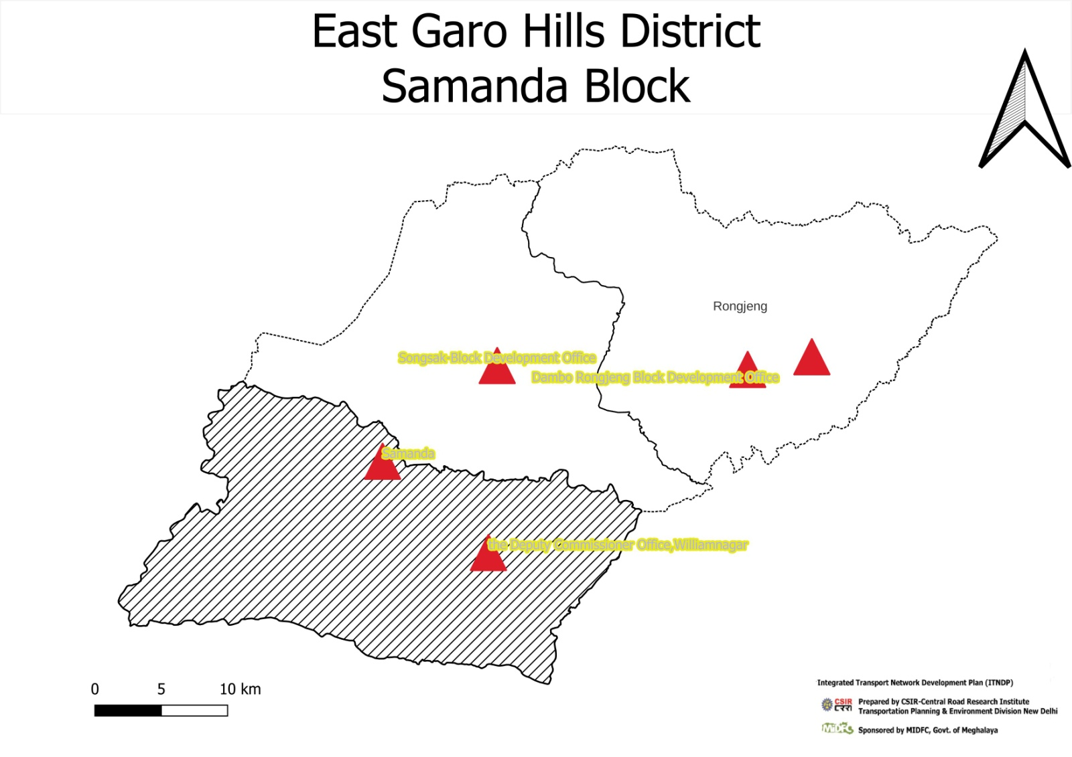

# District: East Garo Hills Block: Samanda C & RD Block

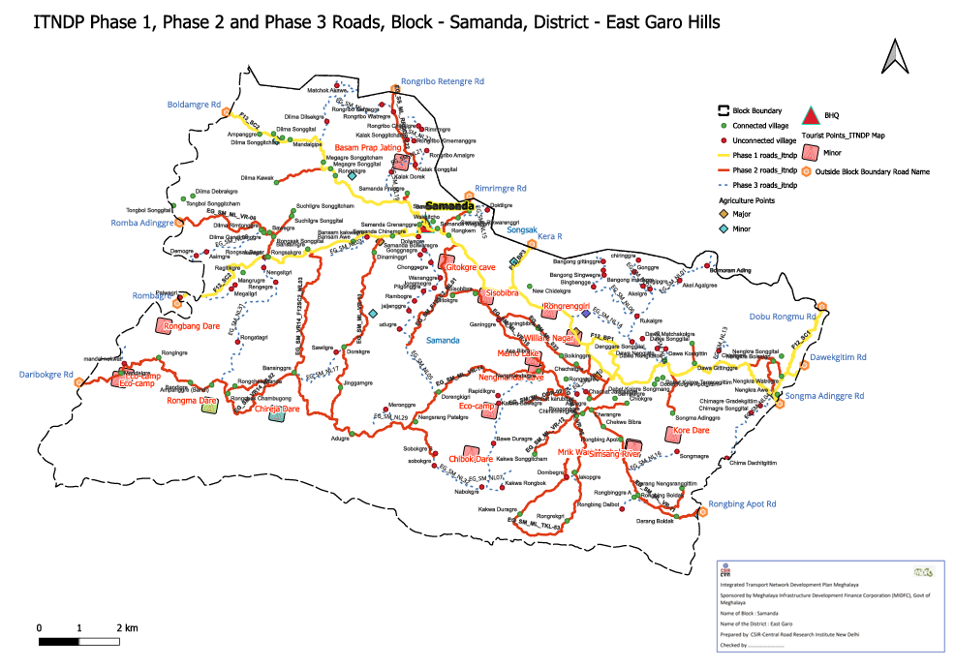

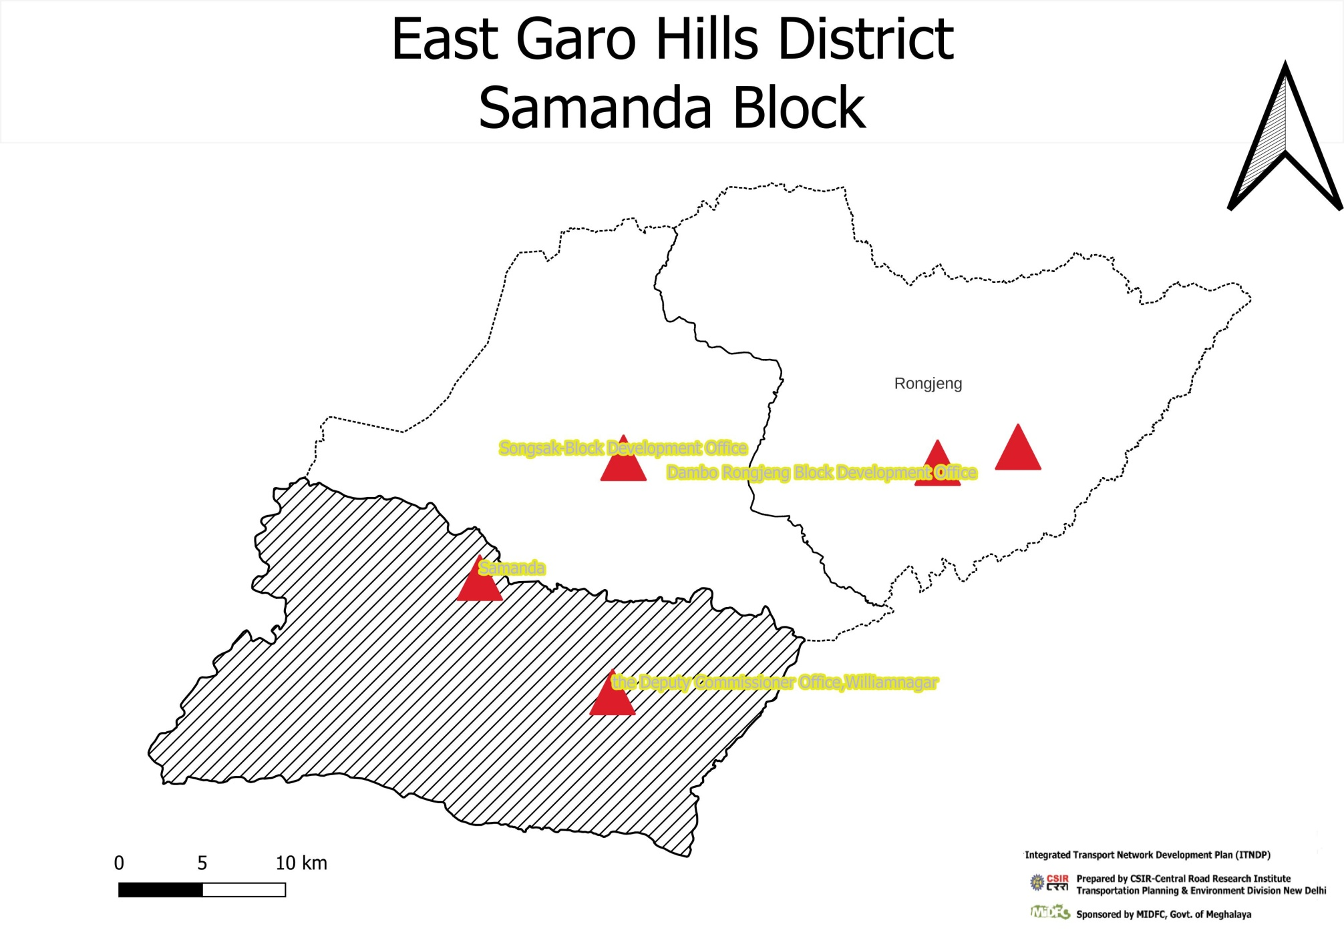

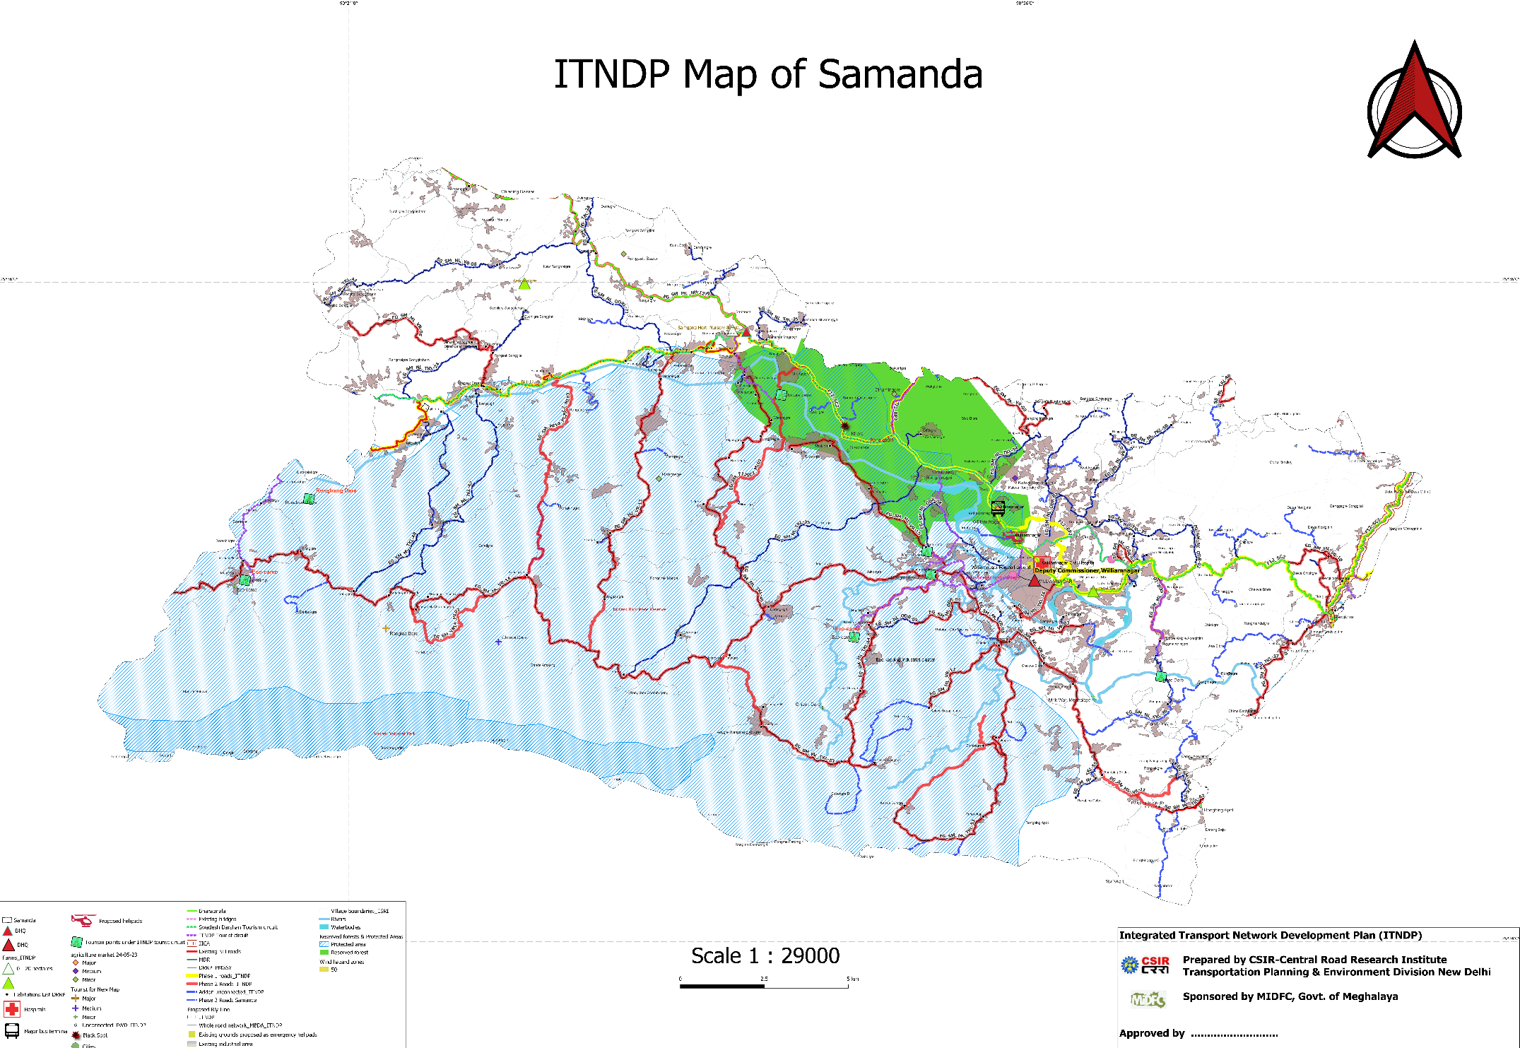

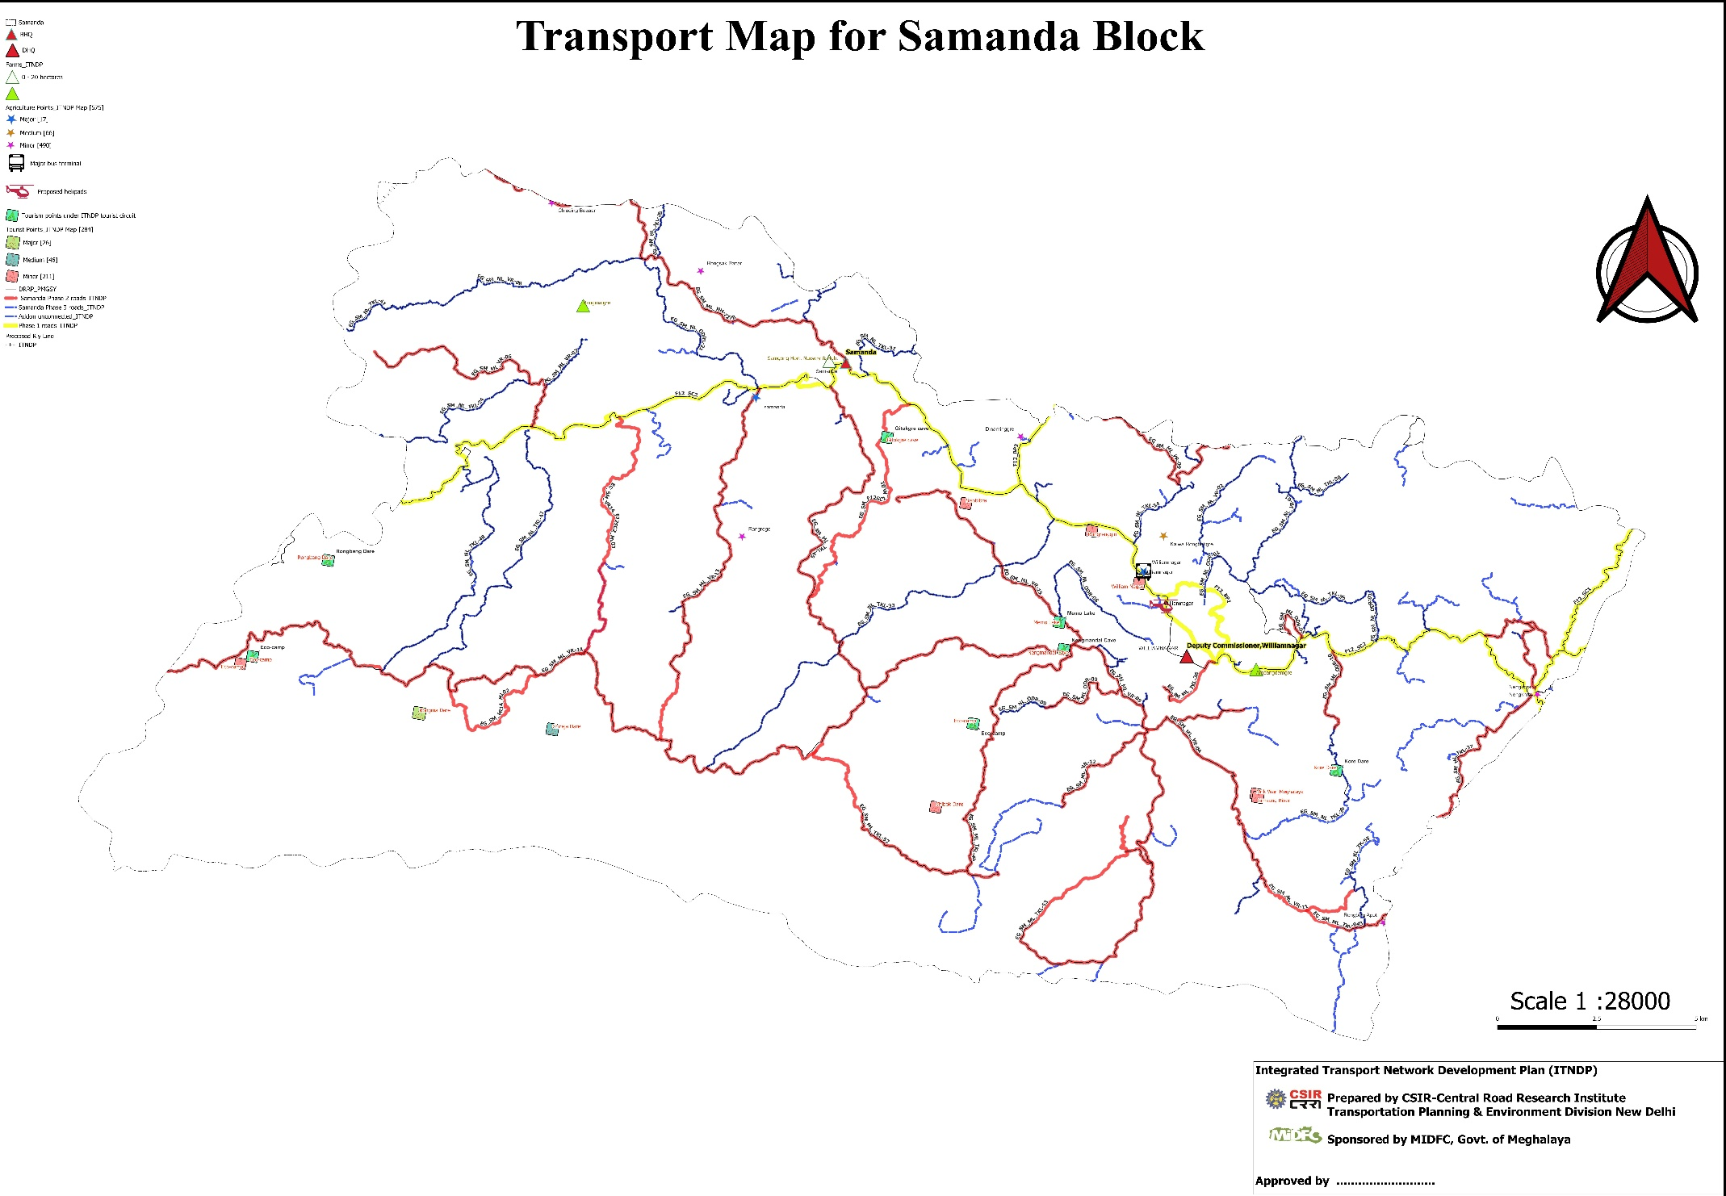

**Summary of allocation of Phase -3 roads and Bridge of ITNDP, Block- Samanda**

|  |  |  |  |  |  |  |  |  |  |  |  |  |  |  |  |  |  |  |  |  |  |  |  |  |  |
| --- | --- | --- | --- | --- | --- | --- | --- | --- | --- | --- | --- | --- | --- | --- | --- | --- | --- | --- | --- | --- | --- | --- | --- | --- | --- |
| fid | UN ID | Length | Block | Road Code | Name of road proposed from | Population serve by New Alignment . | Total cost | Ranking | Absolute | Name & Population served by Habitation in villages. | Whether Road is Sanctioned under any scheme ( Yes/No) eg. MNREGA, PMGSY, PWD, C&RD, BADO, etc. (?) | If YES then consider in PH1/PH2 of ITNDP(road no): | Whether road alignment considered in CRRI ITNDP Phase-3 Roads (Yes/No) | Existing Surface Type E/G/WBM. (?) Proposed E/G/WBM/BT(Provide KML) | Road Agency (PWD/C&RD/Industry/Mining/Agriculture/Tourist/Water/BADA/any other). | Difference | Length (KM) of New Roads Construction Proposed. | Total Cost based on cost per km average rate 2024(in Lakhs) Length*Rate. | Road cost | Rounded | Length portion (KM). | Width of road length(metre) proposed. | Length of New construction of Bridge/CD/Culvert (Meter). | Type Bridge/CD/Culvert/etc. | Cost for Bridge in lakh/CD/Culvert/etc. |
| 24 | 5242 | 1.746 | Samanda | EG_SM_NL23 | L-41 to Rongbing Dolbot | 788 | 207 | 0.263 | 1 | Rongbing Dolbot | FALSE | No | FALSE | Kutcha | PWD | 0.11 | 1.86 | 186 | 174.550 | 175 | 1.86 | 3.75 | 18 | Bridge 7ulvert | 32 |
| 31 | 1868 | 0.763 | Samanda | EG_SM_NL27 | Dolwagre road to Gonggnagre | 236 | 101 | 0.428 | 2 | Gonggnagre | FALSE |  | TRUE | Kutcha | PWD | 0.04 | 0.8 | 100 | 95.357 | 95 | 0.8 | 3.75 | 3 | LSB ,Salb Culvert | 6 |
| 21 | 5399 | 1.463 | Samanda | EG_SM_NL20 | L-22 to Rongribo Kamagre | 163 | 191 | 1.172 | 3 | Rongribo Kamagre | FALSE | No | FALSE | Kutcha | PWD | 0.04 | 1.5 | 150 | 146.274 | 146 | 1.5 | 3.75 | 8 | Bridge 4Culvert | 45 |
| 34 | 4635 | 0.549 | Samanda | EG_SM_NL30 | Rangmalgre to Pakwegri | 82 | 100 | 1.220 | 4 | Pakwegri | FALSE | No | FALSE | Kutcha | PWD | 0.00 | 0.55 | 100 | 99.850 | 100 | 0.55 | 3.75 | 4 | LSB ,Salb Culvert |  |
| 14 | 1282 | 2.045 | Samanda | EG_SM_NL13 | To3 to Chipitgre | 188 | 234 | 1.245 | 5 | Chipitgre | FALSE | ph2 | TRUE | E | PWD | -0.04 | 2 | 200 | 204.469 | 204 | 2 | 3.75 | 9 | Bridge 6Culvert | 30 |
| 11 | 741 | 2.976 | Samanda | EG_SM_NL10 | PMGSY road to Asiragre | 270 | 343 | 1.270 | 6 | Chachat Gangkegre Chachat Karubra | FALSE | ph2 | TRUE | E | PWD | 0.02 | 3 | 300 | 297.579 | 298 | 3 | 3.75 | 13.5 | Bridge 9Culvert | 45 |
| 36 | 5815 | 4.036 | Samanda | EG_SM_NL32 | L44 to Sobokgre B | 336 | 431 | 1.283 | 7 | Sobokgre B , Sobokgre Nabokgre | FALSE | PH2 | TRUE | Kutcha | PWD | 0.16 | 4.2 | 420 | 403.600 | 404 | 4.2 | 3.75 | 20 | Minor Bridge culvert | 27 |
| 26 | 3119 | 1.235 | Samanda | EG_SM_NL24 | PMGSY road to Mandal Nokwat | 89 | 123 | 1.382 | 8 | Mandal Nokwat | FALSE |  | TRUE | Kutcha | PWD | -0.03 | 1.2 | 120 | 123.492 | 123 | 1.2 | 3.75 | 3 |  |  |
| 27 | 1286 | 1.776 | Samanda | EG_SM_NL25 | T03 to Dawa Nengjata | 133 | 194 | 1.459 | 9 | Dawa Nengjata | FALSE | yes | TRUE | Kutcha | PWD | -0.03 | 1.75 | 175 | 177.588 | 178 | 1.75 | 3.75 | 16 | Minor | 16 |
| 9 | 238 | 7.622 | Samanda | EG_SM_NL08 | Asimgre Nawegre to Dimigre | 549 | 1009 | 1.838 | 10 | Asimgre, Baisegre, Dimsgre | FALSE | No | FALSE | E | PWD | -0.12 | 7.5 | 750 | 762.179 | 762 | 7.5 | 3.75 | 65 | Bridge 32Culvert | 247 |
| 20 | 2238 | 1.909 | Samanda | EG_SM_NL19 | L22 to Kalak Dorek | 117 | 221 | 1.889 | 11 | Kalak Dorek | FALSE | PH3 | TRUE | Kutcha | PWD | -0.11 | 1.8 | 180 | 190.891 | 191 | 1.8 | 3.75 | 15 | LSB ,Salb Culvert | 30 |
| 1 | 5435 | 8.148 | Samanda | EG_SM_NL01 | Samgonggre to Agalge via Akelgre | 574 | 1226 | 2.136 | 12 | Akel Agal, Rukalgre, Akegre | FALSE | No | TRUE | Kutcha | PWD | 0.35 | 8.5 | 1062.5 | 1018.481 | 1018 | 8.5 | 3.75 | 60 | Bridge ,Culvert | 208 |
| 17 | 5921 | 3.396 | Samanda | EG_SM_NL16 | T03 to Songmegre | 197 | 438 | 2.223 | 13 | Songmegre | FALSE |  | TRUE | Kutcha | PWD | -0.50 | 2.9 | 290 | 339.628 | 340 | 2.9 | 3.75 | 98 | LSB ,Salb Culvert | 98 |
| 15 | 1289 | 6.455 | Samanda | EG_SM_NL14 | To3 toDangagre Songgital | 803 | 1879 | 2.340 | 14 | Dangagre Songgital | FALSE |  | TRUE | E | PWD | -0.25 | 6.2 | 620 | 645.458 | 645 | 6.2 | 3.75 | 71 | Bridge 21Culvert | 1234 |
| 22 | 5396 | 2.455 | Samanda | EG_SM_NL21 | Kalak Songgital to Rongribo Amelgre | 103 | 291 | 2.825 | 15 | Rongribo Amelgre | FALSE | No | FALSE | Kutcha | PWD | -0.01 | 2.45 | 245 | 245.533 | 246 | 2.45 | 3.75 | 18 | Bridge 5Culvert | 45 |
| 35 | 4073 | 10.460 | Samanda | EG_SM_NL31 | Amparggre to Maregri | 387 | 1143 | 2.953 | 16 | Naregre, Nengsitgre Raengegre | FALSE | PH3 | TRUE | Kutcha | PWD | -0.36 | 10.1 | 1010 | 1045.960 | 1046 | 10.1 | 3.75 | 65 | Minor Bridge culvert | 97 |
| 8 | 222 | 11.300 | Samanda | EG_SM_NL07 | Nengmandalgre to Kakwa Rongbokgre | 850 | 2716 | 3.195 | 17 | Bawe Duragre, Rapdikgre, Kakwa Rongbokgre | FALSE | ph2 | TRUE | Kutcha | PWD | 0.05 | 11.35 | 1418.75 | 1412.478 | 1412 | 11.35 | 3.75 | 114 | Bridge 48Culvert | 1304 |
| 7 | 413 | 7.434 | Samanda | EG_SM_NL06 | Bangong Bingbanggre to Bangong Gittinggre | 403 | 1625 | 4.032 | 18 | Bangong Bingbanggre , Bangong Gittinggre , Bangong Imsokgre | FALSE | ph3 | TRUE | Kutcha | PWD | 0.03 | 7.46 | 932.5 | 929.289 | 929 | 7.46 | 3.75 | 68 | Bridge 34Culvert | 696 |
| 32 | 3776 | 1.629 | Samanda | EG_SM_NL28 | L42 T01 to Meggligri | 45 | 203 | 4.511 | 19 | Meggligri | FALSE |  | TRUE | Kutcha | PWD | -0.13 | 1.5 | 150 | 162.936 | 163 | 1.5 | 3.75 | 68 | LSB, SOHP | 40 |
| 2 | 432 | 2.913 | Samanda | EG_SM_NL02 | Akelgre to Biligipgre | 84 | 403 | 4.792 | 20 | Bilgipgre | FALSE | No | TRUE | Kutcha | PWD | -0.26 | 2.65 | 331.25 | 364.103 | 364 | 2.65 | 3.75 | 15 | Bridge 7 Culvert | 38.5 |
| 18 | 5634 | 4.760 | Samanda | EG_SM_NL17 | L-46 to Sawilgre | 107 | 644 | 6.019 | 21 | Sawilgre | FALSE | No | FALSE | Kutcha | PWD | 0.14 | 4.9 | 490 | 476.025 | 476 | 4.9 | 3.75 | 81.69 | Bridge 16Culvert | 168 |
| 16 | 5543 | 2.781 | Samanda | EG_SM_NL15 | Samanda Rikwareng to Dobtilgre | 69 | 428 | 6.203 | 22 | Dobtilgre | FALSE |  |  | E | PWD | 0.22 | 3 | 385 | 356.904 | 357 | 3 | 3.75 | 25.5 | Bridge 10Culvert | 71 |
| 5 | 698 | 6.105 | Samanda | EG_SM_NL04 | To3 to Chima Dachitgittim | 587 | 4078 | 6.947 | 23 | Chima Dachitgittim, Chima Gradegittim, Chmagre Songgital | FALSE | ph2 | TRUE | Kutcha | PWD | 0.40 | 6.5 | 812.5 | 763.112 | 763 | 6.5 | 3.75 | 149 | Bridge 28 Culvert | 3315 |
| 6 | 706 | 12.362 | Samanda | EG_SM_NL05 | Dorengkegre to Dolwagre | 713 | 5503 | 7.719 | 24 | Dolwarigre, Chonggegre, Wananggre, Jongmegre, Pilgonggre, Rambogre, Jaljenggre, Udugre | FALSE | ph2 | TRUE | Kutcha | PWD | 1.14 | 13.5 | 1687.5 | 1545.266 | 1545 | 13.5 | 3.75 | 202.5 | Bridge 42 Culvert | 3958.5 |
| 12 | 1250 | 7.147 | Samanda | EG_SM_NL11 | Mandalgre to Daribekgre, | 509 | 4523 | 8.885 | 25 | Daribekgre, | TRUE | ph2 | TRUE | E | PWD | 0.15 | 7.3 | 1730 | 1693.859 | 1694 | 7.3 | 3.75 | 135.75 | Bridge 26Culvert | 2828.5 |
| 13 | 1408 | 9.949 | Samanda | EG_SM_NL12 | Magagre Songgital to Dilma Matchok Akawe | 191 | 1718 | 8.992 | 26 | Dilma Dilsekgsa , Dilma Matchok Akawe | FALSE |  | TRUE | E | PWD | 0.55 | 10.5 | 1050 | 994.930 | 995 | 10.5 | 3.75 | 57 | Bridge 34Culvert | 722.5 |
| 33 | 3811 | 2.139 | Samanda | EG_SM_NL29 | Rongrenggre Aidigree to Nengsrang Sonntim | 32 | 300 | 9.375 | 27 | Meronggre | FALSE |  | TRUE | Kutcha | PWD | 0.01 | 2.15 | 268.75 | 267.433 | 267 | 2.15 | 3.75 | 6 | LSB, SOHP | 33 |
| 23 | 5154 | 6.965 | Samanda | EG_SM_NL22 | L-22 to Rongribo Chibolgre | 138 | 1312 | 9.507 | 28 | Ronribo Chibogre, Rimrimgre | FALSE | No | FALSE | Kutcha | PWD | 0.33 | 7.3 | 730 | 696.501 | 697 | 7.3 | 3.75 | 61.5 | Bridge 24ulvert | 615 |
| 28 | 1553 | 1.073 | Samanda | EG_SM_NL26 | L53 to Dombegre | 12 | 392 | 32.667 | 29 | Dombegre | FALSE | PH3 | TRUE | Kutcha | PWD | 0.13 | 1.2 | 120 | 107.251 | 107 | 1.2 | 3.75 | 28.5 | LSB ,Salb Culvert | 285 |
| 3 | 1541 | 2.824 | Samanda | EG_SM_NL03 | RRD road to Bansam Kakwagre | 81 | 2748 | 33.926 | 30 | Bansam Kakwagre | FALSE | ph1 | TRUE | Kutcha | PWD | 0.04 | 2.86 | 357.5 | 352.955 | 353 | 2.86 | 3.75 | 150 | Bridge ,11 Culvert | 2395 |
|  |  | 136.414 |  |  |  |  |  |  |  |  |  |  |  |  |  |  |  | 9231 |  | 16093 |  |  |  |  | 18630 |

Financing Plan of Roads of Phase 3 Samanda

|  |  |
| --- | --- |
| Total No of Road | 30 |
| Total Length of New Construction(km) | 136.414 |
| Total Cost of Bridge and Culvert | 18630 |
| Total Cost of Road | 16093 |
| Total Cost for Samanda (lakh) | 34723 |
| Yearly budget (20 years) | 1736.15 |

|  |  |  |  |  |  |
| --- | --- | --- | --- | --- | --- |
| Year | RoadCode | RoadName | km to be done | Amount required | Budget |
| 2024 | EG_SM_NL23 | L-41 to Rongbing Dolbot |  | 207 | 1730 |
|  | EG_SM_NL27 | Dolwagre road to Gonggnagre |  | 101 |  |
|  | EG_SM_NL20 | L-22 to Rongribo Kamagre |  | 191 |  |
|  | EG_SM_NL30 | Rangmalgre to Pakwegri |  | 100 |  |
|  | EG_SM_NL13 | To3 to Chipitgre |  | 234 |  |
|  | EG_SM_NL10 | PMGSY road to Asiragre |  | 343 |  |
|  | EG_SM_NL32 | L44 to Sobokgre B |  | 431 |  |
|  | EG_SM_NL24 | PMGSY road to Mandal Nokwat |  | 123 |  |
| 2025 | EG_SM_NL25 | T03 to Dawa Nengjata |  | 194 | 1424 |
|  | EG_SM_NL08 | Asimgre Nawegre to Dimigre |  | 1009 |  |
|  | EG_SM_NL19 | L22 to Kalak Dorek |  | 221 |  |
| 2026 | EG_SM_NL01 | Samgonggre to Agalge via Akelgre |  | 1226 | 1664 |
|  | EG_SM_NL16 | T03 to Songmegre |  | 438 |  |
| 2027 | EG_SM_NL14 | To3 toDangagre Songgital (0-5.68km) | 5.68 | 1656 | 1656 |
| 2028 | EG_SM_NL14 | To3 toDangagre Songgital (5.68-6.45km) | 0.77 | 223 | 1657 |
|  | EG_SM_NL21 | Kalak Songgital to Rongribo Amelgre |  | 291 |  |
|  | EG_SM_NL31 | Amparggre to Maregri |  | 1143 |  |
| 2029 | EG_SM_NL07 | Nengmandalgre to Kakwa Rongbokgre (0-6.86km) | 6.86 | 1649 | 1649 |
| 2030 | EG_SM_NL07 | Nengmandalgre to Kakwa Rongbokgre (6.86-11.3km) | 4.44 | 1067 | 1649 |
|  | EG_SM_NL06 | Bangong Bingbanggre to Bangong Gittinggre (0-2.66km) | 2.66 | 582 |  |
| 2031 | EG_SM_NL06 | Bangong Bingbanggre to Bangong Gittinggre (2.66-7.43km) | 4.77 | 1043 | 1649 |
|  | EG_SM_NL28 | L42 T01 to Meggligri |  | 203 |  |
|  | EG_SM_NL02 | Akelgre to Biligipgre |  | 403 |  |
| 2032 | EG_SM_NL17 | L-46 to Sawilgre |  | 644 | 1717 |
|  | EG_SM_NL15 | Samanda Rikwareng to Dobtilgre |  | 428 |  |
|  | EG_SM_NL04 | To3 to Chima Dachitgittim (0-0.96km) | 0.96 | 645 |  |
| 2033 | EG_SM_NL04 | To3 to Chima Dachitgittim (0.96-3.53km) | 2.57 | 1717 | 1717 |
| 2034 | EG_SM_NL04 | To3 to Chima Dachitgittim (3.53-6.1km) | 2.57 | 1716 | 1716 |
| 2035 | EG_SM_NL05 | Dorengkegre to Dolwagre (0-3.75km) | 3.75 | 1671 | 1671 |
| 2036 | EG_SM_NL05 | Dorengkegre to Dolwagre (3.75-7.5km) | 3.75 | 1671 | 1671 |
| 2037 | EG_SM_NL05 | Dorengkegre to Dolwagre (7.5-11.25km) | 3.75 | 1671 | 1671 |
| 2038 | EG_SM_NL05 | Dorengkegre to Dolwagre (11.25-12.35km) | 1.1 | 490 | 1671 |
|  | EG_SM_NL11 | Mandalgre to Daribekgre (0-1.87km) | 1.87 | 1181 |  |
| 2039 | EG_SM_NL11 | Mandalgre to Daribekgre (1.87-4.51km) | 2.64 | 1671 | 1671 |
| 2040 | EG_SM_NL11 | Mandalgre to Daribekgre (4.51-7.15km) | 2.64 | 1671 | 1671 |
| 2041 | EG_SM_NL12 | Magagre Songgital to Dilma Matchok Akawe |  | 1718 | 1718 |
| 2042 | EG_SM_NL29 | Rongrenggre Aidigree to Nengsrang Sonntim |  | 300 | 1612 |
|  | EG_SM_NL22 | L-22 to Rongribo Chibolgre |  | 1312 |  |
| 2043 | EG_SM_NL26 | L53 to Dombegre |  | 392 | 1570 |
|  | EG_SM_NL03 | RRD road to Bansam Kakwagre (0-1.21km) | 1.21 | 1178 |  |
| 2044 | EG_SM_NL03 | RRD road to Bansam Kakwagre (1.21-2.82km) | 1.61 | 1570 | 1570 |
|  |  |  |  | 34724 | 34724 |

List Unconnected Habitation of Block - Samanda

|  |  |  |  |  |  |
| --- | --- | --- | --- | --- | --- |
| fid | Block | Habitation | Population | Y | X |
| 58 | Samanda | Nongbak Wapil | 395 | 25.72526889 | 90.87198153 |
| 62 | Samanda | sobokgre | 157 | 25.46523598 | 90.52189451 |
| 63 | Samanda | Sobokgre B | 50 | 25.47126407 | 90.52250303 |
| 64 | Samanda | mandal nokwat | 89 | 25.51574688 | 90.36859497 |
| 65 | Samanda | Meronggre | 32 | 25.49306453 | 90.49790092 |
| 66 | Samanda | Sawilgre | 107 | 25.52137608 | 90.47339736 |
| 67 | Samanda | Rongbing Dalbot | 217 | 25.44372628 | 90.61478952 |
| 68 | Samanda | Kakwa Rongbok | 184 | 25.45432242 | 90.5555174 |
| 69 | Samanda | Nabokgre | 129 | 25.45465355 | 90.54541796 |
| 70 | Samanda | Chima Dachitgittim | 182 | 25.4688921 | 90.66661124 |
| 71 | Samanda | Songmagre | 197 | 25.47220339 | 90.64194211 |
| 72 | Samanda | Chimagre Gradekgittim | 260 | 25.49488574 | 90.6831677 |
| 73 | Samanda | Chipitgrre | 188 | 25.52203833 | 90.66263769 |
| 74 | Samanda | Dawa Nengjata | 133 | 25.52319729 | 90.6321738 |
| 75 | Samanda | Denggare Songgital | 388 | 25.52650858 | 90.61975646 |
| 76 | Samanda | Rukalgre | 145 | 25.53919148 | 90.62216656 |
| 77 | Samanda | Ganinggre | 186 | 25.53735306 | 90.55377897 |
| 78 | Samanda | Bingbangge | 116 | 25.55373421 | 90.60069387 |
| 79 | Samanda | Akelgre | 268 | 25.552585 | 90.62861416 |
| 80 | Samanda | Bilgipgre | 80 | 25.55407508 | 90.62513731 |
| 81 | Samanda | Bangong imsokgre | 103 | 25.55953872 | 90.60593181 |
| 82 | Samanda | Bangong gittinggre | 184 | 25.56624082 | 90.60550779 |
| 83 | Samanda | chiringgre | 128 | 25.56690634 | 90.62290218 |
| 84 | Samanda | udugre | 67 | 25.53280003 | 90.50468907 |
| 85 | Samanda | jaljenggre | 32 | 25.54190609 | 90.50932487 |
| 86 | Samanda | Rambogre | 30 | 25.54670746 | 90.51213947 |
| 87 | Samanda | Pilgonggre | 38 | 25.55150883 | 90.51660972 |
| 88 | Samanda | Jongmegre | 169 | 25.55316448 | 90.52190778 |
| 89 | Samanda | Wananggre | 33 | 25.55813142 | 90.52488795 |
| 90 | Samanda | Chonggegre | 67 | 25.56574739 | 90.52025214 |
| 91 | Samanda | Gonggnagre | 236 | 25.56955537 | 90.51495407 |
| 92 | Samanda | Dolwagre | 227 | 25.57849586 | 90.51412625 |
| 93 | Samanda | Doktilgre | 69 | 25.59174103 | 90.54814977 |
| 94 | Samanda | Rimrimgre | 0 | 25.6316148 | 90.51570404 |
| 95 | Samanda | Kalak Dorek | 117 | 25.61053364 | 90.5007193 |
| 96 | Samanda | Rongribo Amalgre | 103 | 25.62110983 | 90.51820379 |
| 97 | Samanda | Rongribo Kimemanggre | 66 | 25.62593751 | 90.51185705 |
| 98 | Samanda | Megaligri | 45 | 25.55265027 | 90.42159277 |
| 99 | Samanda | Mangrugre | 249 | 25.55463158 | 90.4234015 |
| 100 | Samanda | Rengegre | 241 | 25.55597908 | 90.44351295 |
| 101 | Samanda | Nengsitgri | 47 | 25.56318966 | 90.43757215 |
| 102 | Samanda | naregri | 109 | 25.56828447 | 90.43801398 |
| 103 | Samanda | Dilma Dilsekgre | 140 | 25.63554235 | 90.46880918 |
| 104 | Samanda | Rongribo Kamagre | 163 | 25.64388471 | 90.49595978 |
| 105 | Samanda | Matchok Akawe | 51 | 25.65327811 | 90.47374948 |
| 106 | Samanda | Demogre | 138 | 25.5691221 | 90.40421428 |
| 107 | Samanda | Asimgre | 78 | 25.57100446 | 90.40925386 |
| 108 | Samanda | Akel Agalgree | 161 | 25.5568069 | 90.64326663 |
| 109 | Samanda | Bawe Duragre | 99 | 25.47622042 | 90.55122908 |
| 110 | Samanda | Bansam kakwagre | 81 | 25.57835732 | 90.48862762 |
| 111 | Samanda | Chachat karubibra | 63 | 25.50066057 | 90.59252505 |
| 112 | Samanda | Chachat Jangkegre | 207 | 25.50182018 | 90.59687442 |
| 113 | Samanda | Dombegre | 12 | 25.4596282 | 90.58733449 |
| 114 | Samanda | Rapidikgre | 279 | 25.49986514 | 90.55341366 |
| 115 | Samanda | Palwegri | 82 | 25.54846592 | 90.39623609 |
| 116 | Samanda | Rongribo Chibolgre | 138 | 25.63332113 | 90.51410932 |
| 117 | Samanda | Kalak Songgitcham | 82 | 25.62650446 | 90.50856147 |
| 118 | Samanda | Bolmoram Ading | 153 | 25.56413239 | 90.65682324 |
| 119 | Samanda | Gonggre | 143 | 25.56102851 | 90.620787 |
| 120 | Samanda | Bangong Singwegre | 73 | 25.5618858 | 90.60553669 |
| 121 | Samanda | Dawa Matchakolgre | 159 | 25.52806996 | 90.62485336 |
| 122 | Samanda | Dawa Kosigittin | 196 | 25.52301425 | 90.63639425 |
| 123 | Samanda | Rongribo Watregre | 232 | 25.64029476 | 90.50176749 |
| 124 | Samanda | Kalak Songgital | 72 | 25.61415047 | 90.5125528 |
| 125 | Samanda | Samanda Bolwaregre | 228 | 25.57190662 | 90.51698949 |
| 126 | Samanda | Kakwa Bawegre | 349 | 25.49611616 | 90.5537877 |
| 127 | Samanda | Rongatagri | 55 | 25.52641845 | 90.42466582 |
| 128 | Samanda | Chimagre Songgital | 145 | 25.49131987 | 90.67856176 |
| 253 | Samanda | Sudu Nengjaring | 145 | 25.5507069 | 90.75289442 |

List Connected Habitation of Block - Samanda

|  |  |  |  |  |  |
| --- | --- | --- | --- | --- | --- |
| fid | Block | Habitation | Population | Y | X |
| 242 | Samanda | Bansinggre | 191 | 25.51127579 | 90.4525988 |
| 243 | Samanda | Chiokgre | 540 | 25.49614093 | 90.61715443 |
| 244 | Samanda | Rongbing Apot | 205 | 25.4781819 | 90.61411268 |
| 245 | Samanda | Bolkinggre | 390 | 25.51958719 | 90.58472359 |
| 246 | Samanda | Chachatgre | 509 | 25.51542291 | 90.5921513 |
| 247 | Samanda | Rongregre | 129 | 25.50807287 | 90.58709692 |
| 248 | Samanda | Bandigre | 112 | 25.50634726 | 90.40136833 |
| 249 | Samanda | Mandalgre | 379 | 25.5110497 | 90.36702422 |
| 250 | Samanda | Dawa Gittinggre | 516 | 25.51586676 | 90.65062316 |
| 251 | Samanda | Dawa Songgital | 306 | 25.52570214 | 90.649432 |
| 252 | Samanda | Songma Adinggre | 232 | 25.49120083 | 90.63978751 |
| 253 | Samanda | Dobet Kolgre Apotgittim | 94 | 25.50789417 | 90.63218387 |
| 254 | Samanda | Dobet Kolgre Songmang | 0 | 25.50549643 | 90.63082561 |
| 255 | Samanda | Dobet Kolgre Terracegittim | 0 | 25.50879653 | 90.63492639 |
| 256 | Samanda | Gitokgre | 429 | 25.54940064 | 90.53095091 |
| 257 | Samanda | Sisobibra | 541 | 25.550394 | 90.542208 |
| 258 | Samanda | Asa Bibra | 353 | 25.51969898 | 90.57063499 |
| 259 | Samanda | Nengmandalgre | 824 | 25.51207549 | 90.57345119 |
| 260 | Samanda | New Chidekgre | 101 | 25.55394904 | 90.56908792 |
| 261 | Samanda | Rongkem | 210 | 25.5791982 | 90.52904585 |
| 262 | Samanda | Samanda Megapgri | 401 | 25.58257796 | 90.52347345 |
| 263 | Samanda | Samanda Rikwarenggri | 165 | 25.58787322 | 90.53368189 |
| 264 | Samanda | Ampanggre (Bandi) | 471 | 25.5051016 | 90.41181659 |
| 265 | Samanda | Rongchek Chambugong | 88 | 25.50082622 | 90.41984126 |
| 266 | Samanda | Rongchek Manda | 114 | 25.50462835 | 90.42332765 |
| 267 | Samanda | Samanda Prapgre | 323 | 25.6000147 | 90.50855661 |
| 268 | Samanda | Chekwe Bibra | 425 | 25.48454013 | 90.60551505 |
| 269 | Samanda | Jakopgre | 170 | 25.46189062 | 90.59134602 |
| 270 | Samanda | Bansam Awe | 290 | 25.57618741 | 90.48178631 |
| 271 | Samanda | Dinaminggri | 496 | 25.57073387 | 90.49220613 |
| 272 | Samanda | Nengkra Awe - I | 904 | 25.50045856 | 90.69162342 |
| 273 | Samanda | Nengkra Watregre | 333 | 25.50942934 | 90.69365982 |
| 274 | Samanda | Nengkra Bolsalgri | 543 | 25.51693878 | 90.68964696 |
| 275 | Samanda | Nengkra Songgital | 0 | 25.51939498 | 90.69364317 |
| 276 | Samanda | Samanda Chinemgre | 522 | 25.57885429 | 90.50123654 |
| 277 | Samanda | Chiminmingre | 58 | 25.48985491 | 90.59221383 |
| 278 | Samanda | Rongonggre | 202 | 25.49101816 | 90.5953001 |
| 279 | Samanda | Ganingbibra | 337 | 25.5332699 | 90.57319412 |
| 280 | Samanda | Bansamgre | 761 | 25.57238283 | 90.45935616 |
| 281 | Samanda | Bawegre | 333 | 25.580571 | 90.440464 |
| 282 | Samanda | Dilma Gandinanggre | 119 | 25.580565 | 90.43762 |
| 283 | Samanda | Dilma Kawak | 138 | 25.60528365 | 90.44383704 |
| 284 | Samanda | Dilma Rimtonggre | 114 | 25.58185416 | 90.43633841 |
| 285 | Samanda | Ragitikgre | 22 | 25.56076824 | 90.42735584 |
| 286 | Samanda | Rongsak Bazar | 113 | 25.56862859 | 90.43917738 |
| 287 | Samanda | Rongsak Songgital | 252 | 25.57864179 | 90.44254648 |
| 288 | Samanda | Rongsakgre | 586 | 25.56846159 | 90.43981266 |
| 289 | Samanda | Suchilgre Songgital | 198 | 25.588781 | 90.451452 |
| 290 | Samanda | Suchilgre Songgitcham | 161 | 25.591383 | 90.452296 |
| 291 | Samanda | Rongbinggre A | 576 | 25.44960525 | 90.62075391 |
| 292 | Samanda | Rongrekgri | 210 | 25.43790952 | 90.58758238 |
| 293 | Samanda | Darang Boldak | 281 | 25.44011666 | 90.64168842 |
| 294 | Samanda | Adugre | 124 | 25.481018 | 90.4813 |
| 295 | Samanda | Nengsrang Patalgre | 43 | 25.486932 | 90.512656 |
| 296 | Samanda | Jinggamgre | 56 | 25.50387534 | 90.47553821 |
| 297 | Samanda | Dorakgre | 208 | 25.5239743 | 90.47725989 |
| 298 | Samanda | Dawa Nengkatok | 398 | 25.51732576 | 90.63593023 |
| 299 | Samanda | Darang Nengsranggittim | 176 | 25.45408472 | 90.64436032 |
| 300 | Samanda | Rongbing Boldak | 666 | 25.45056945 | 90.62270998 |
| 301 | Samanda | Megagre Songgital | 173 | 25.61215699 | 90.47067188 |
| 302 | Samanda | Megagre Songgitcham | 231 | 25.61539094 | 90.46707553 |
| 303 | Samanda | Rongakgre | 123 | 25.60872887 | 90.47300525 |
| 304 | Samanda | Samanda Grenanggre | 208 | 25.58450814 | 90.51458684 |
| 305 | Samanda | Wakgitcho | 114 | 25.58604693 | 90.52133626 |
| 306 | Samanda | Asiragre | 277 | 25.49832236 | 90.59858304 |
| 307 | Samanda | Cherangre | 178 | 25.4928383 | 90.5996198 |
| 308 | Samanda | Sampalgre | 723 | 25.49850906 | 90.61128903 |
| 309 | Samanda | Kakwa Songgitcham | 202 | 25.47090283 | 90.57156003 |
| 310 | Samanda | Kakwa Duragre | 143 | 25.44127261 | 90.56429617 |
| 311 | Samanda | Dilma Songgital | 113 | 25.62944497 | 90.44244714 |
| 312 | Samanda | Dilma Songgitcham | 113 | 25.627495 | 90.446819 |
| 313 | Samanda | Ampanggre | 471 | 25.6291915 | 90.43552127 |
| 314 | Samanda | Dorengkigri | 265 | 25.50165716 | 90.52408337 |
| 315 | Samanda | Rongingre | 129 | 25.51872704 | 90.38564812 |
| 316 | Samanda | Mandalgipe | 68 | 25.62650959 | 90.45063223 |
| 317 | Samanda | Samanda Patranggre | 55 | 25.5912355 | 90.5392357 |
| 318 | Samanda | Samanda Wagetgri | 62 | 25.59556639 | 90.53776762 |
| 319 | Samanda | Dilma Debrakgre | 189 | 25.59869246 | 90.40250979 |
| 320 | Samanda | Tongbol Songgital | 183 | 25.59389337 | 90.39301575 |
| 321 | Samanda | Tongbol Songgitcham | 349 | 25.59720466 | 90.39781712 |
| 323 | Samanda | Rongribo Retenggre | 103 | 25.65661831 | 90.50220428 |
| 347 | Samanda | Rongribo Gongmagre | 217 | 25.670082 | 90.499376 |